We get important information that we gain about how the system works from people with lesions in the brain, missing parts or not working parts.

Try to see and understand what is going on in patients with lesion, makes us able to understand what those parts of the brain are useful for

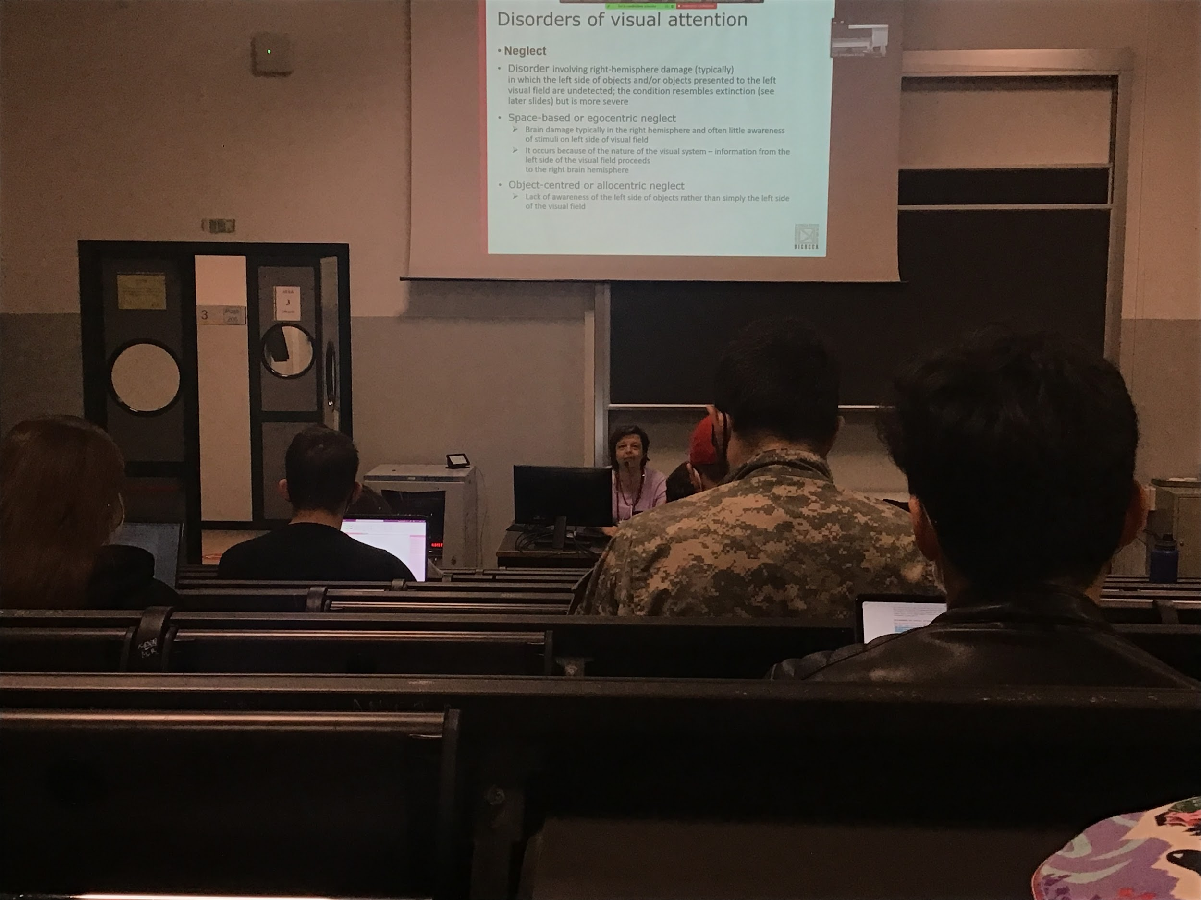

2 main disorder of visual attention

* **unilateral neglect**: disease of half of the visual field, half of what you see, an asymmetric disorder, lesion in the primary visual cortex you don’t see physically half of the visual field, lesion on the left you don’t see the right. Neglect is very special: most of the time, 95% of patients have right emphiserse damage, inability to represent the left part of the visual field or of objects. Huge debate why this asymmetry is present with this deficit
* **extinction**: when I show you 2 objects and you are unable to see one of the two objects. The typical test doctors do to test extension they present people with two fingers and they have to tell what they see. When I present them together they only see the right finger

neglect: you describes only half of the room

extinction: when there is a presentation in both hemispheres you see only one. Present people with two fingers, when presented together they only see the right one.

Two different types of neglect.

* **Space base or egocentric neglect**: The most prototypical the one that has been tested more. Brain damage in the right empshere, have no awareness of the stimuli of the left side of the visual field. Don’t know what is there
* **Object centred neglect**: don’t represent the left side of all the objects present in the field, you perceive half of everything.

Neglected and extension sometimes goes together

Neglect: eat only half of the food in the plate, draw only on half of the page, reproduce only half the pictures, you shave only half of the face

**Emanopia**: deficit on the primary visual cortex, you don’t see physically the things on the left, you just move your head, you know that you are missing half

**But with neglect you don’t know to have this deficit, patients are unaware of their deficit**

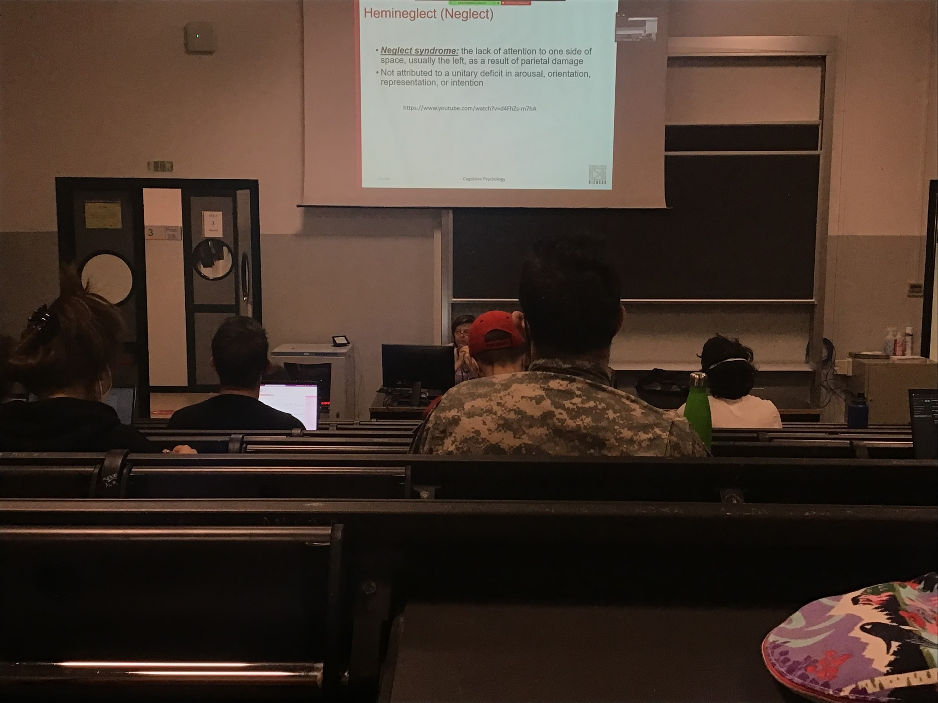

**Neglect**: lack of attention to one side of the space, usually larger parietal damage, people can have others deficit together,

Not aware that there is half of the word missing, you keep telling these people that they are eating half of the plate…

They are aware in some sense that this is happening but not conscious of this difficulty

They actually do not perform very well, there is improved after time for man of them (not for all)

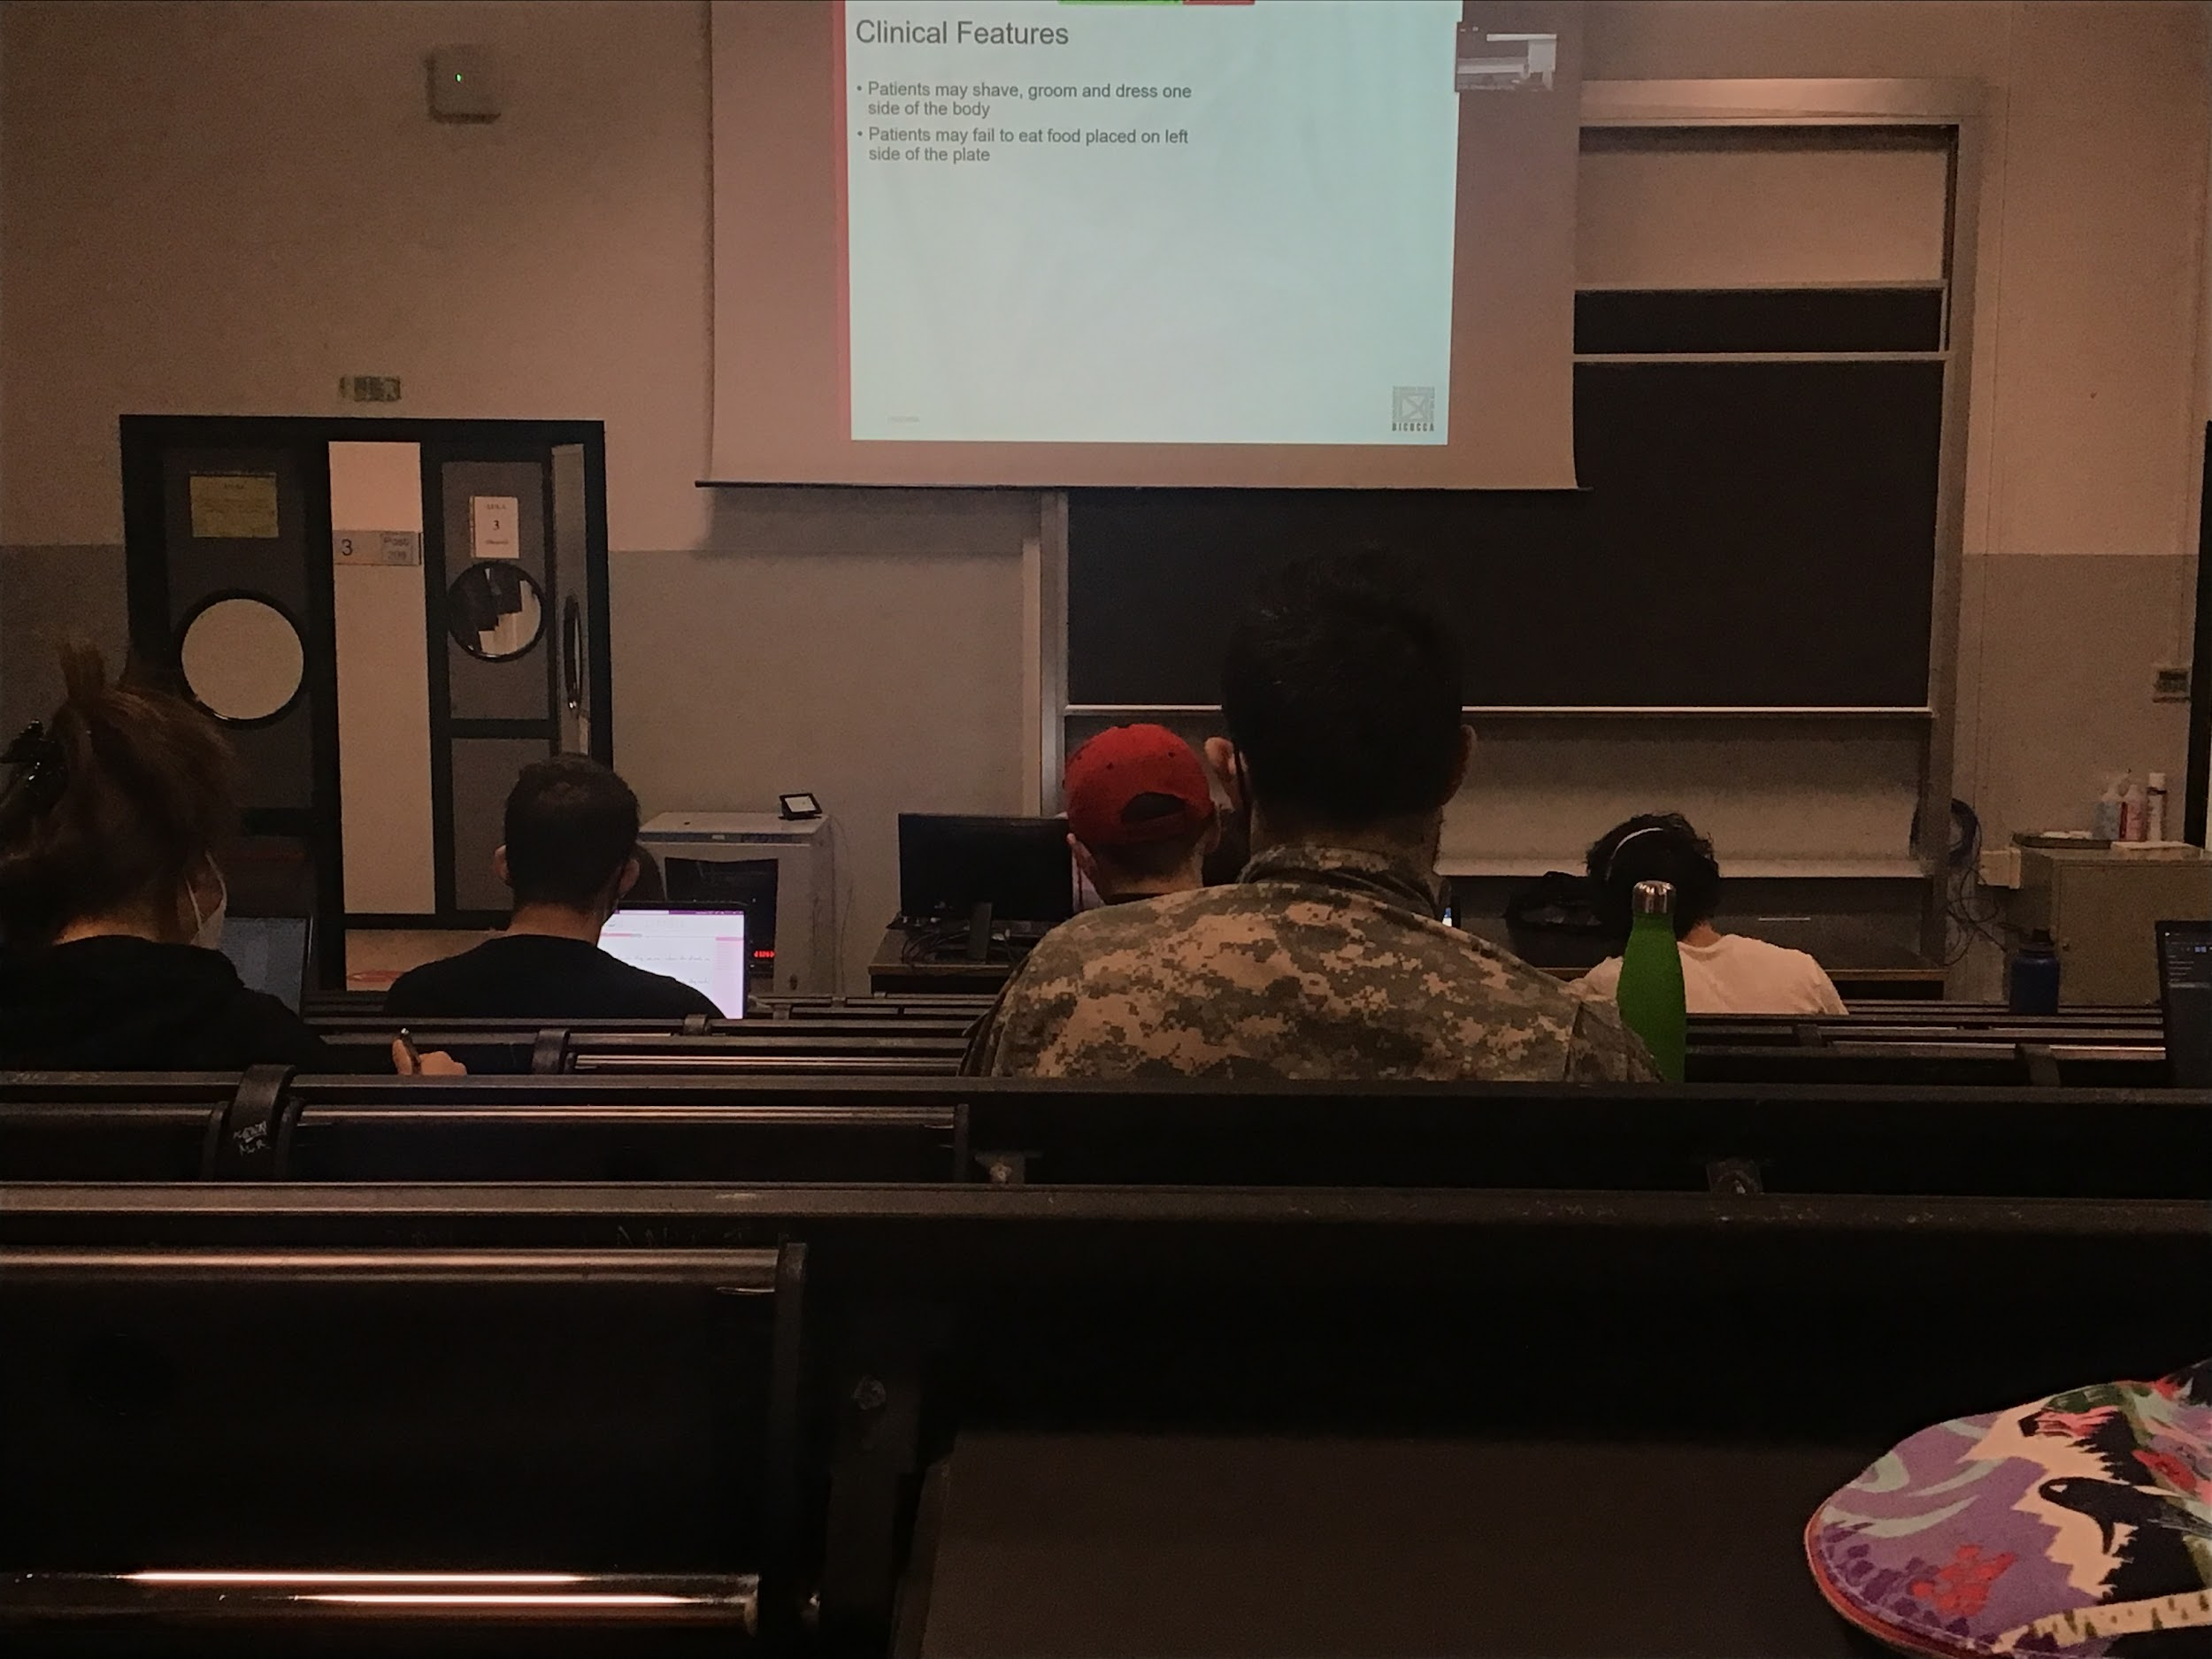

They were dress and put make up only in half of the face, they think they did perfectly well, but in reality they missed half of the face

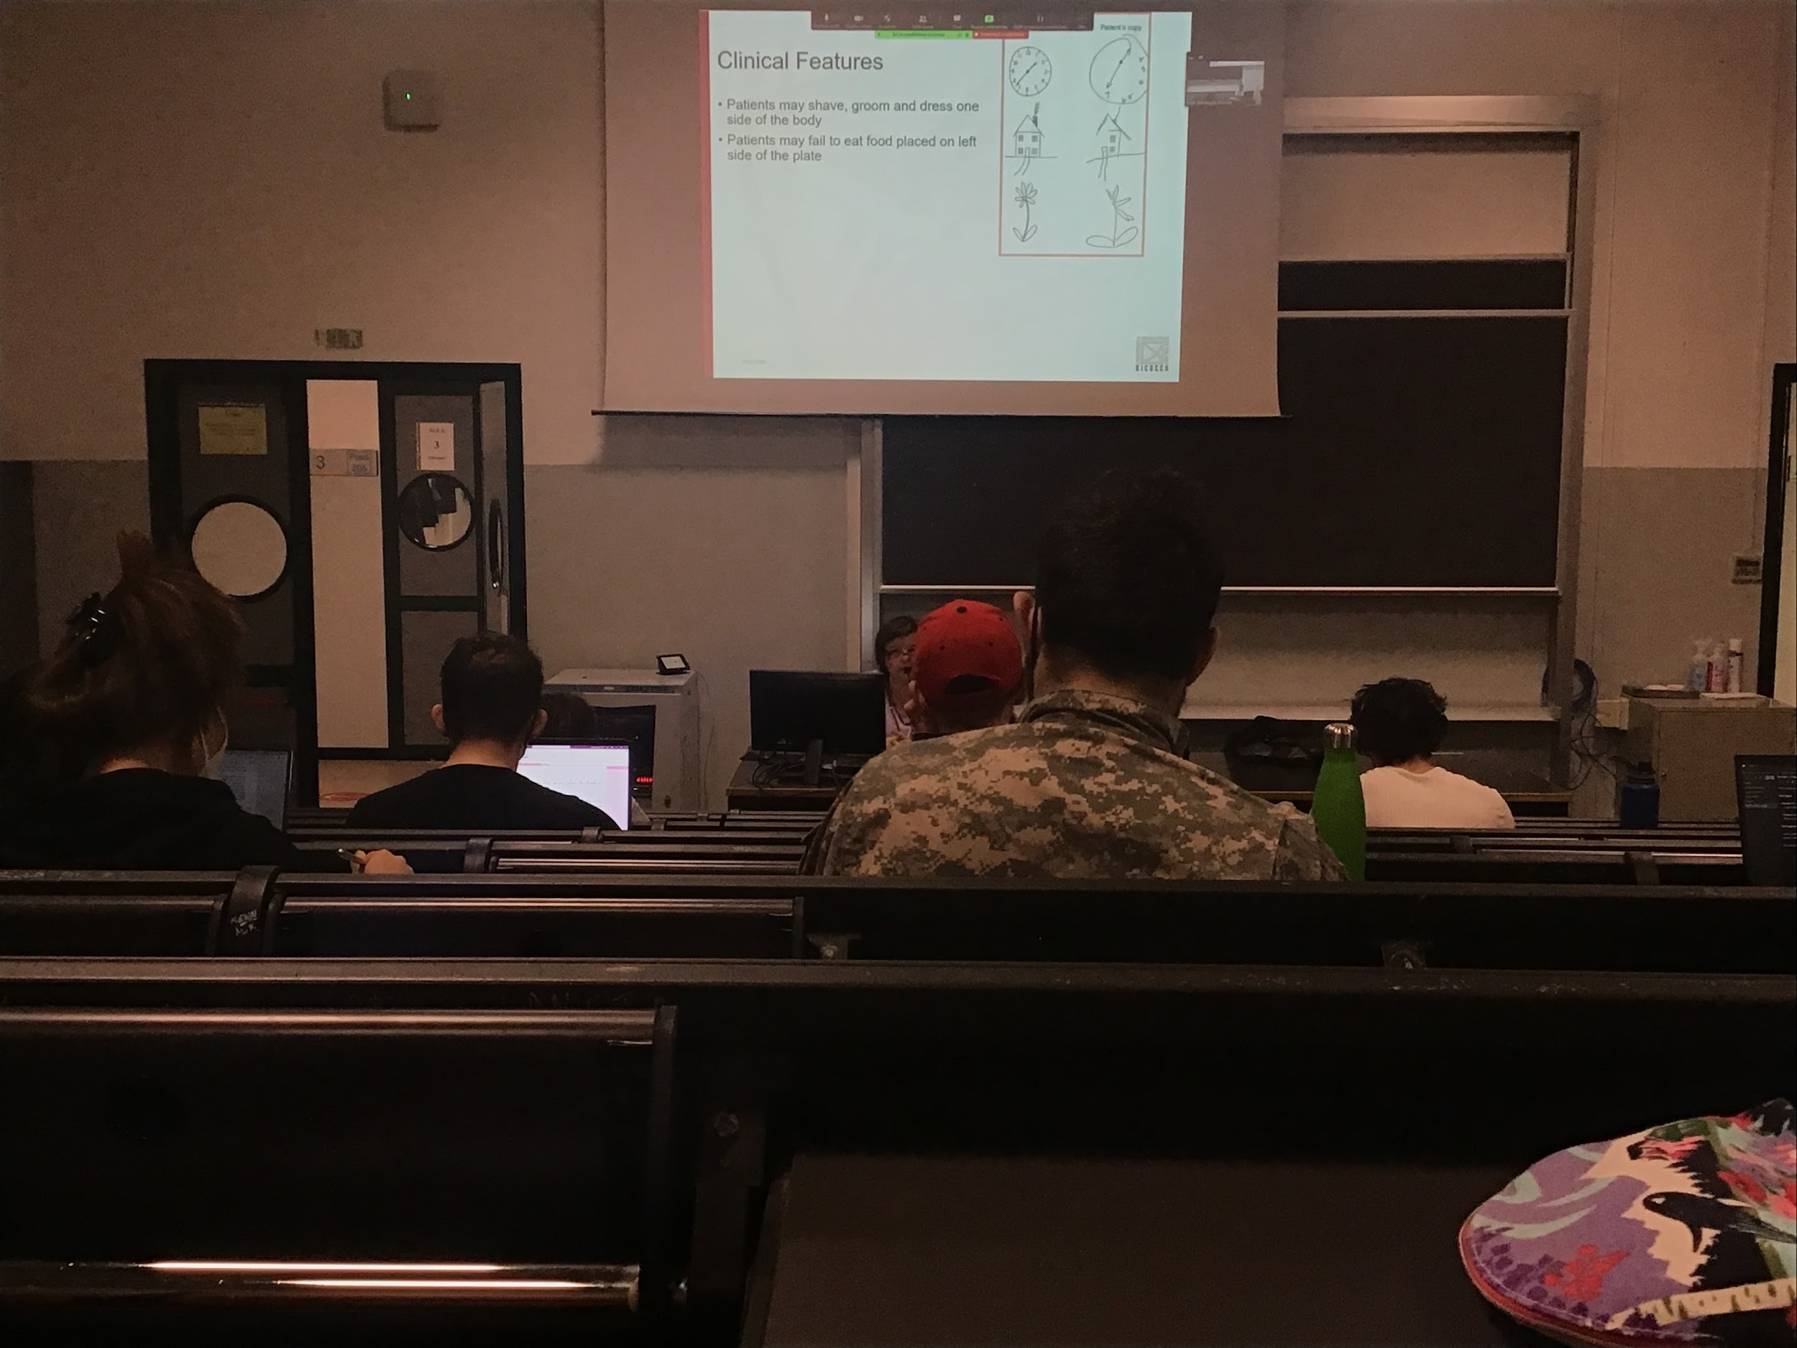

the test is usually a **drawing test**, have in on a piece of paper, require to draw the same identical thing on the side

People remember what the image is, this test is not a problem of memory but is a problem of perception and attention (the image is not hidden from the patient)

They draw the number only on half side of the clock, they stop at 7

They do not realise that there is a missing part

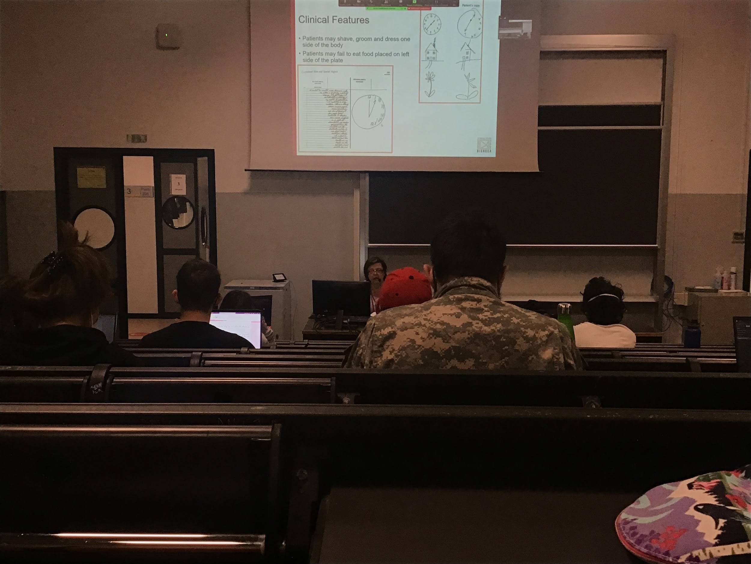

They write only one side

Difficult to read also, read only half part of the words

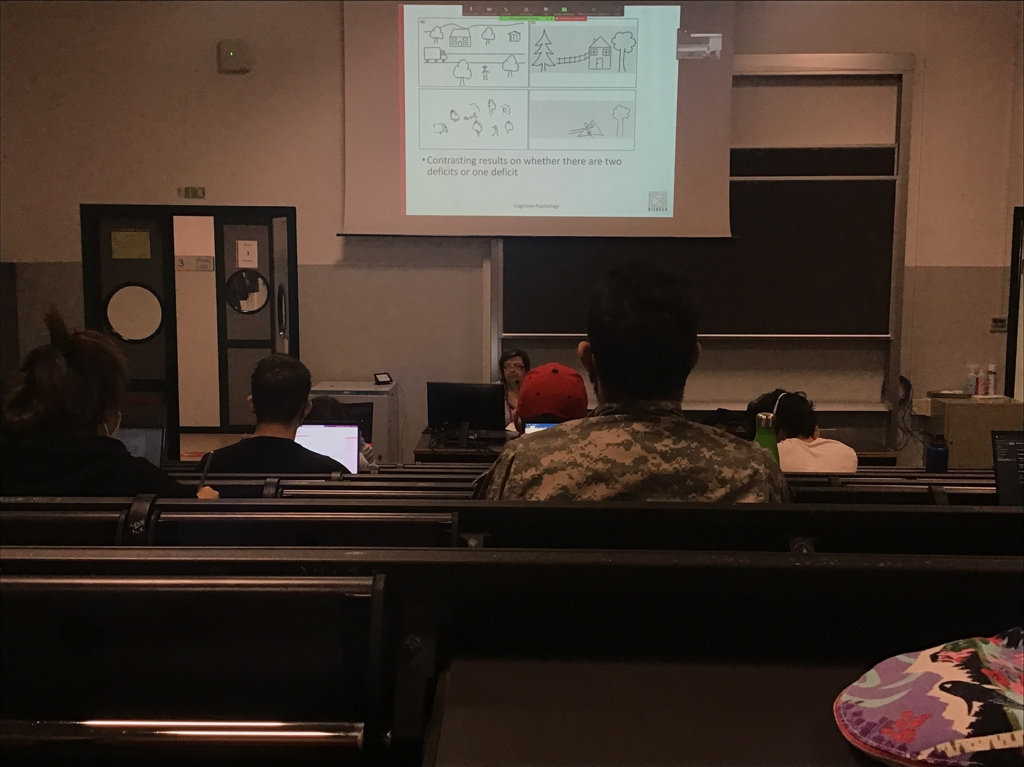

Two types of neglect

* **Space base neglect**, draw half of the scene
* **Object based neglect**: draw all the objects, but draw only half of the object, but they don’t complete the object

Sometimes they coexist

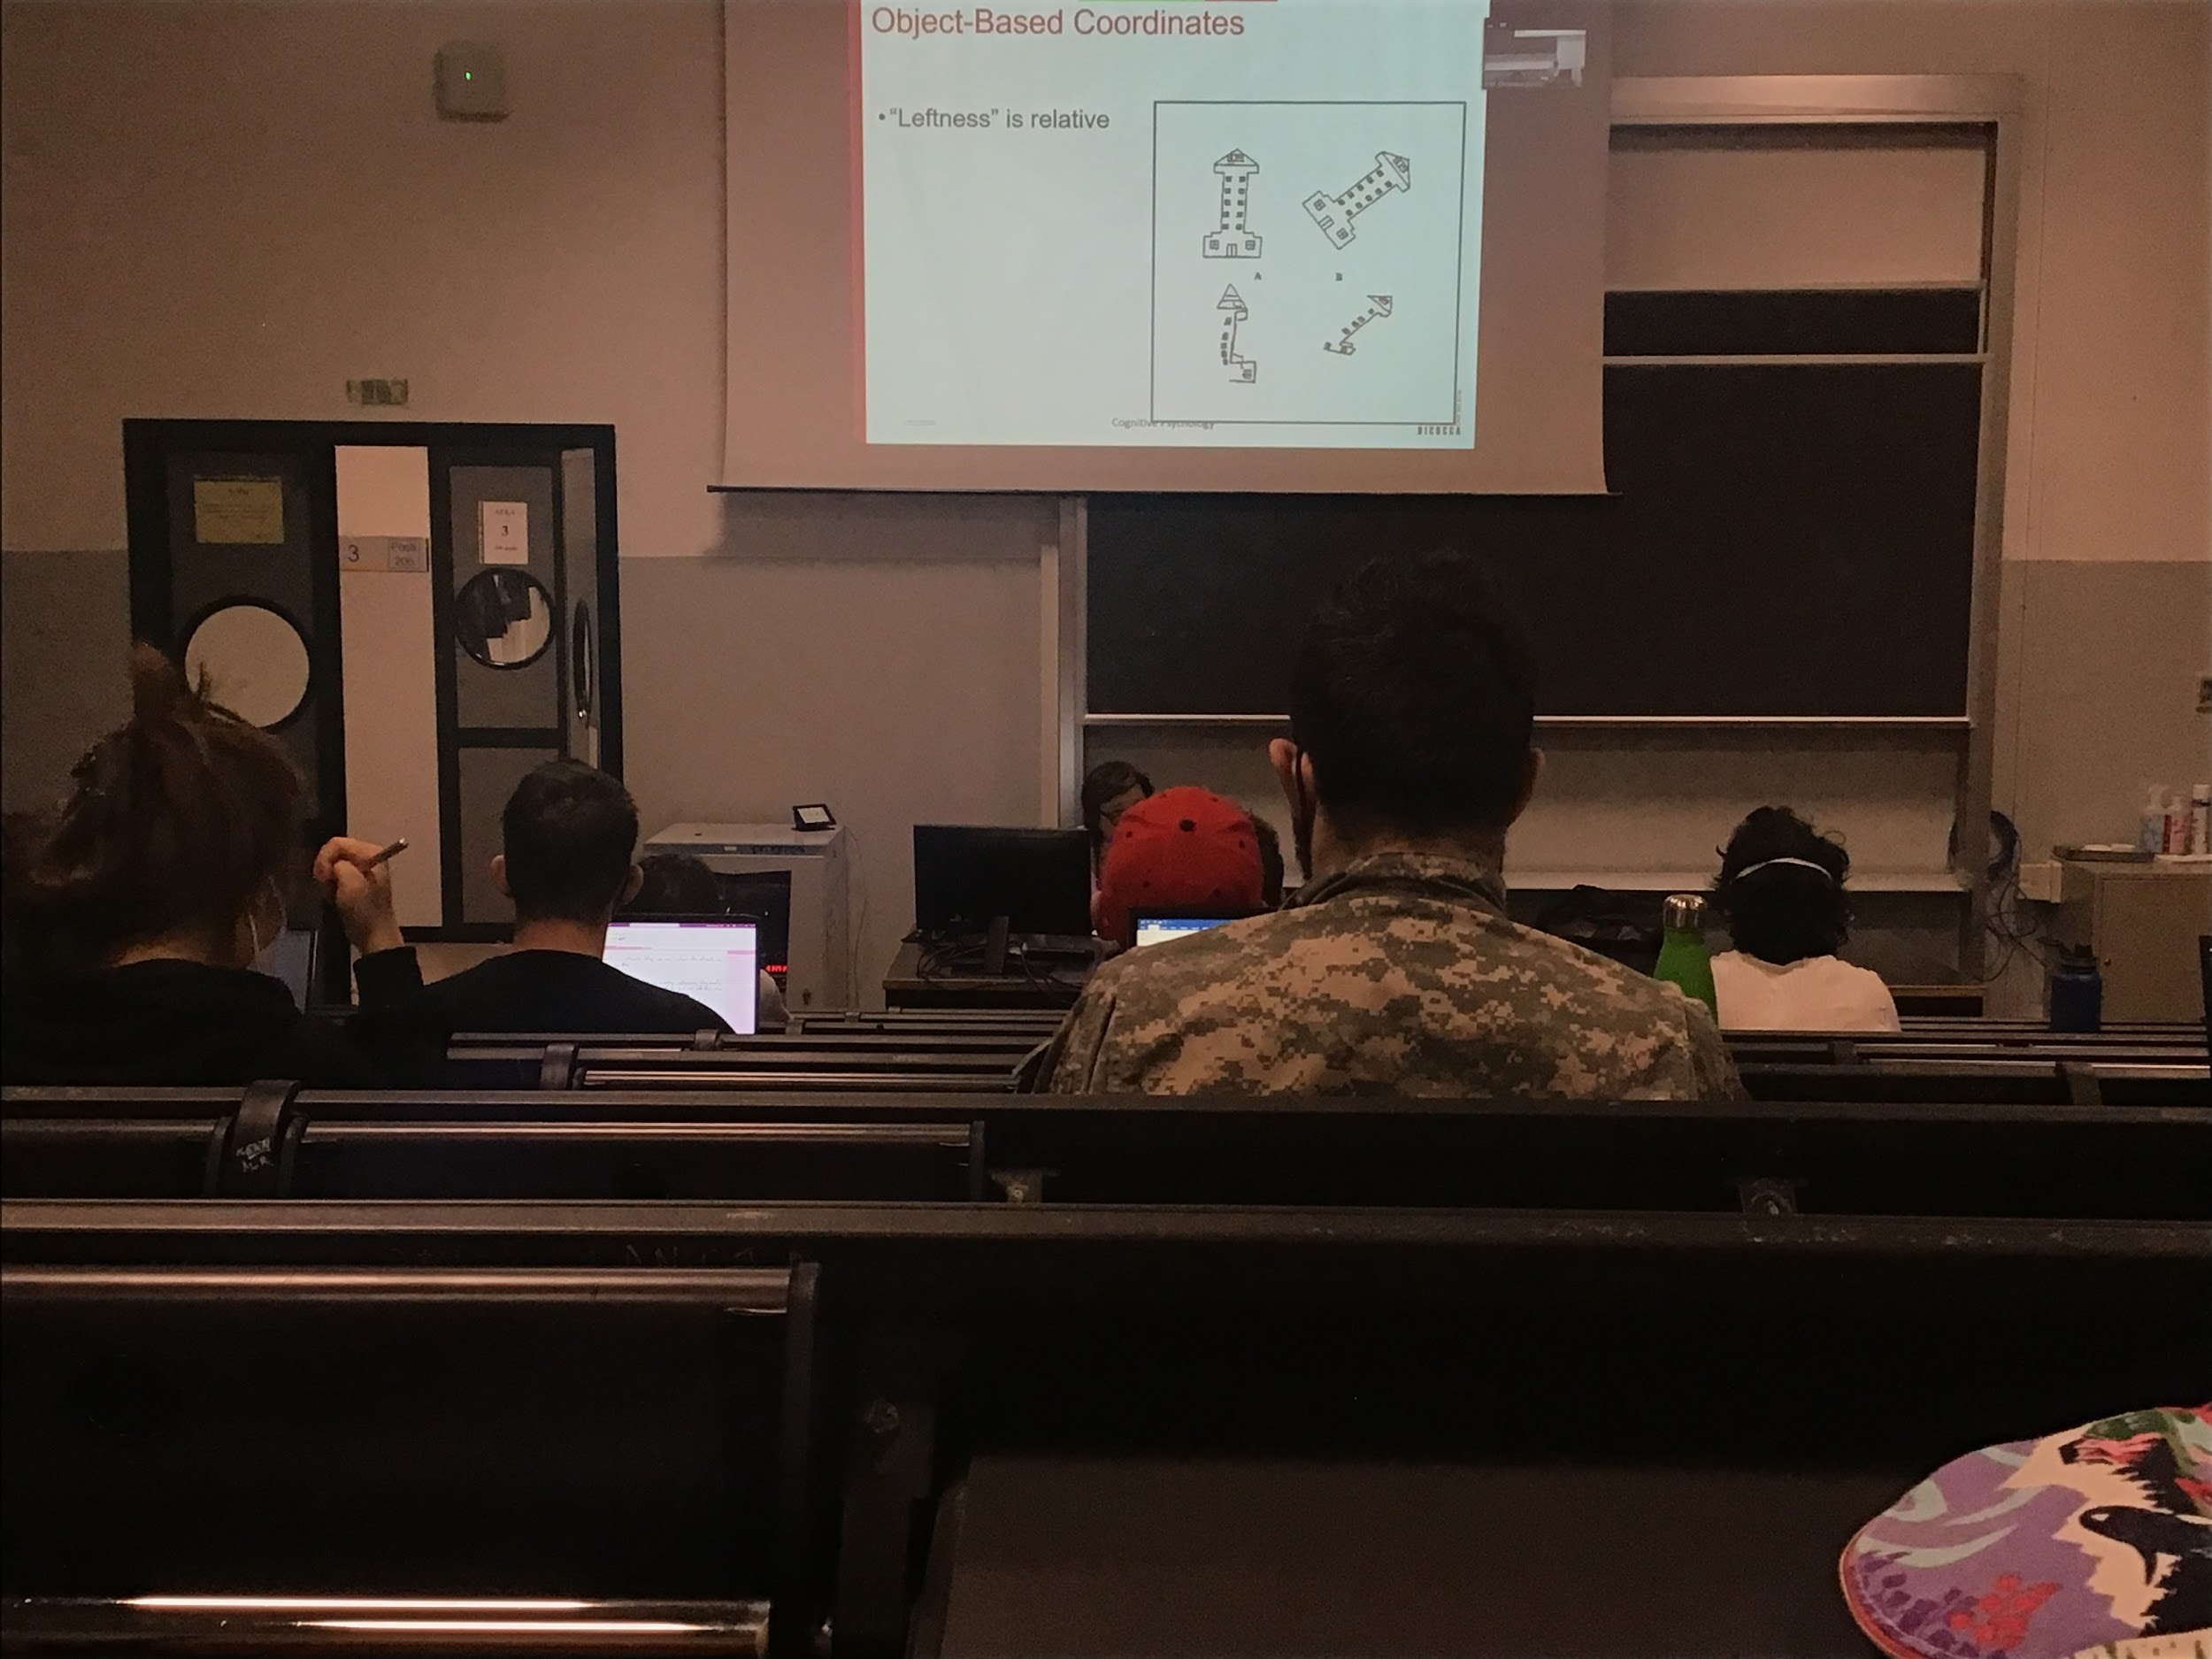

**Object based neglect: left relative to the object**

The object is represented in your brain as a whole but is missing the description of the left part

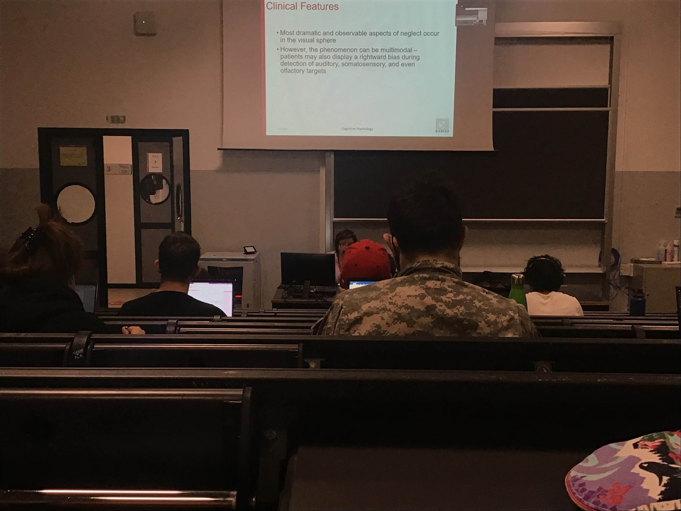

Most of the time problem is with vision but also can be with auditory deficit

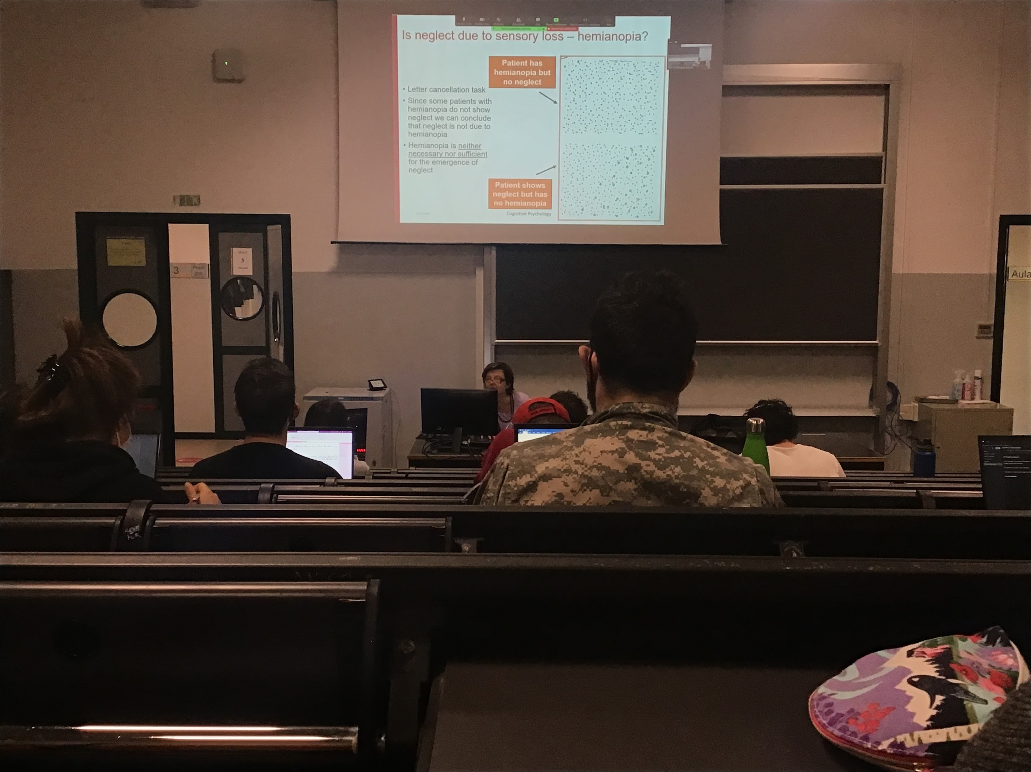

Many patients may also have hemianopia: don’t see physically half of the space

Cancellation test: have to cross out all the letters *a* in a paper

Hemianopia: lesion on the visual cortex, they don't see very well but just move half of the eyes, just move the eyes and cross all the letters

Neglect: circle the *a* but missing half of the paper

**No correlation between hemianopia and neglect**

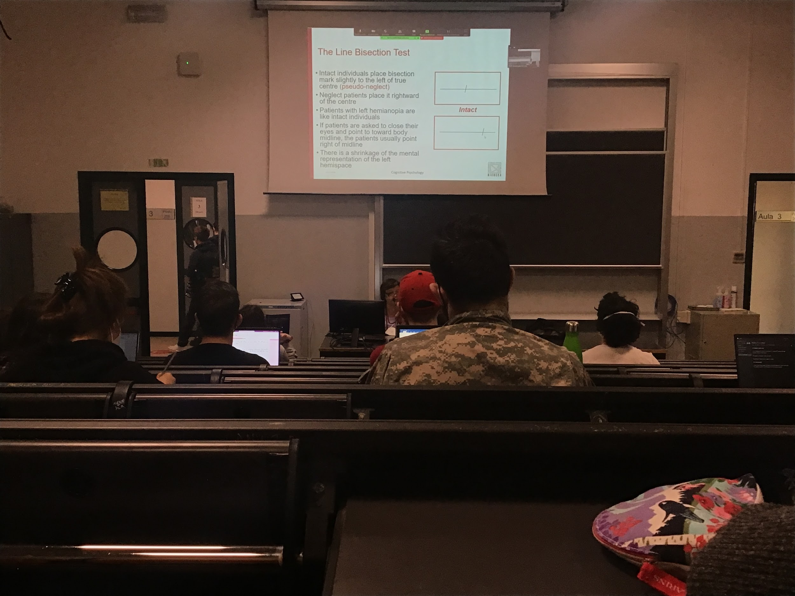

The other way to test neglect is like **bisection**: present you with a horizontal line and ask you to draw a line in the middle of it.

We have pseudo neglect, we tent to put the cut a little bit on the left

But neglect papers place it far away from the centre, do not see a part of the line, patients with hemianopia instead just move the eyes and cut it closer to the centre

No mental representation of the fact that there is a left part of the space

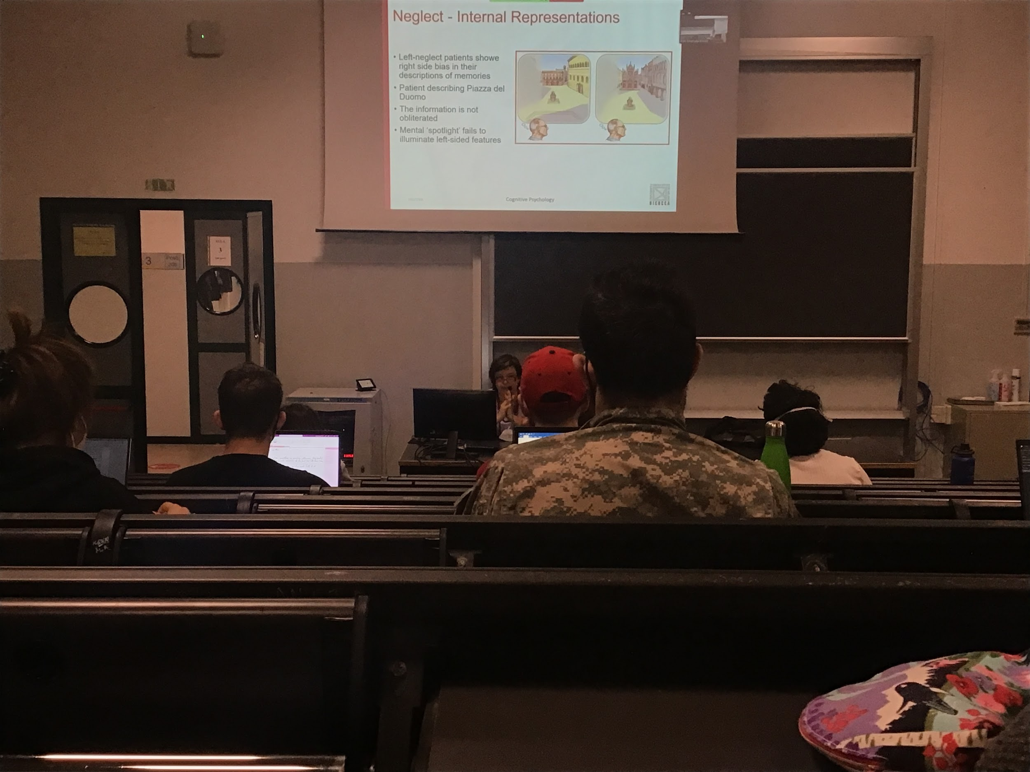

Patient with neglect. He had to imagine being in the piazza duomo and you were facing the dome, he had to describe what he saw. The only thing that the person describes is the right part of the square.

But if you ask you to move in front of the square and facing the macdonald, he describes what was in front and the galleria, he describes everything he had on the right

The **information is there somewhere but he can't put it together**, as if attention is always put on the right side of the mental representation even if the complete information is somewhere, as if the mental spotlight fails to illuminate what is on the left



Tend not to explore the left, with time they improve

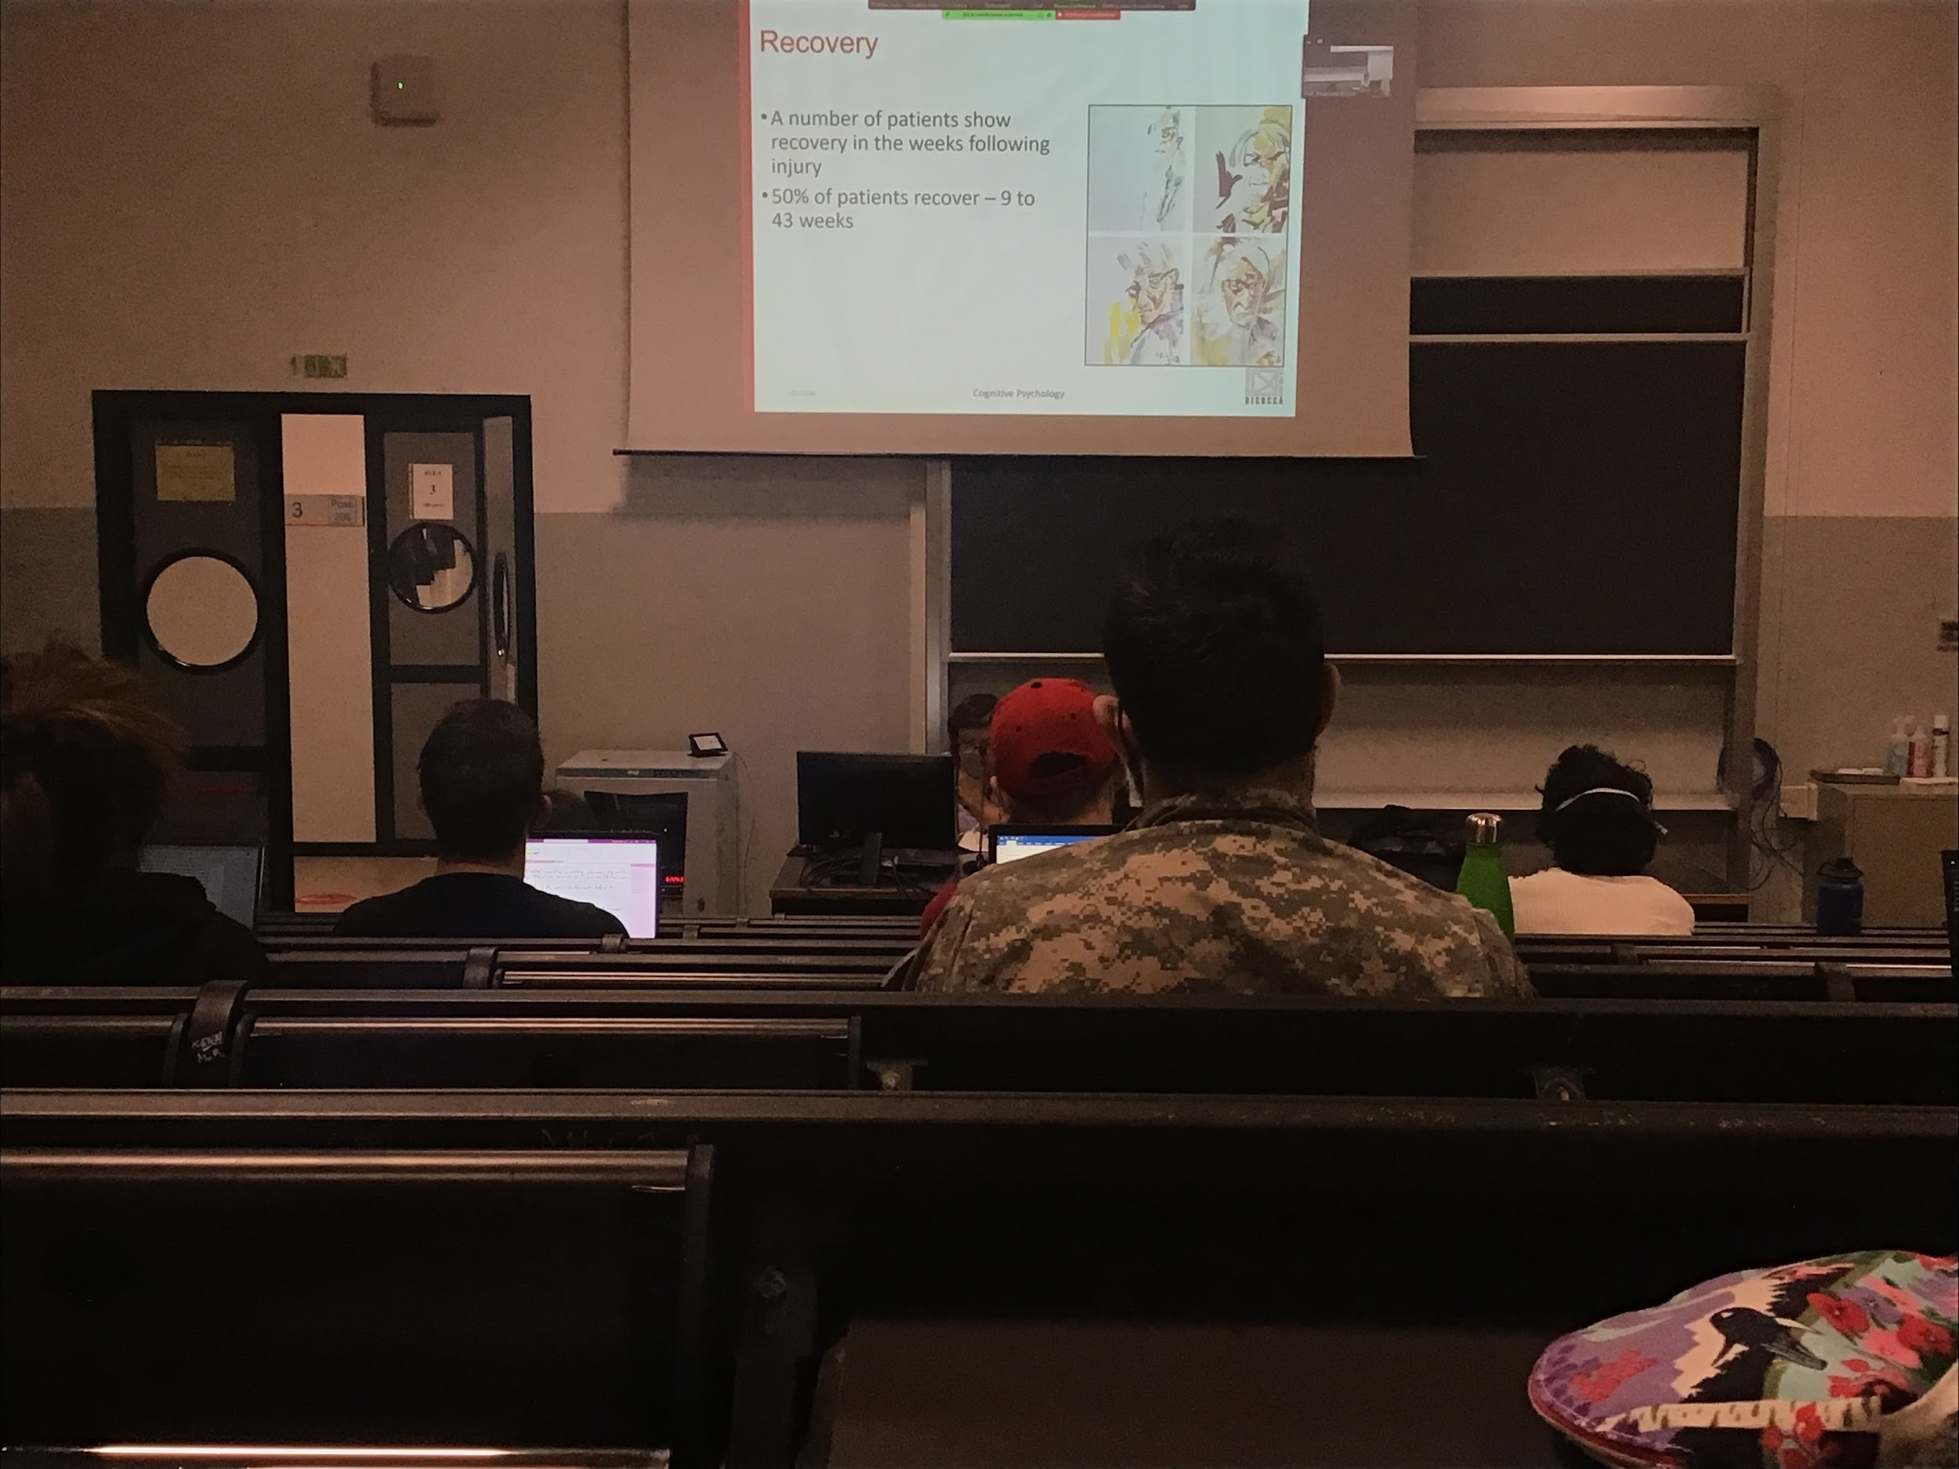

Example of recovery, a number of patients show recovery in the weeks following injury

Painter was recovery from a stroke, self portrait made in different times after the stroke

**Improving over time**, more details come up, improving the representation of the whole scene

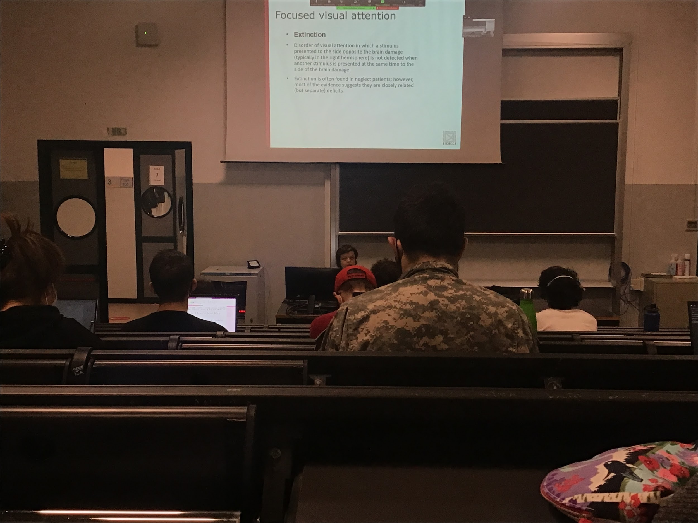

Testing of the doctor moving the fingers

Extincion: in this case is a problem of conflict of multiple stimulus present in the brain, unable to attend more than one object

But this deficit not always go together with neglect, can be both isolated or together

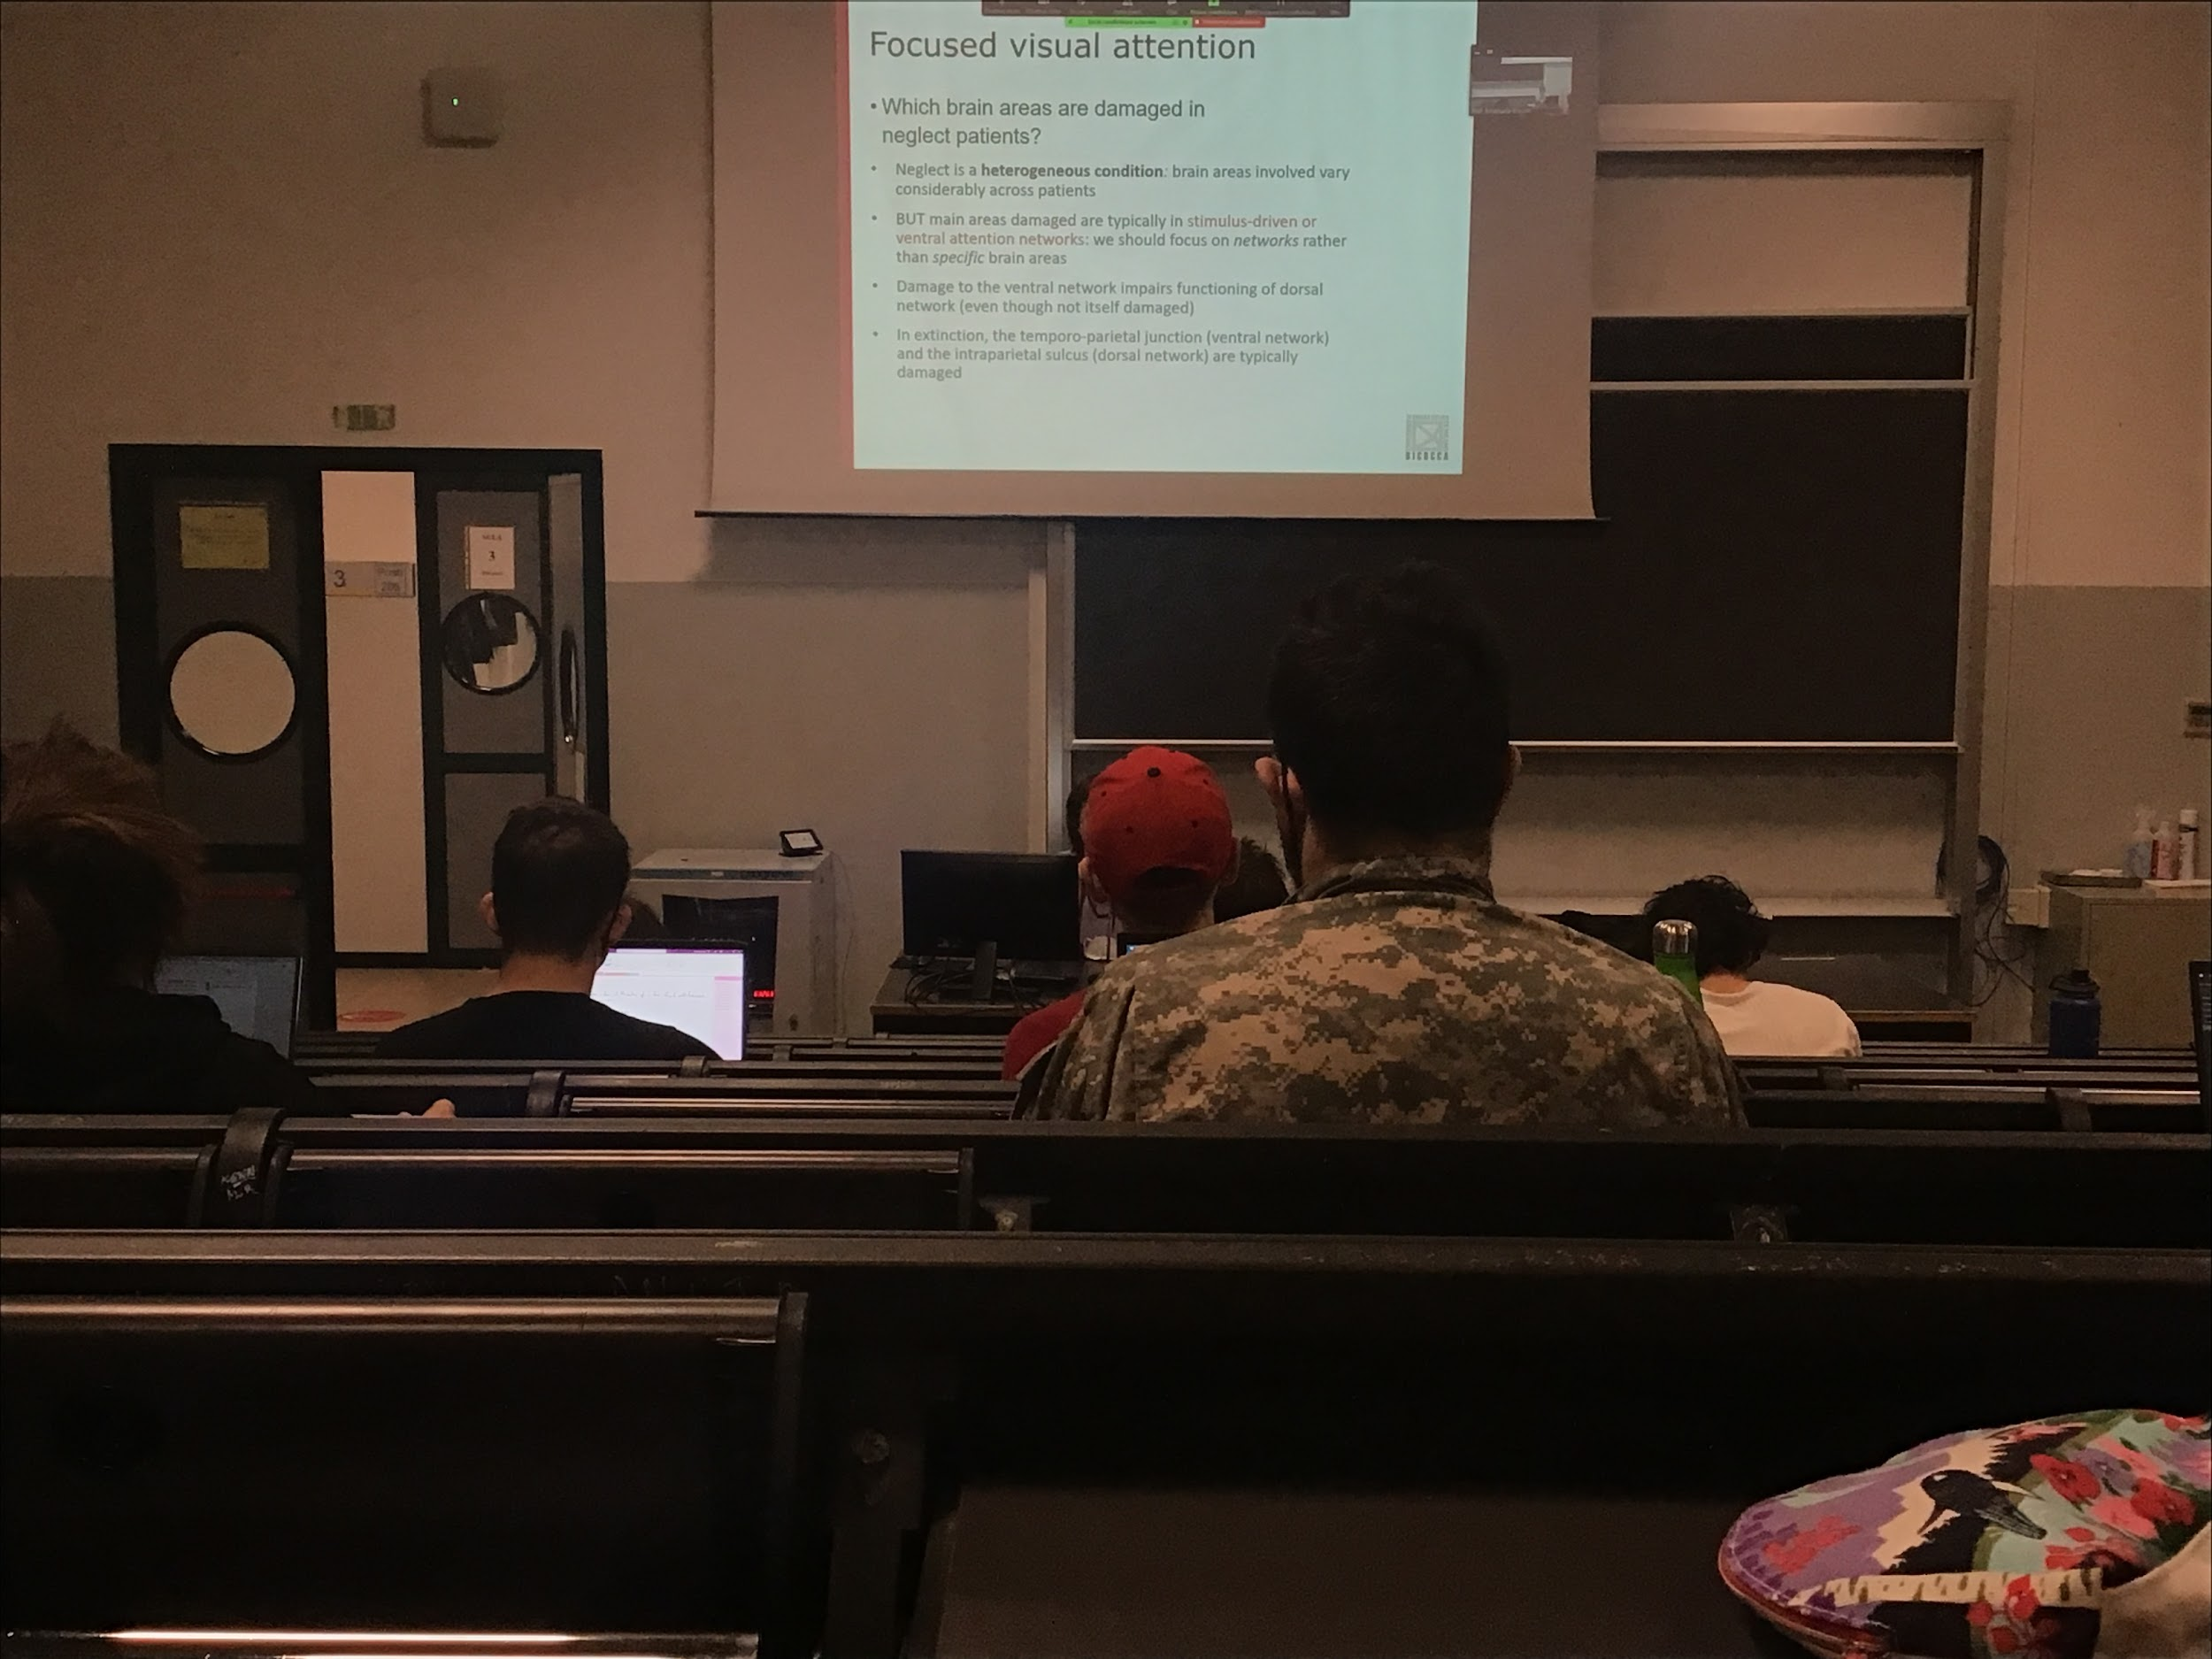

Attention is not a problem of perception (like hemianopia is), unable even if you see everything because it can force them to move their head and see what is there. Is a problem of attention

Being unable to represent what is there in the field, complex condition, brain areas are many and different across different patients, people with neglect usually have large brain lesion

Some areas are typically damaged, ventral attention network

The damage on this network causes effects that can be associated to the dorsal network even if physically is not damaged

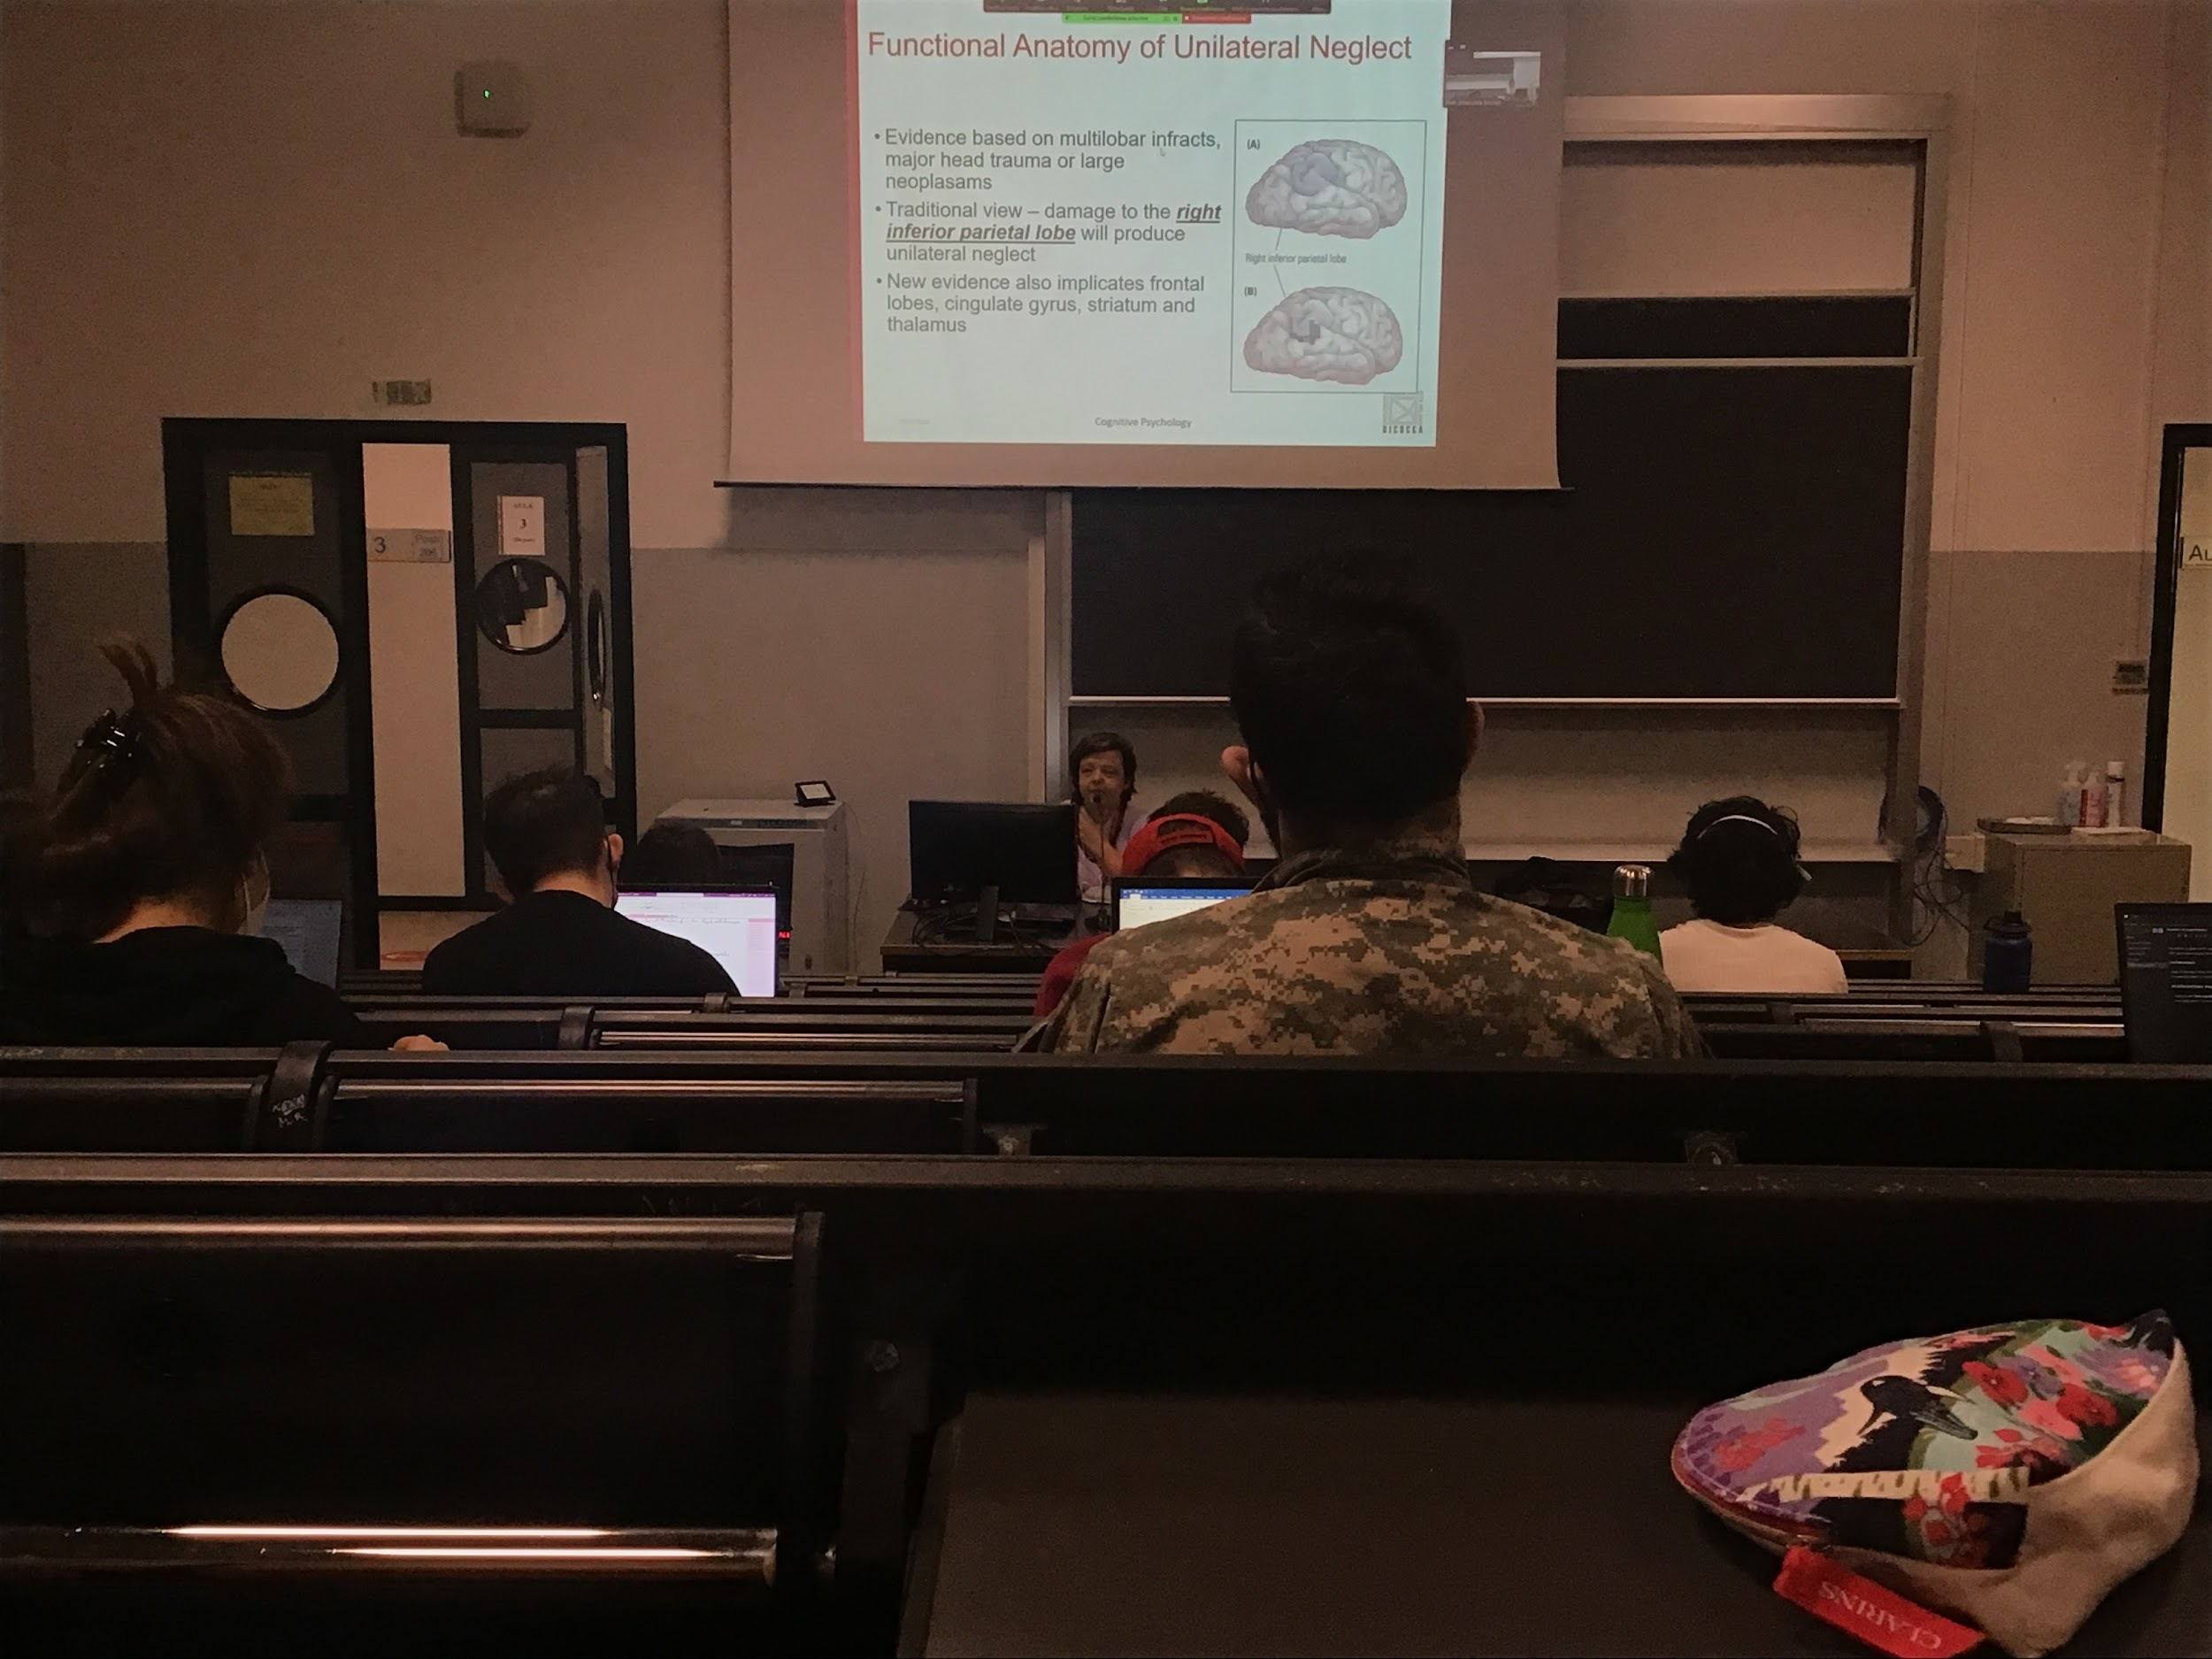

There are areas that is one of the most involved in unilateral neglect

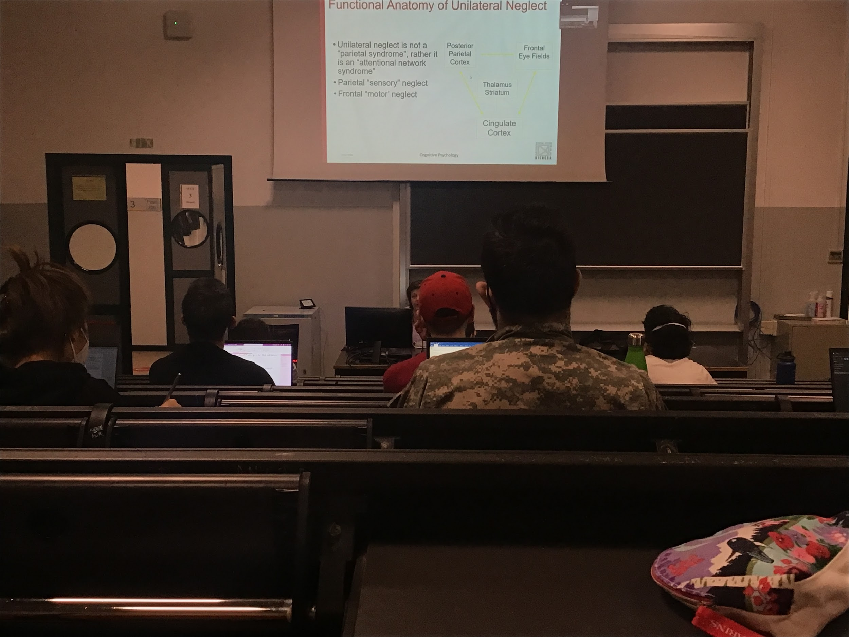

Multiples are causes the deficit



Neglect patients have intact early processing stimulus, but not conscious aware of it

There is activity in the low visual areas

Informations is coded (not like extensions that there is no activity in the primary visual area), they brain codes at the low level the initiation but they do not reach consciousness

They do not know what is in the left visual field but if in the right visual field I present some kind of degraded information (not clear information) and I present some information in the left neglected field that can help me code what is in the right I am actually using it. **The brain uses this information that does not reach awareness but is coded in the brain**

The information in the left neglected field can prime what we see in the right part

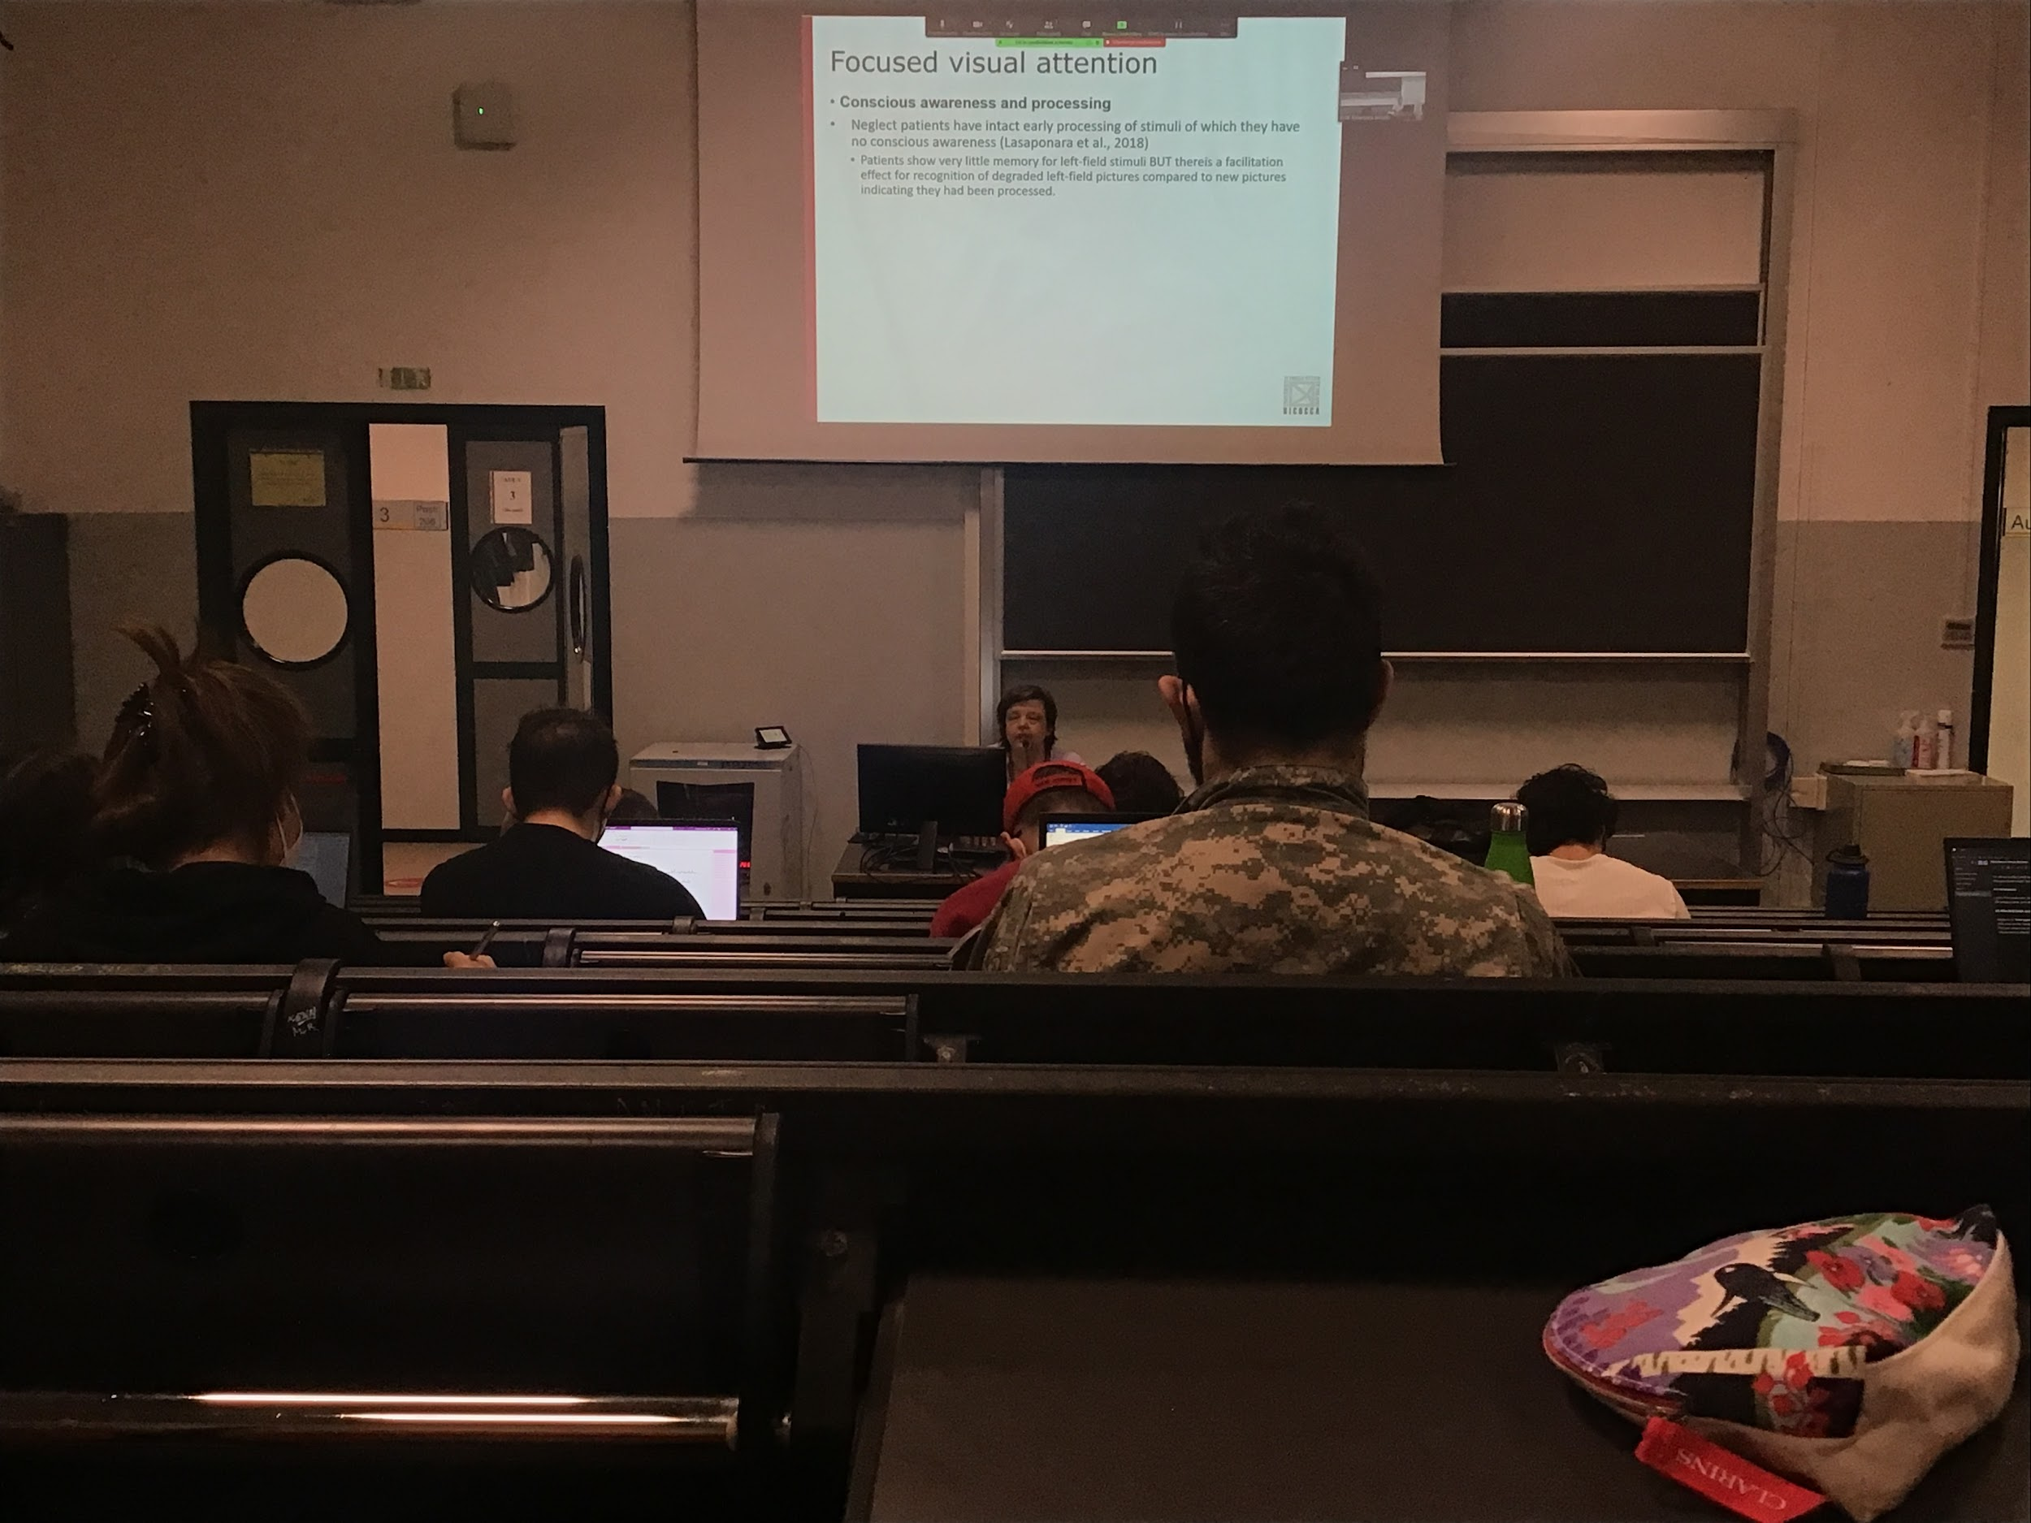

The brain uses this information that does not reach awareness but it is coded in the brain

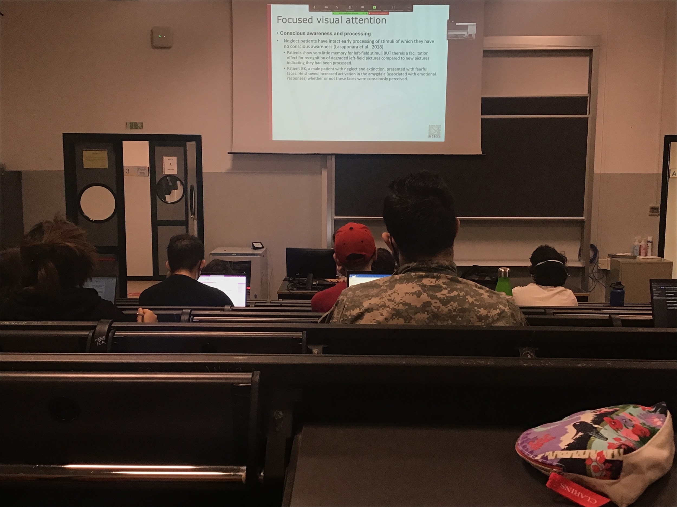

Patient with both neglect and exition: present a patient with faces that show fear and there is a higher activation in the **amygdala** (one the the brain areas not in the cortex that codes the presence of fearful stimuli) even if the faces were not actually perceived consciously. The fear stimulus is coded even if you are not aware of it

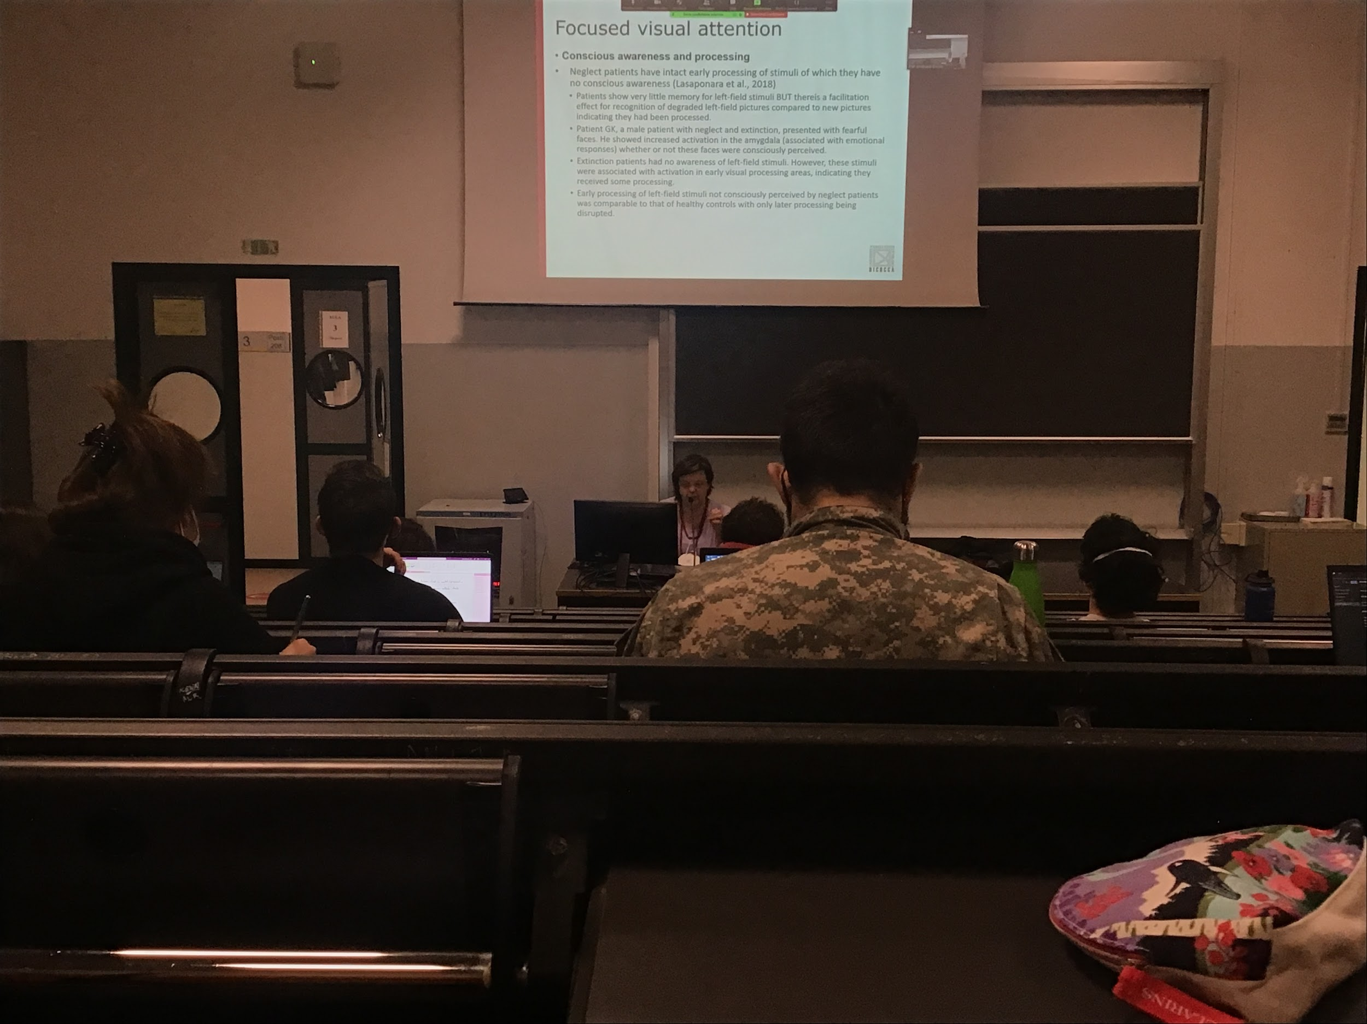

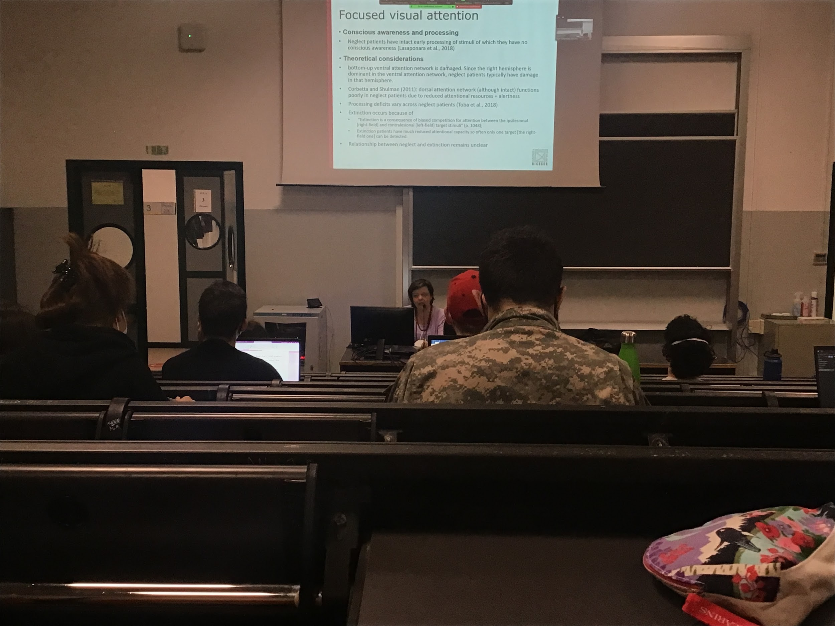

The damage in the bottom-up ventral network and this can be an explain on why we have left side neglect

The ventral attention network is stronger in the right hemisphere (don’t understand why we have this asymmetry)

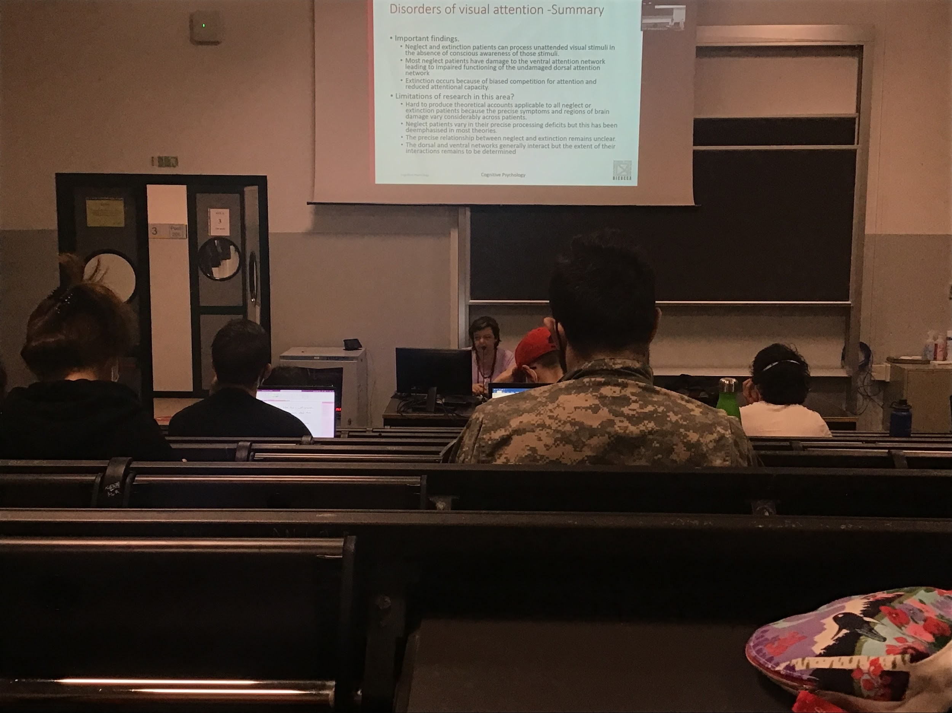

Neglect and attention can process unattend stimuli in the absence of conscious awareness

Extinction is due to inability to code two stimulus at the same time

We can have a problem of awareness of what we code, but we don’t know enough to associate different difficulties with different brain areas, the deficit is very huge, **theories are more generic can’t explain the performance of different patients**

Exition: you don’t see half of the body

**Chapter 5**

**Attention and performance**

**Visual search**

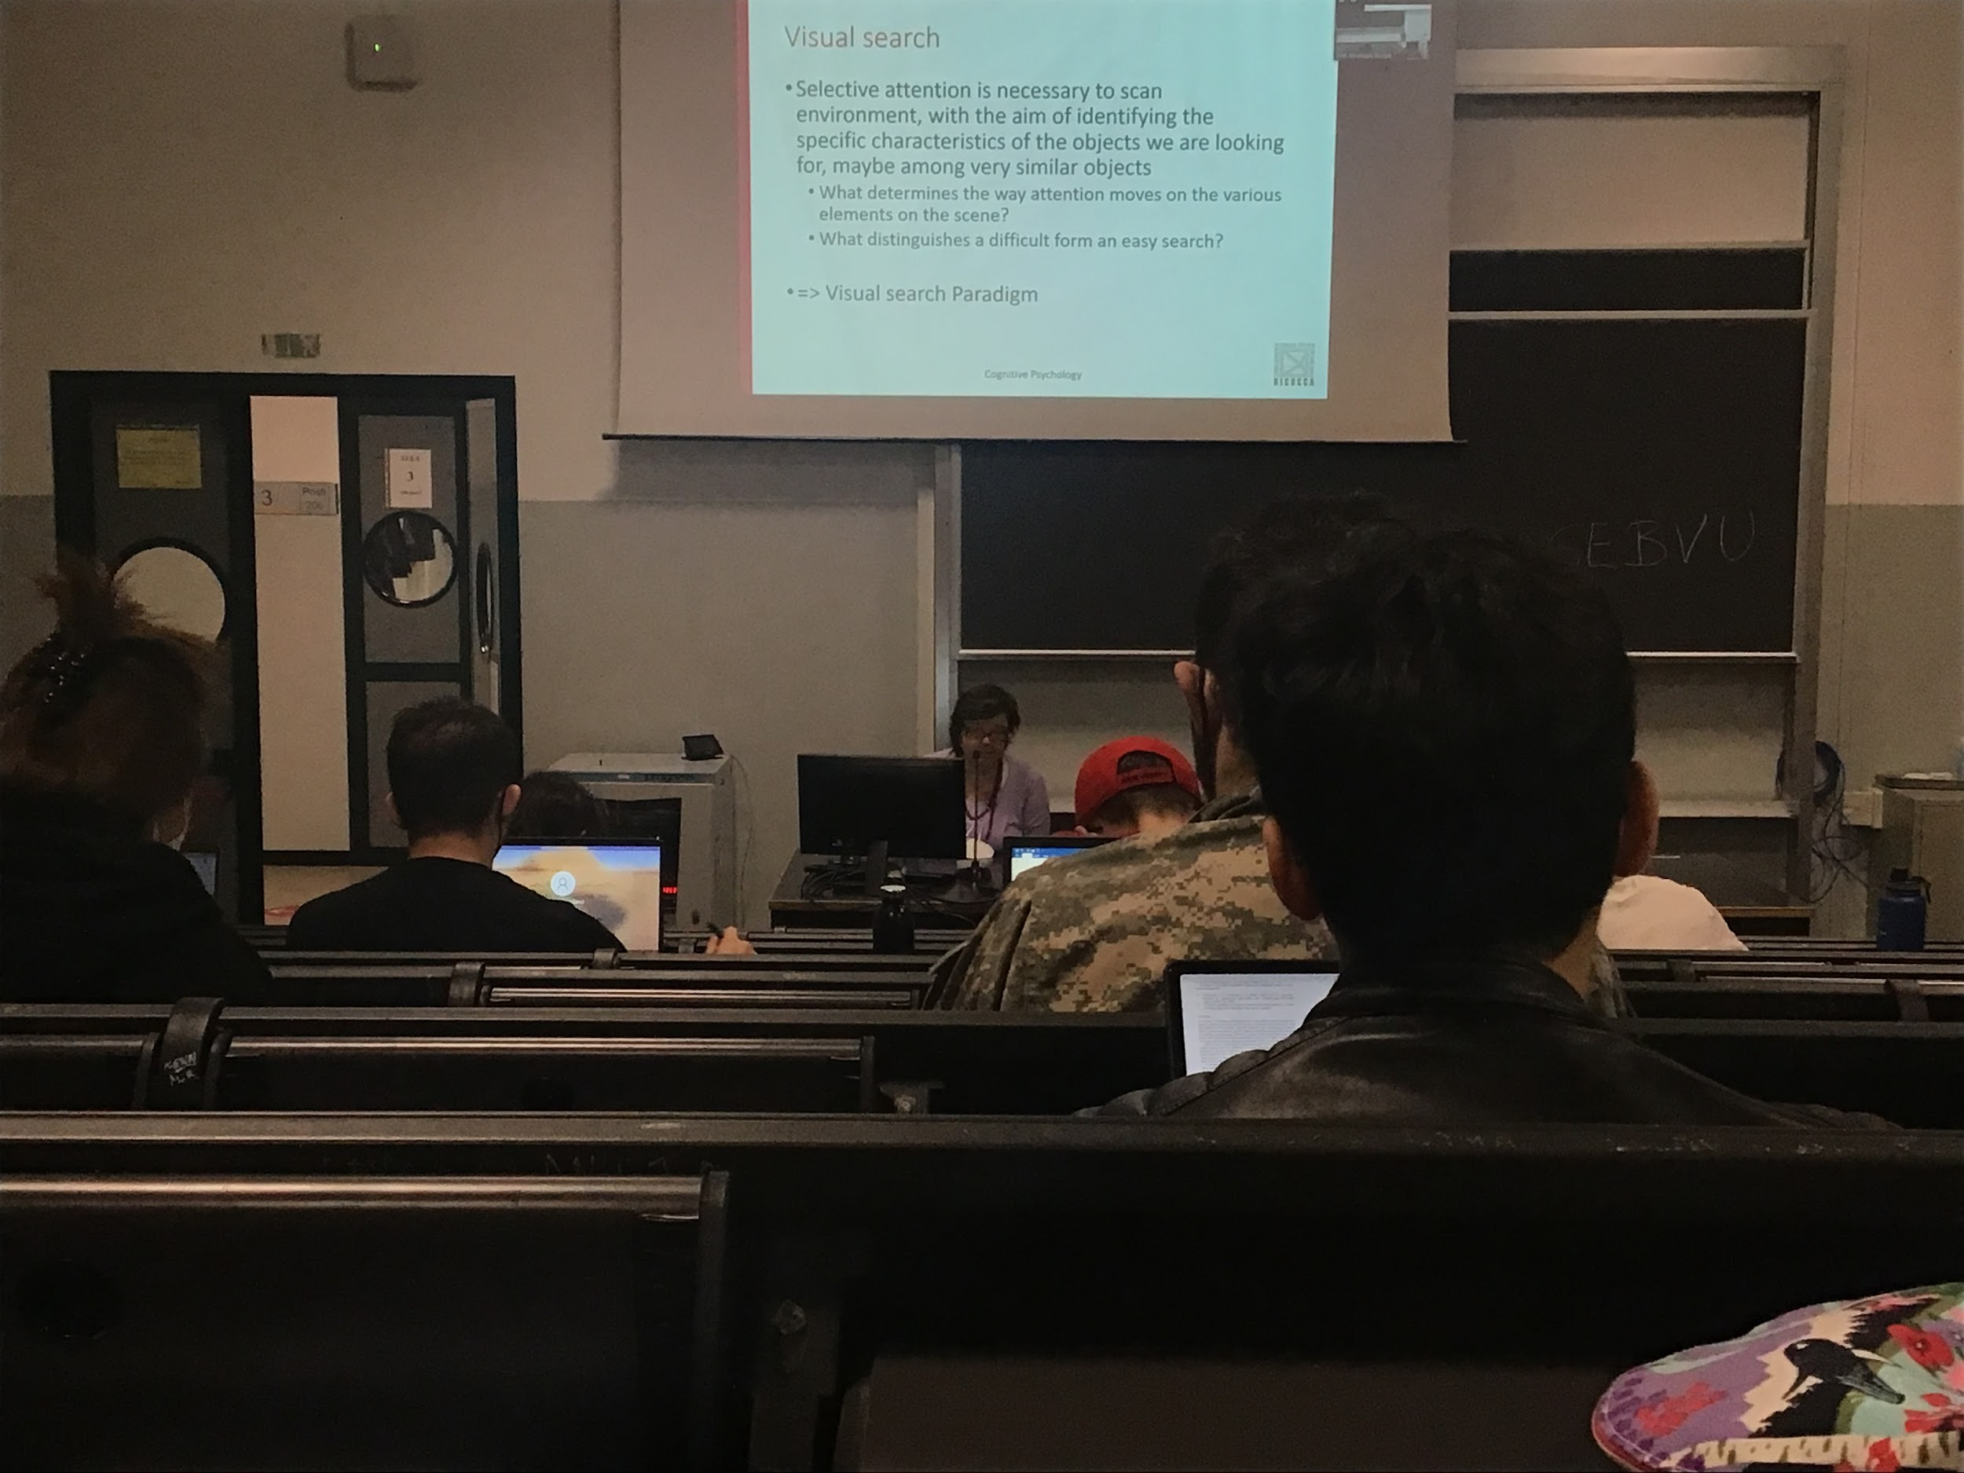

Visual search: our ability to find what is in our interest in the visual field (when looking for a friend in a group..)

Search implies the use of attention

Different theories proposed on how attention moves on various object in the scene

Sometimes search is easy but also sometimes is difficult

In the literature the first step is done using a specific paradigm.

Visual search paradigm: you present on the scene a number of artificial stimuli and ask people to find a specific target

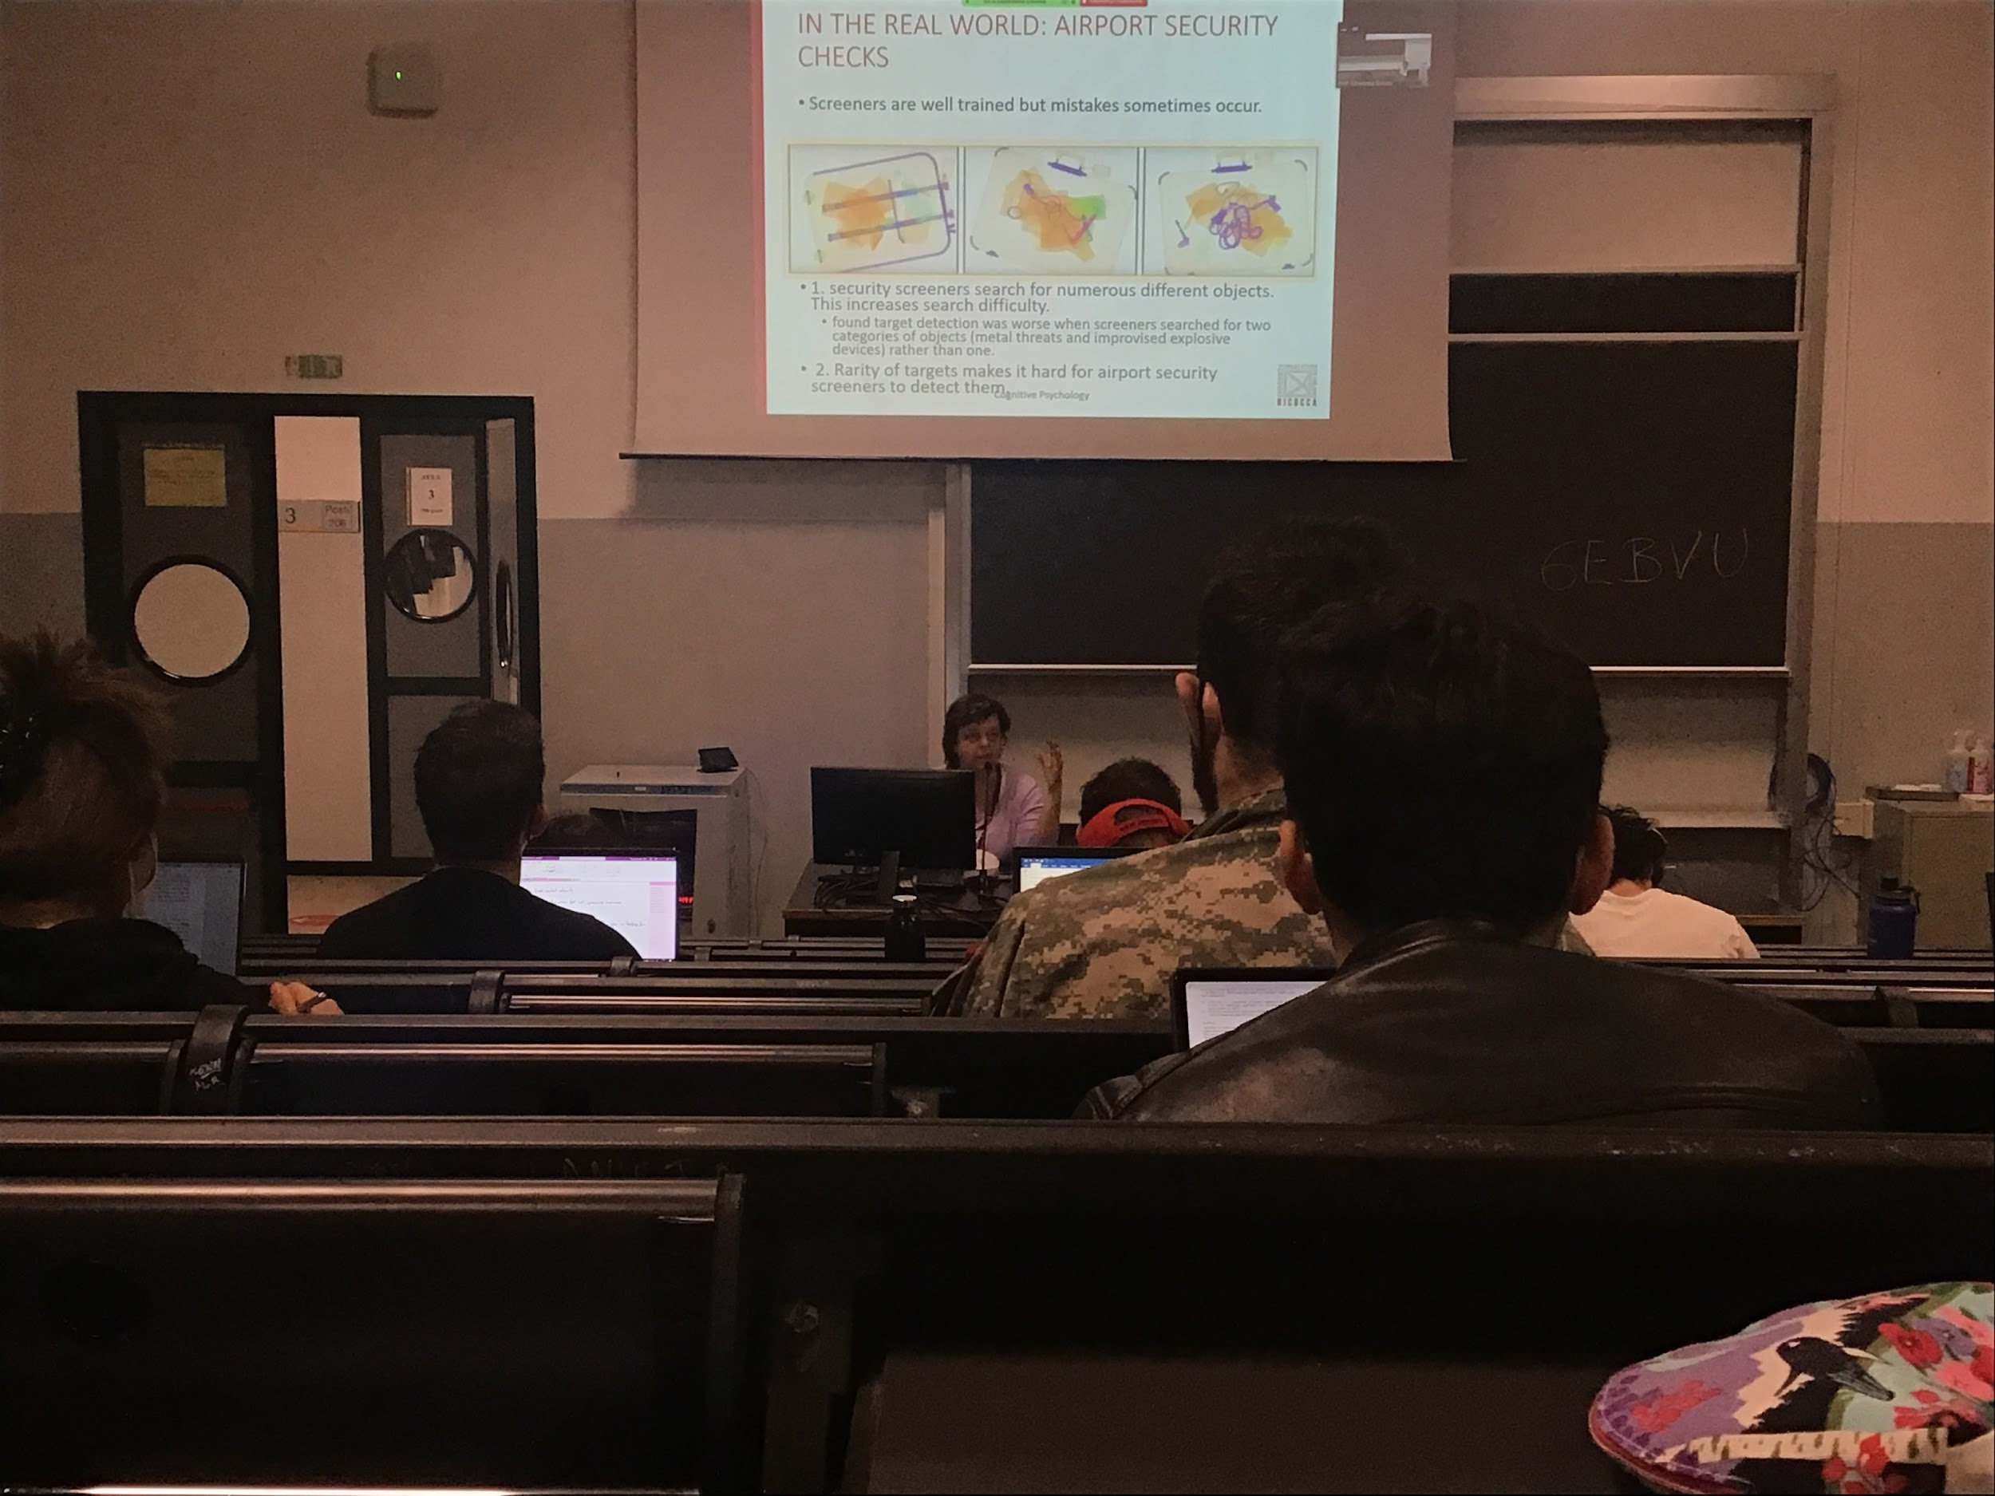

Medical application: how radiologist find a tumour in a scan

People that screen luggage in the airport, need to find a lot of different object in the bags

These people get trained, training procedures before working and periodically

Their task is not easy

* They **are not looking for the same thing**, a dangerous object can be of many shapes, increasing search difficulties. Look for an object with a shape that you are not actually sure of

If you are asked to find an object specifically they perform better. When a person have to look for only one object their performance is better then when they have to look to two different objects

* People the airport have to look to object that they don’t even know
* The **rarity of targets**. The majority of people have non dangerous objects. When the target is present 90% of the time you find 80%. But the performance decreases a lot when the target is present only 10% of the time

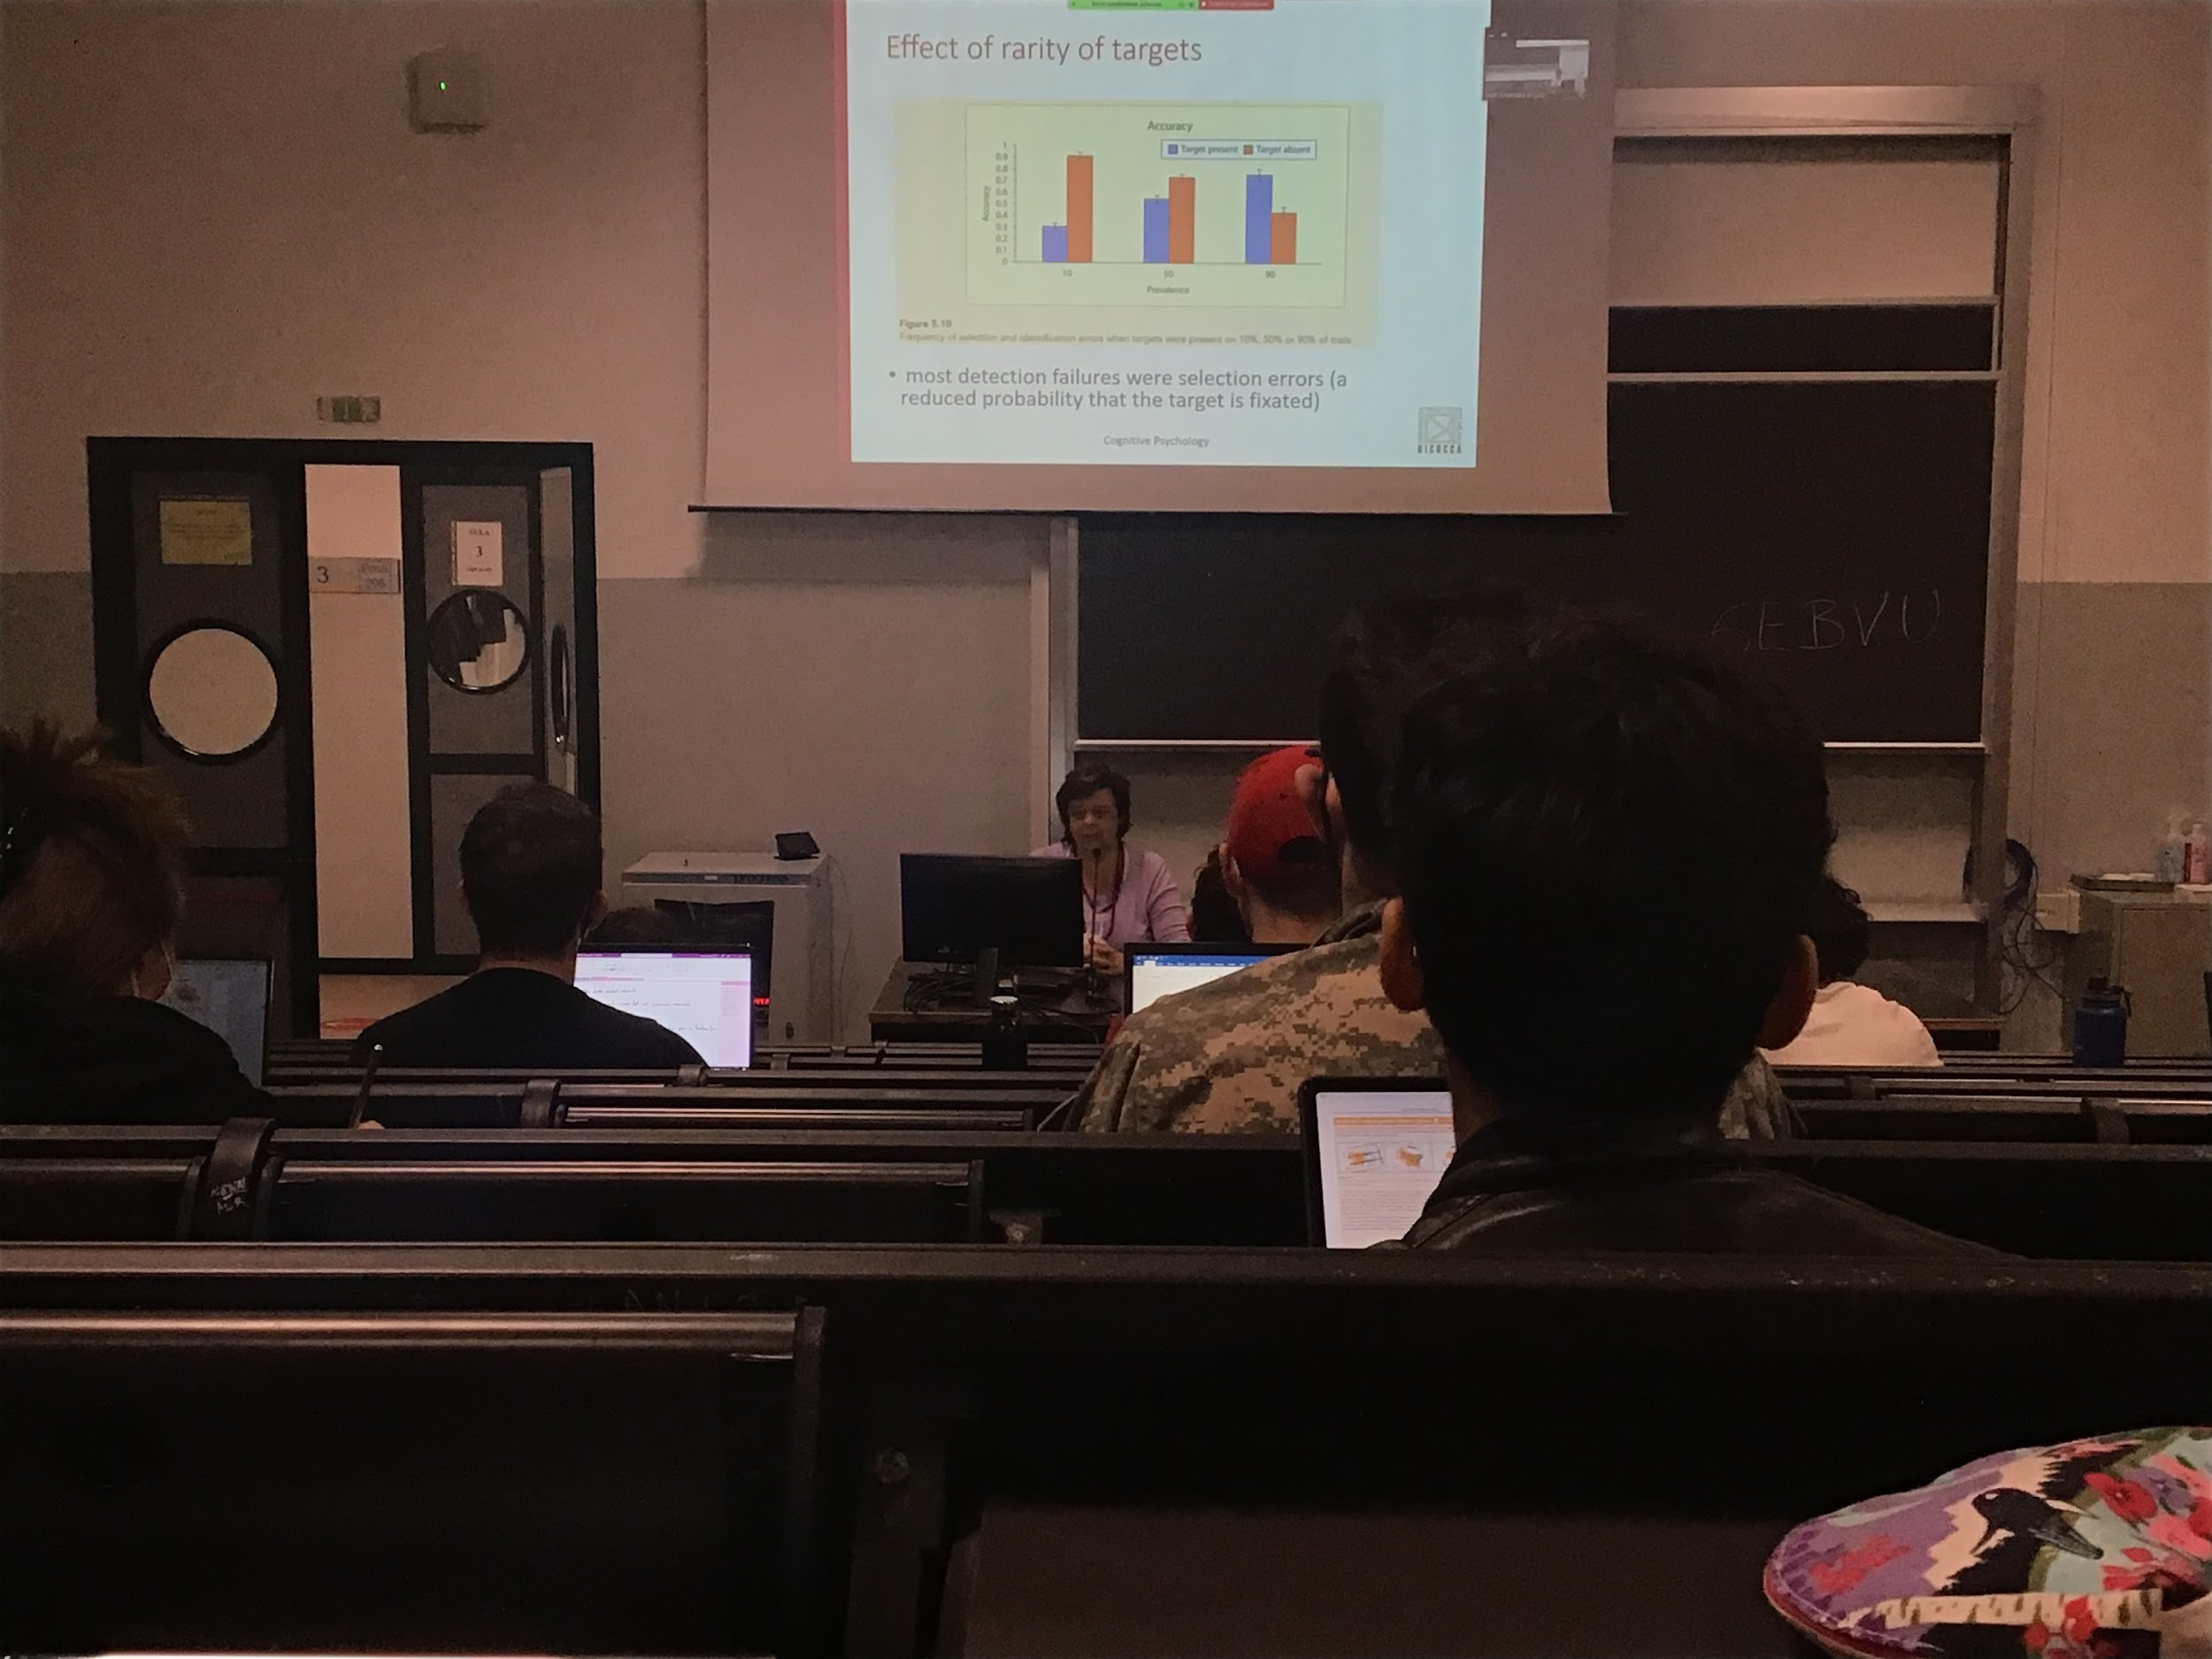

Performance decrease a lot if the target have a low probability

When you are looking a random object in the luggage your perception of detection is very slow

Real life problem of visual search

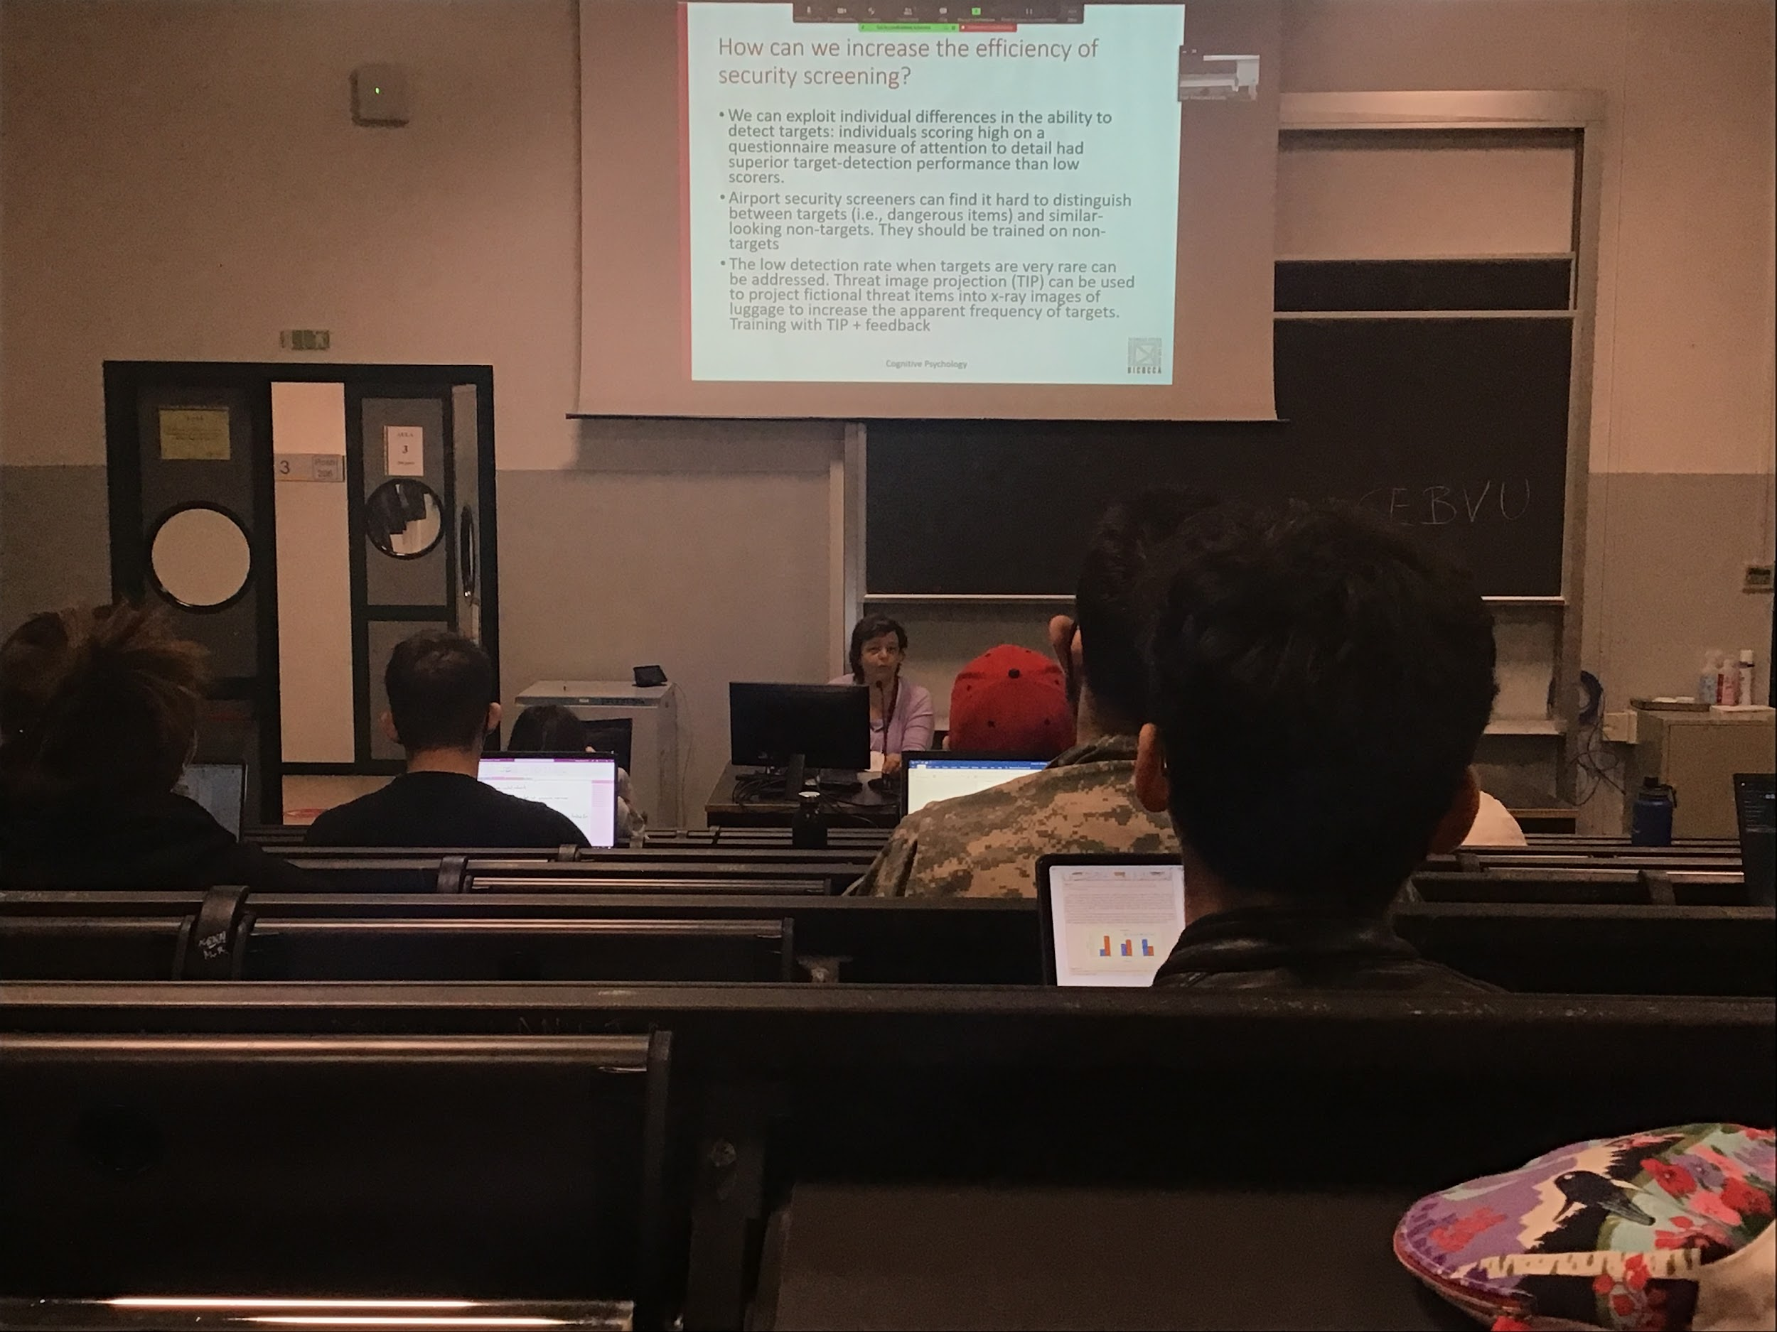

People are trying to find a way to increase performance

There is a huge difference in people's ability to detect targets, **some people are much better.** Not everybody have the same level of performance

Difficulty to check between targets and not targets that are very similar, this is a relative problem, many people have their luggage double checked.

Randomly in some number of luggage put a **fake object in the image** if the person does not detected a feedback is given

**The feedback improves a lot the performance**

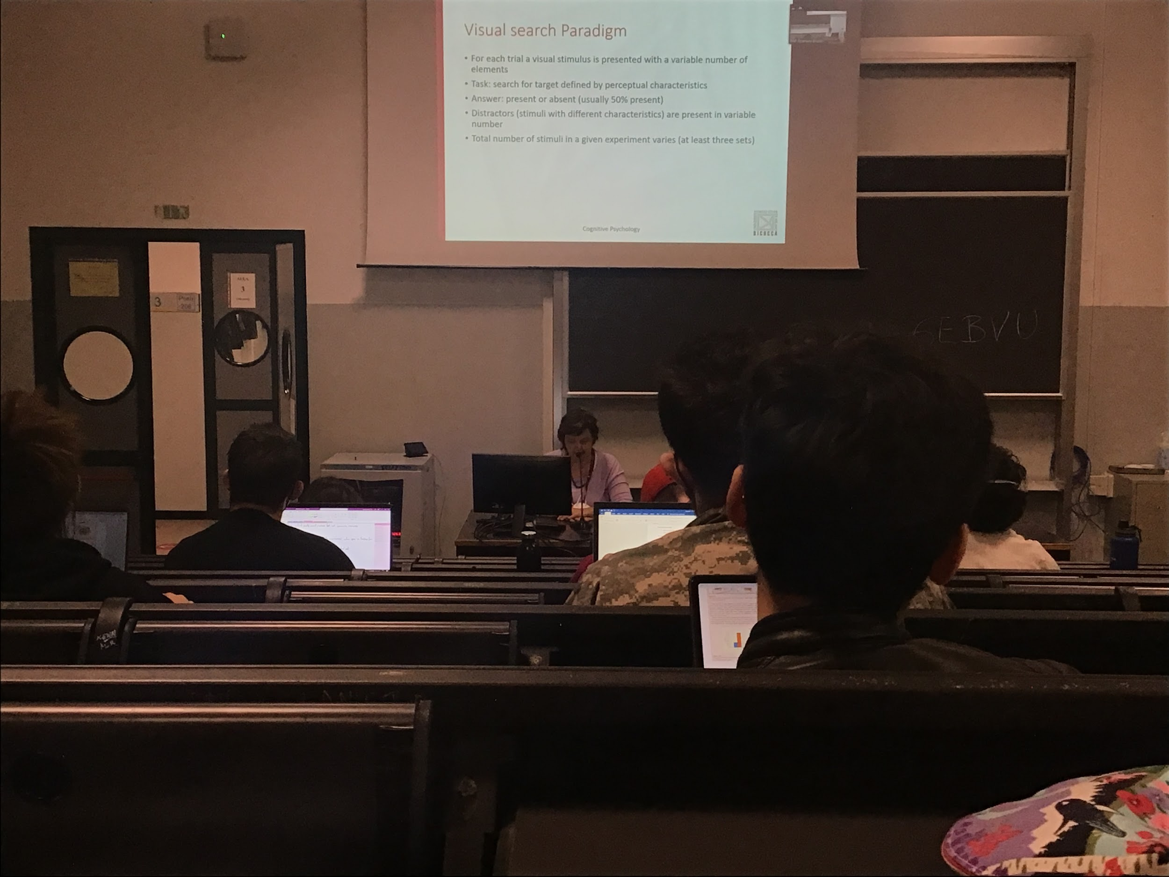

It is an artificial task, you present objects with a lot of stimuli on a scene, one of them is called target, the target is defined by specific characteristic

You can identify a target by a single characteristic, or a mixture of characteristics

In each stimulus 50% of the times one of the items is a target

The others objects are called distractros, other stimuli present in the scene

The total number of the stimuli (target+distractors) is called set size

The difficult of the perceptual task depends on the +compl

Measure reaction time:

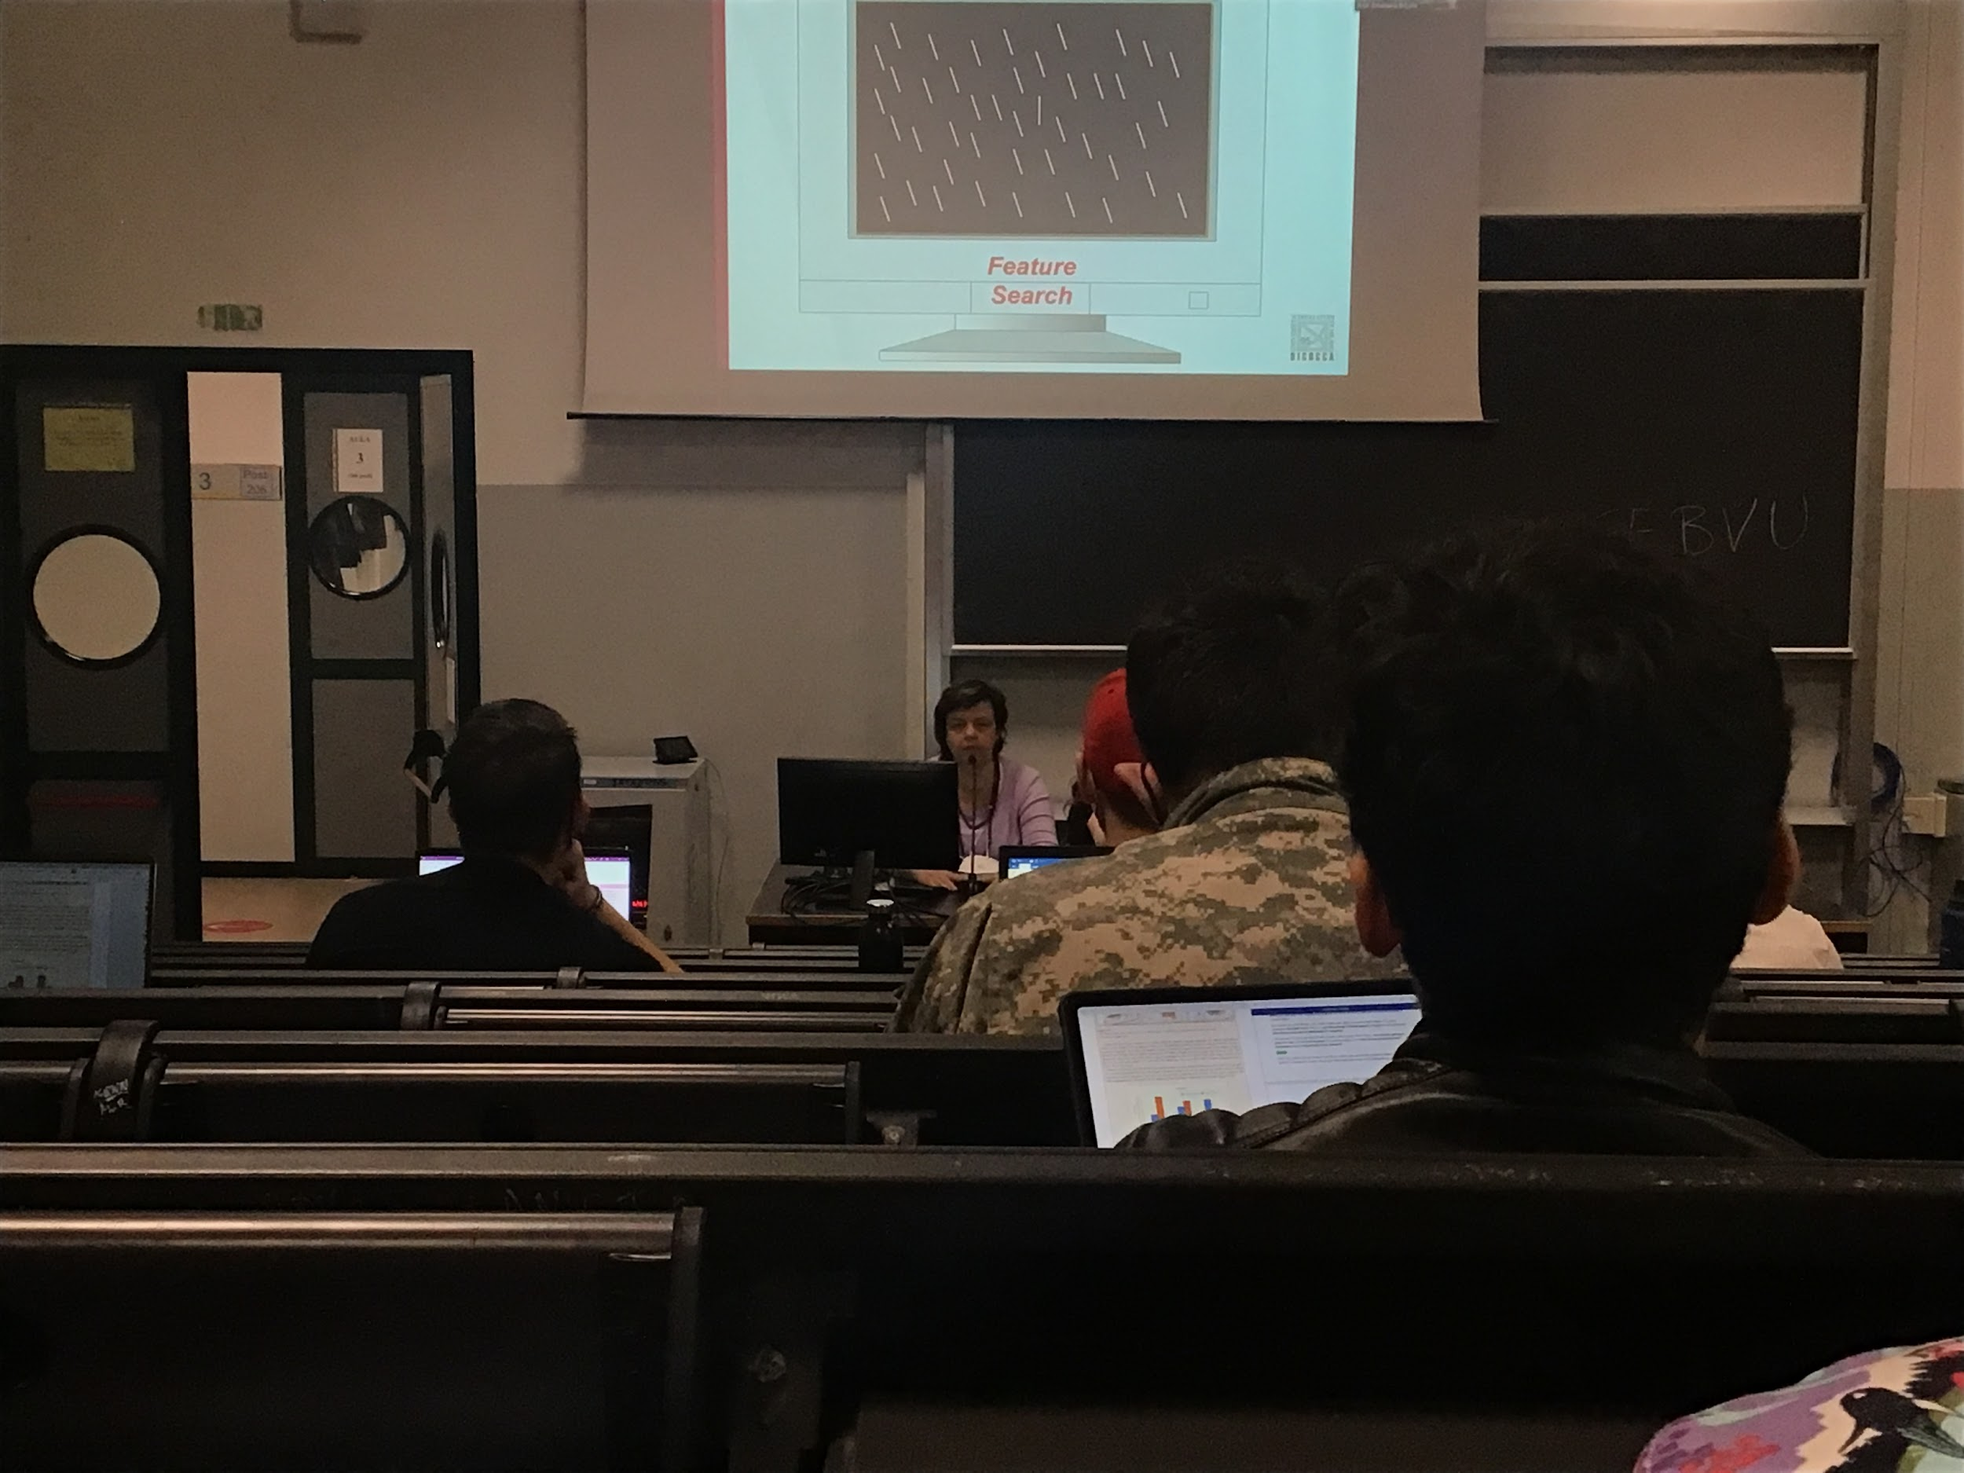

Easy to identify the target, you can distinguish the target by one single feature (orientation). The target is the only bar that is oriented vertically, can discriminate by using only one characteristic

**Pop-out effect**: can see the target relatively easy, does not depends on the number of distractors I have on the scene

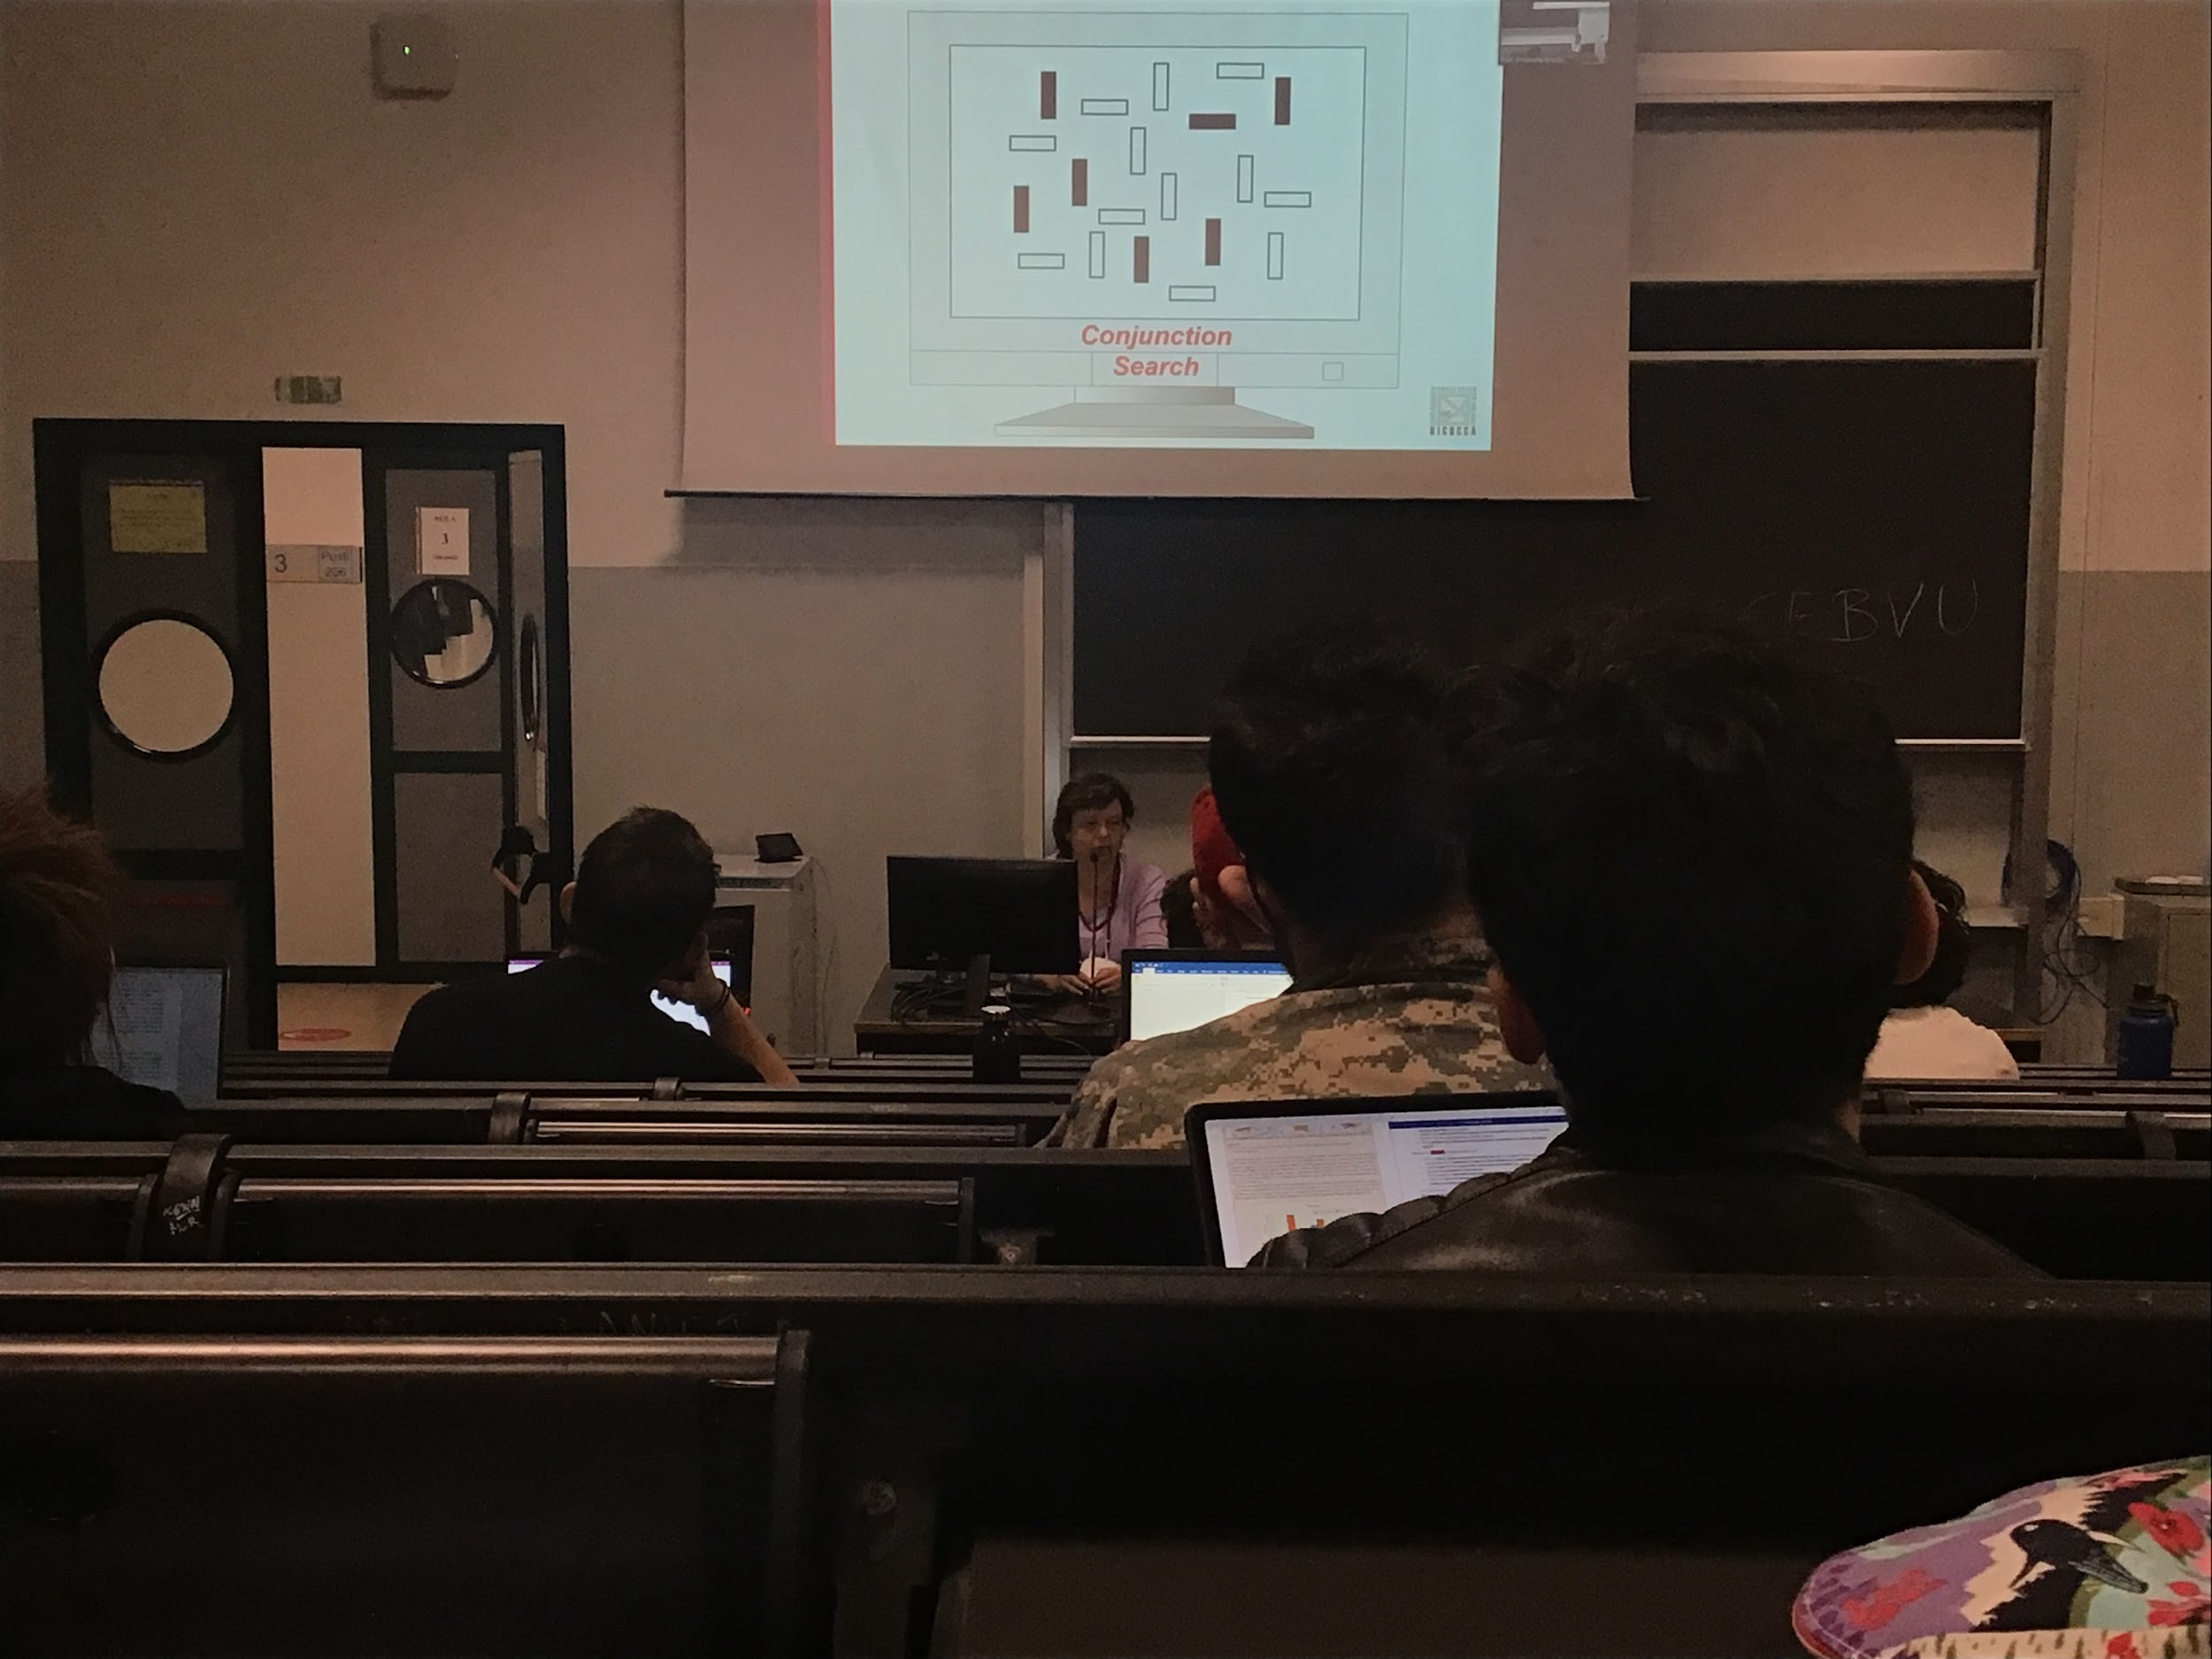

Combine different chatersitc for the target

Combination of two features, both horizontal (some distractors are horizontal) and black (some distractions are black)

I have to combine different characteristic to be able to discriminate between the target and the distractors

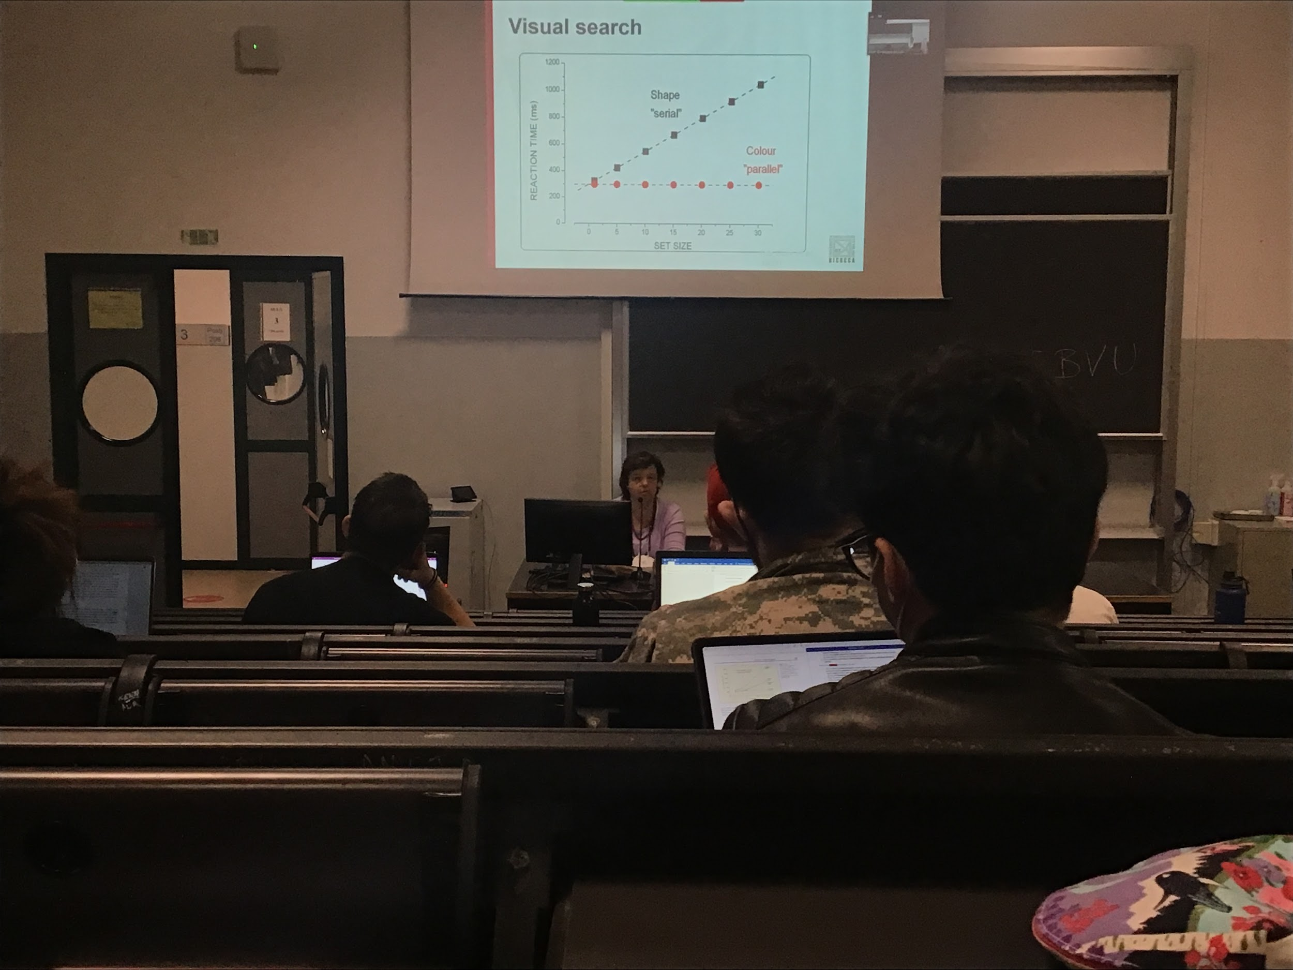

When I am talking about a features I can discriminate for the discrators of one features, I have the reaction time the same, independently of the number of distractors

If I need to do conjunction search the time increases as I increase the number of distractors

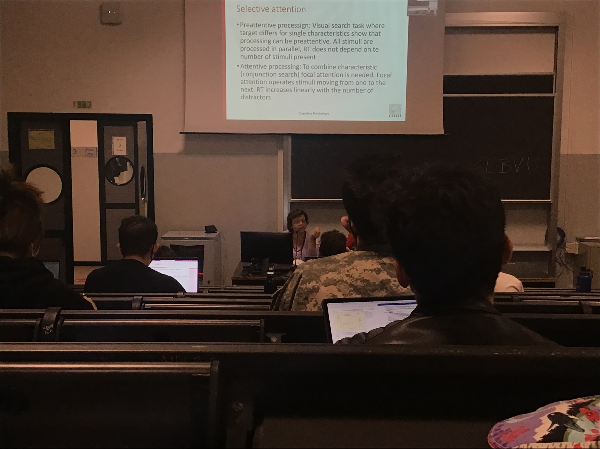

Two types of processing

* **Preattentive processing**: don’t need to use attention, all the stimuli are coded at the same time. When I look at the characteristic orientation I detect it straight away reaction time does not depends on the number of stimuli
* **Attentive processing**: when I have to combine 2 or more characteristics I need to use attention, to combine features, I need to move attention to the different objects and combine the information that I have there. I need to look to all the objects, requires more time

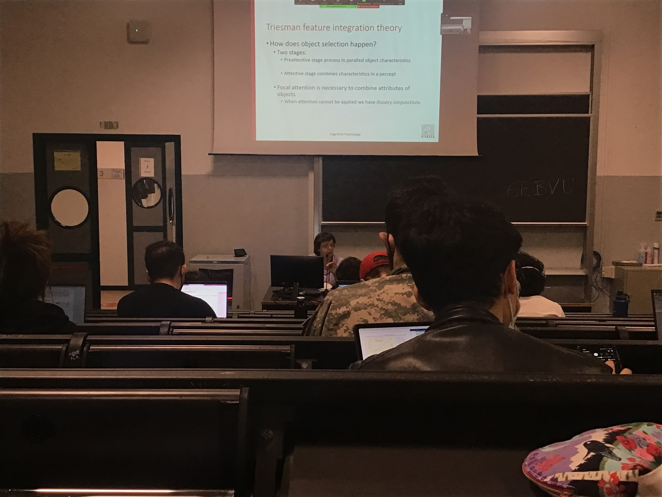

Preattentive stage always there, even if I am doing a feature search or if I am doing a conjunction search. If I am doing a feature search the preattentive stage is sufficient to give a response. If I am doing a conjunction search I need the attentive state

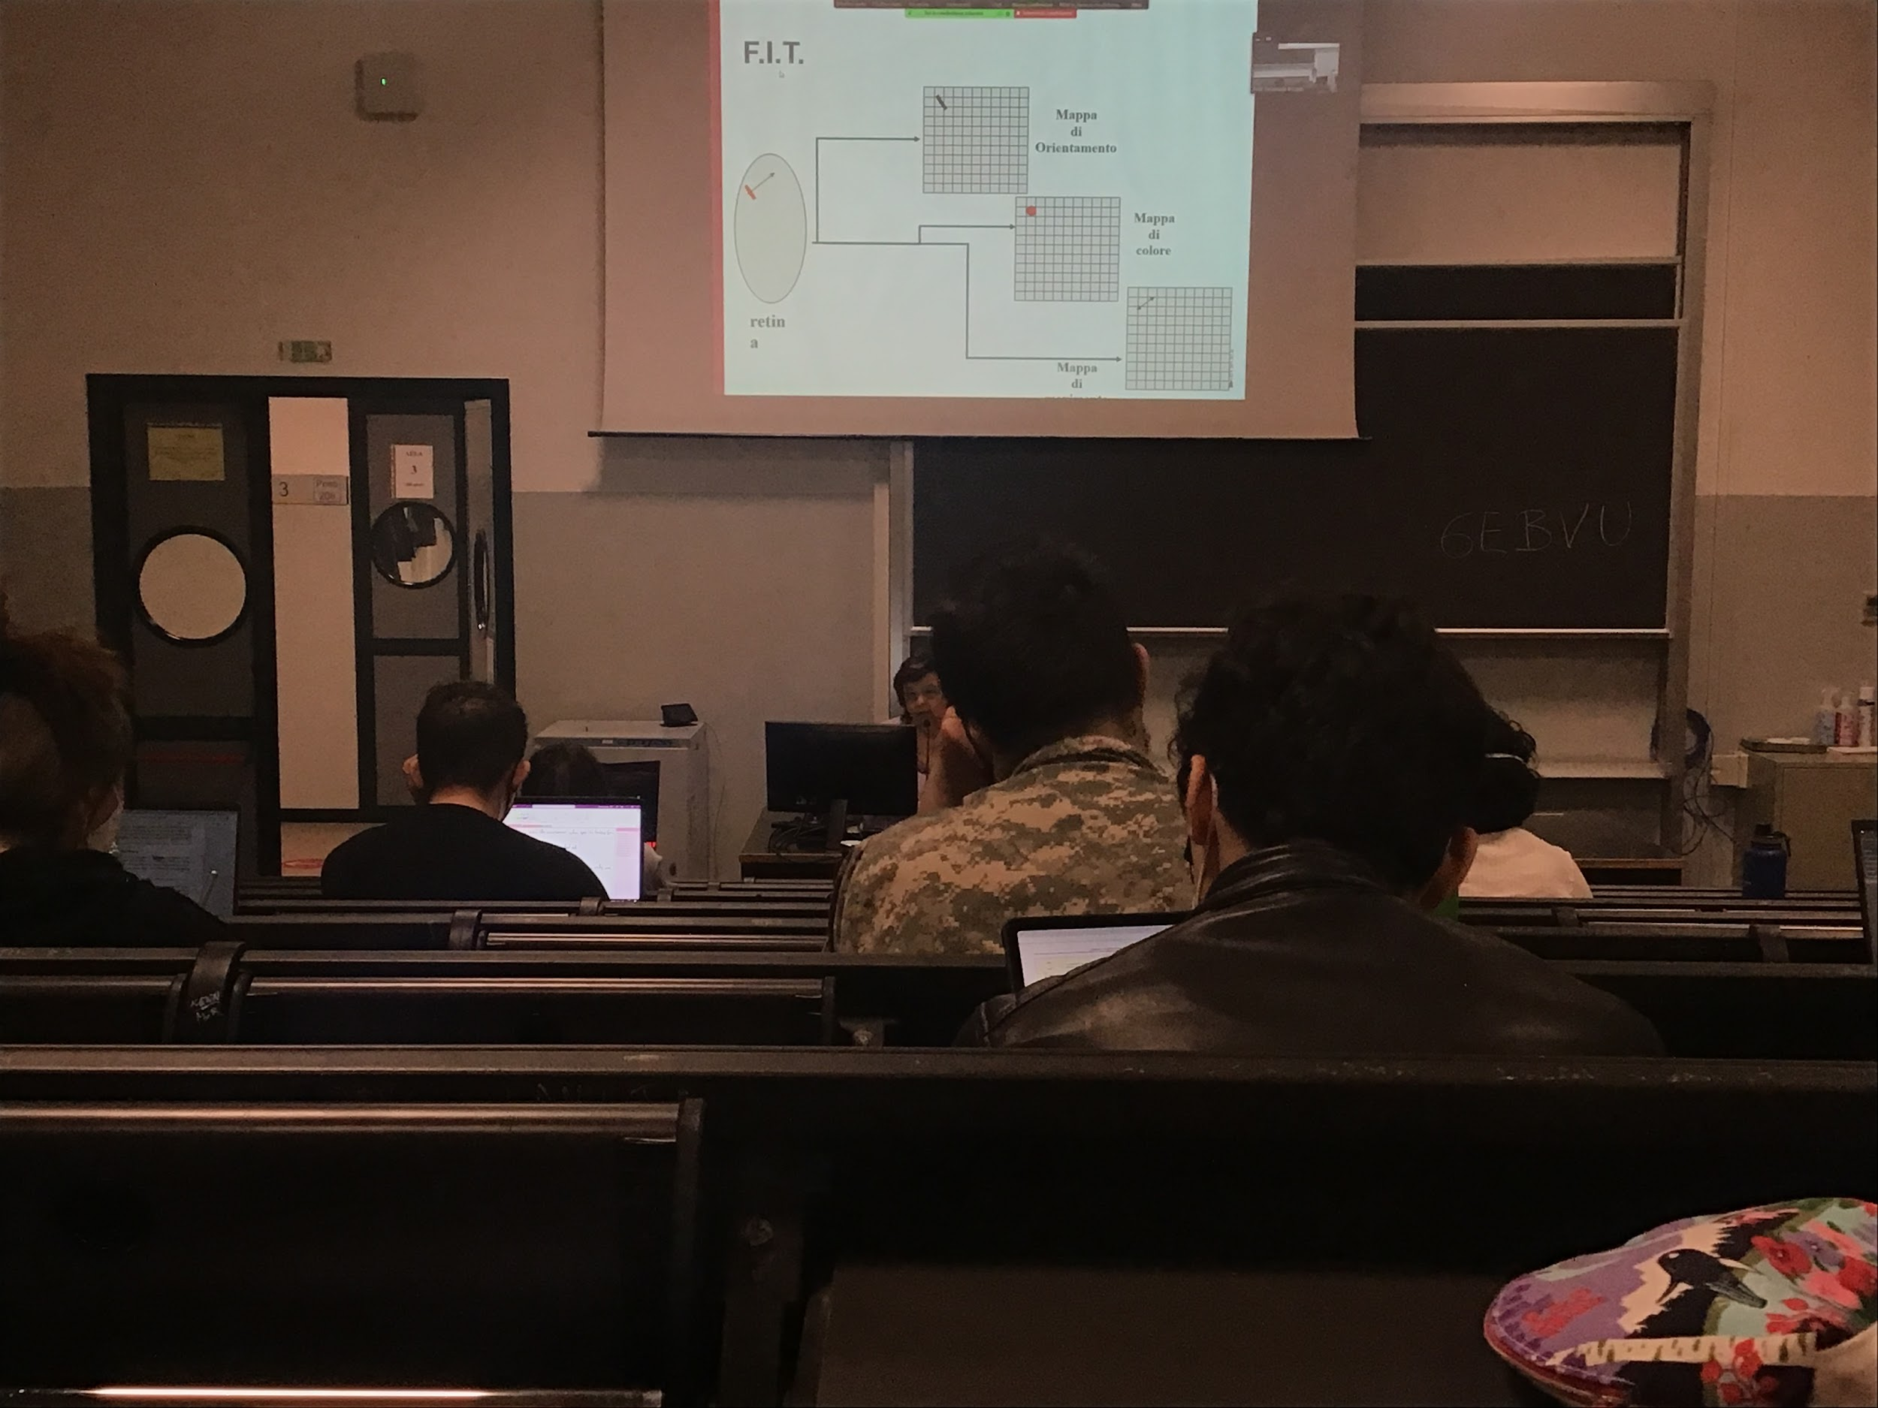

Feature integration theory

In my retina there is a red diagonal bar that moves, different maps are created automatically in the brain that codes

* One orientation
* One colour
* One movement

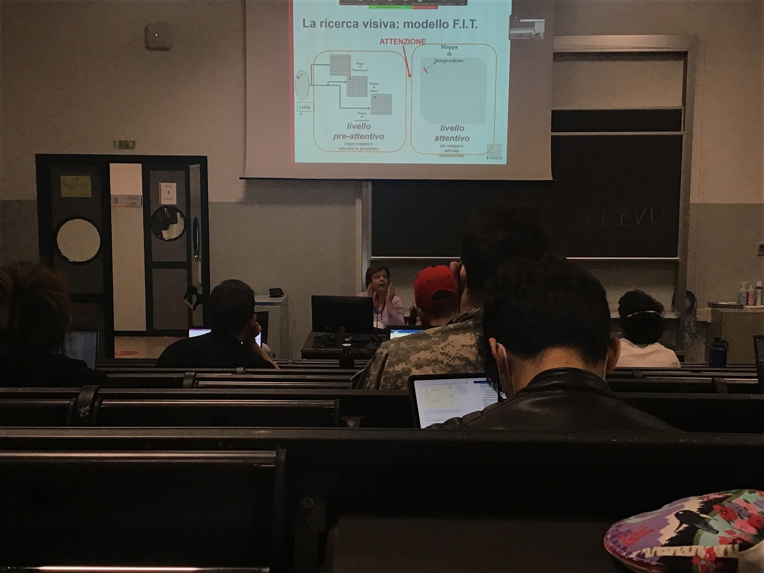

If this information is sufficient to give the response I stop there. If I am looking for a red object and there is only a red object I conclude my search

**Attention**: looks at the signal position in space and combine the different characteristic, more object I have more times it takes

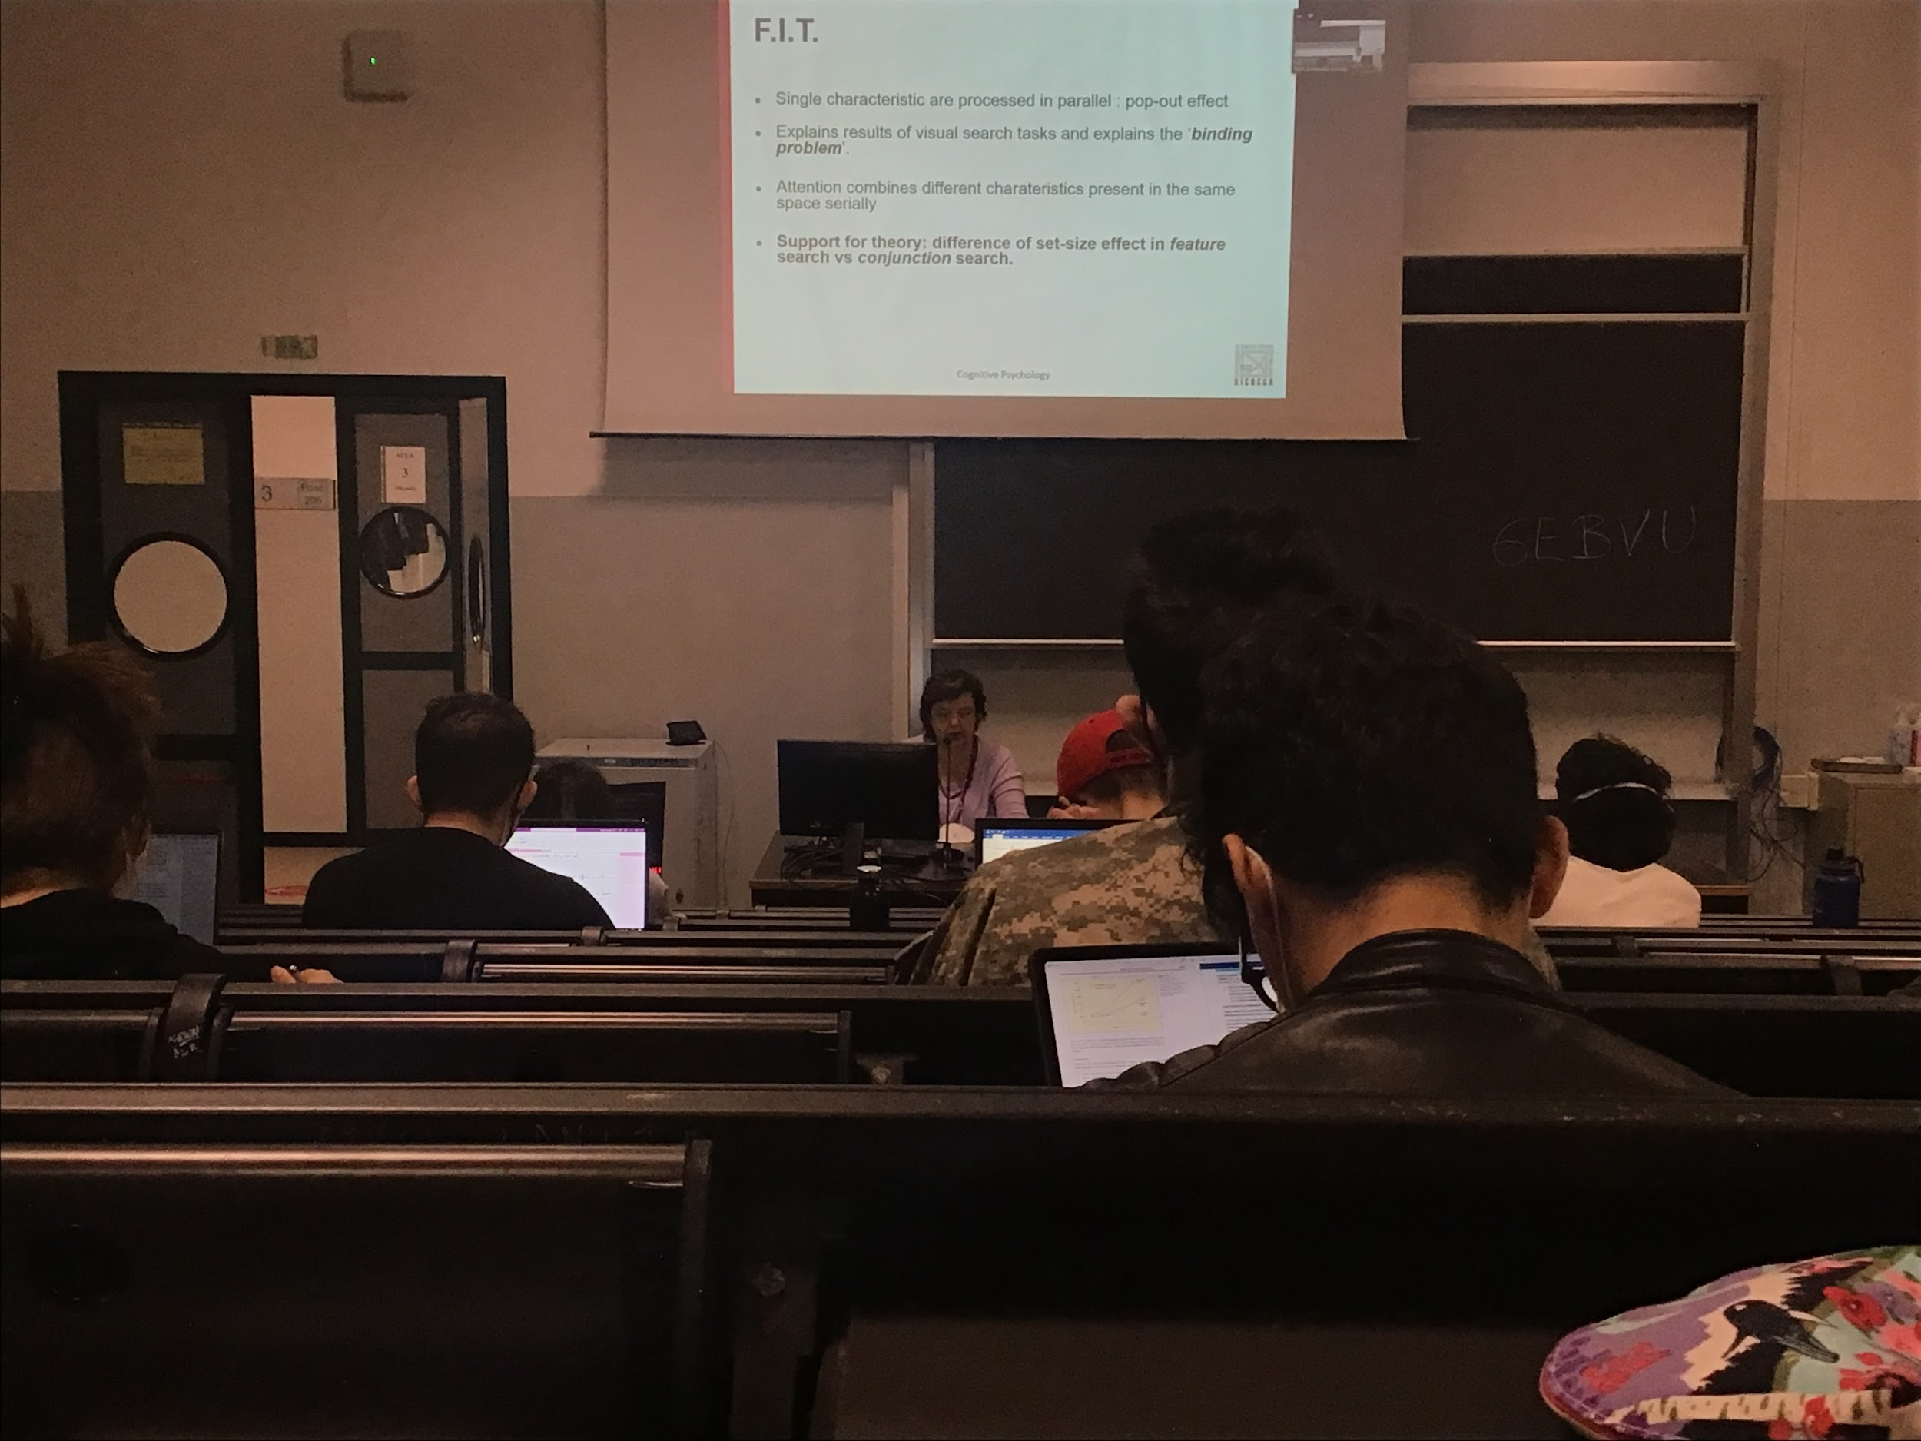

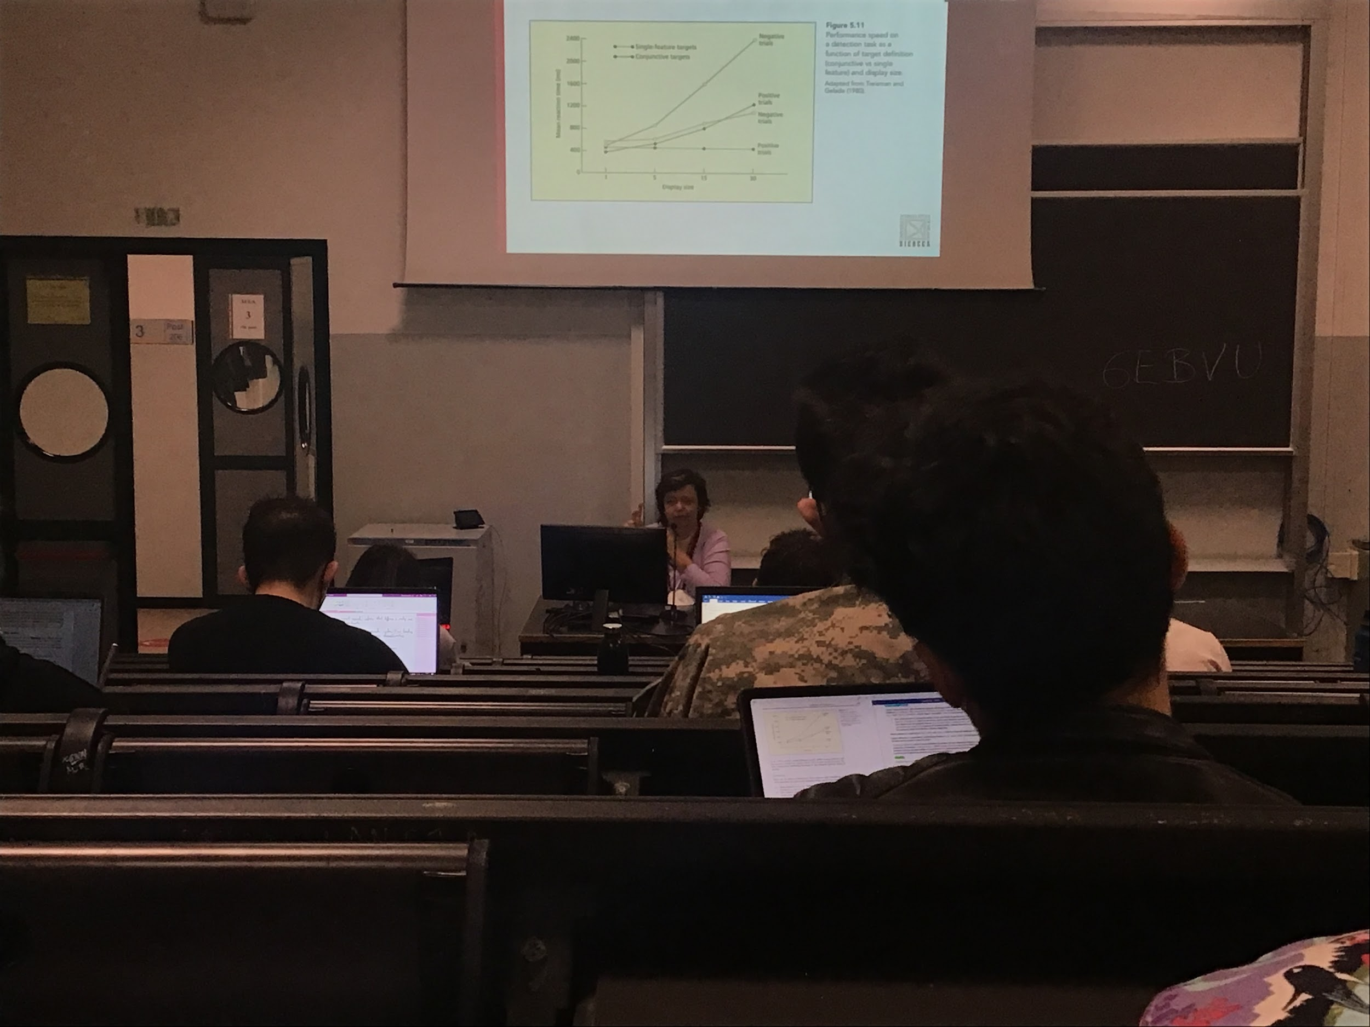

To respond yes in the case of single feature target the reaction time is always the same, using the maps automatically creates in the first step

The times increases because we have to move the focus of attention in different position

Difference also with positive and negative trials. It opens up with time. Takes longer to say no (usually double of the time). On average I have to look half of the items, 50% of the times

All the time I have to check all if there is or not the target, that is because there is the difference of positive and negative trial

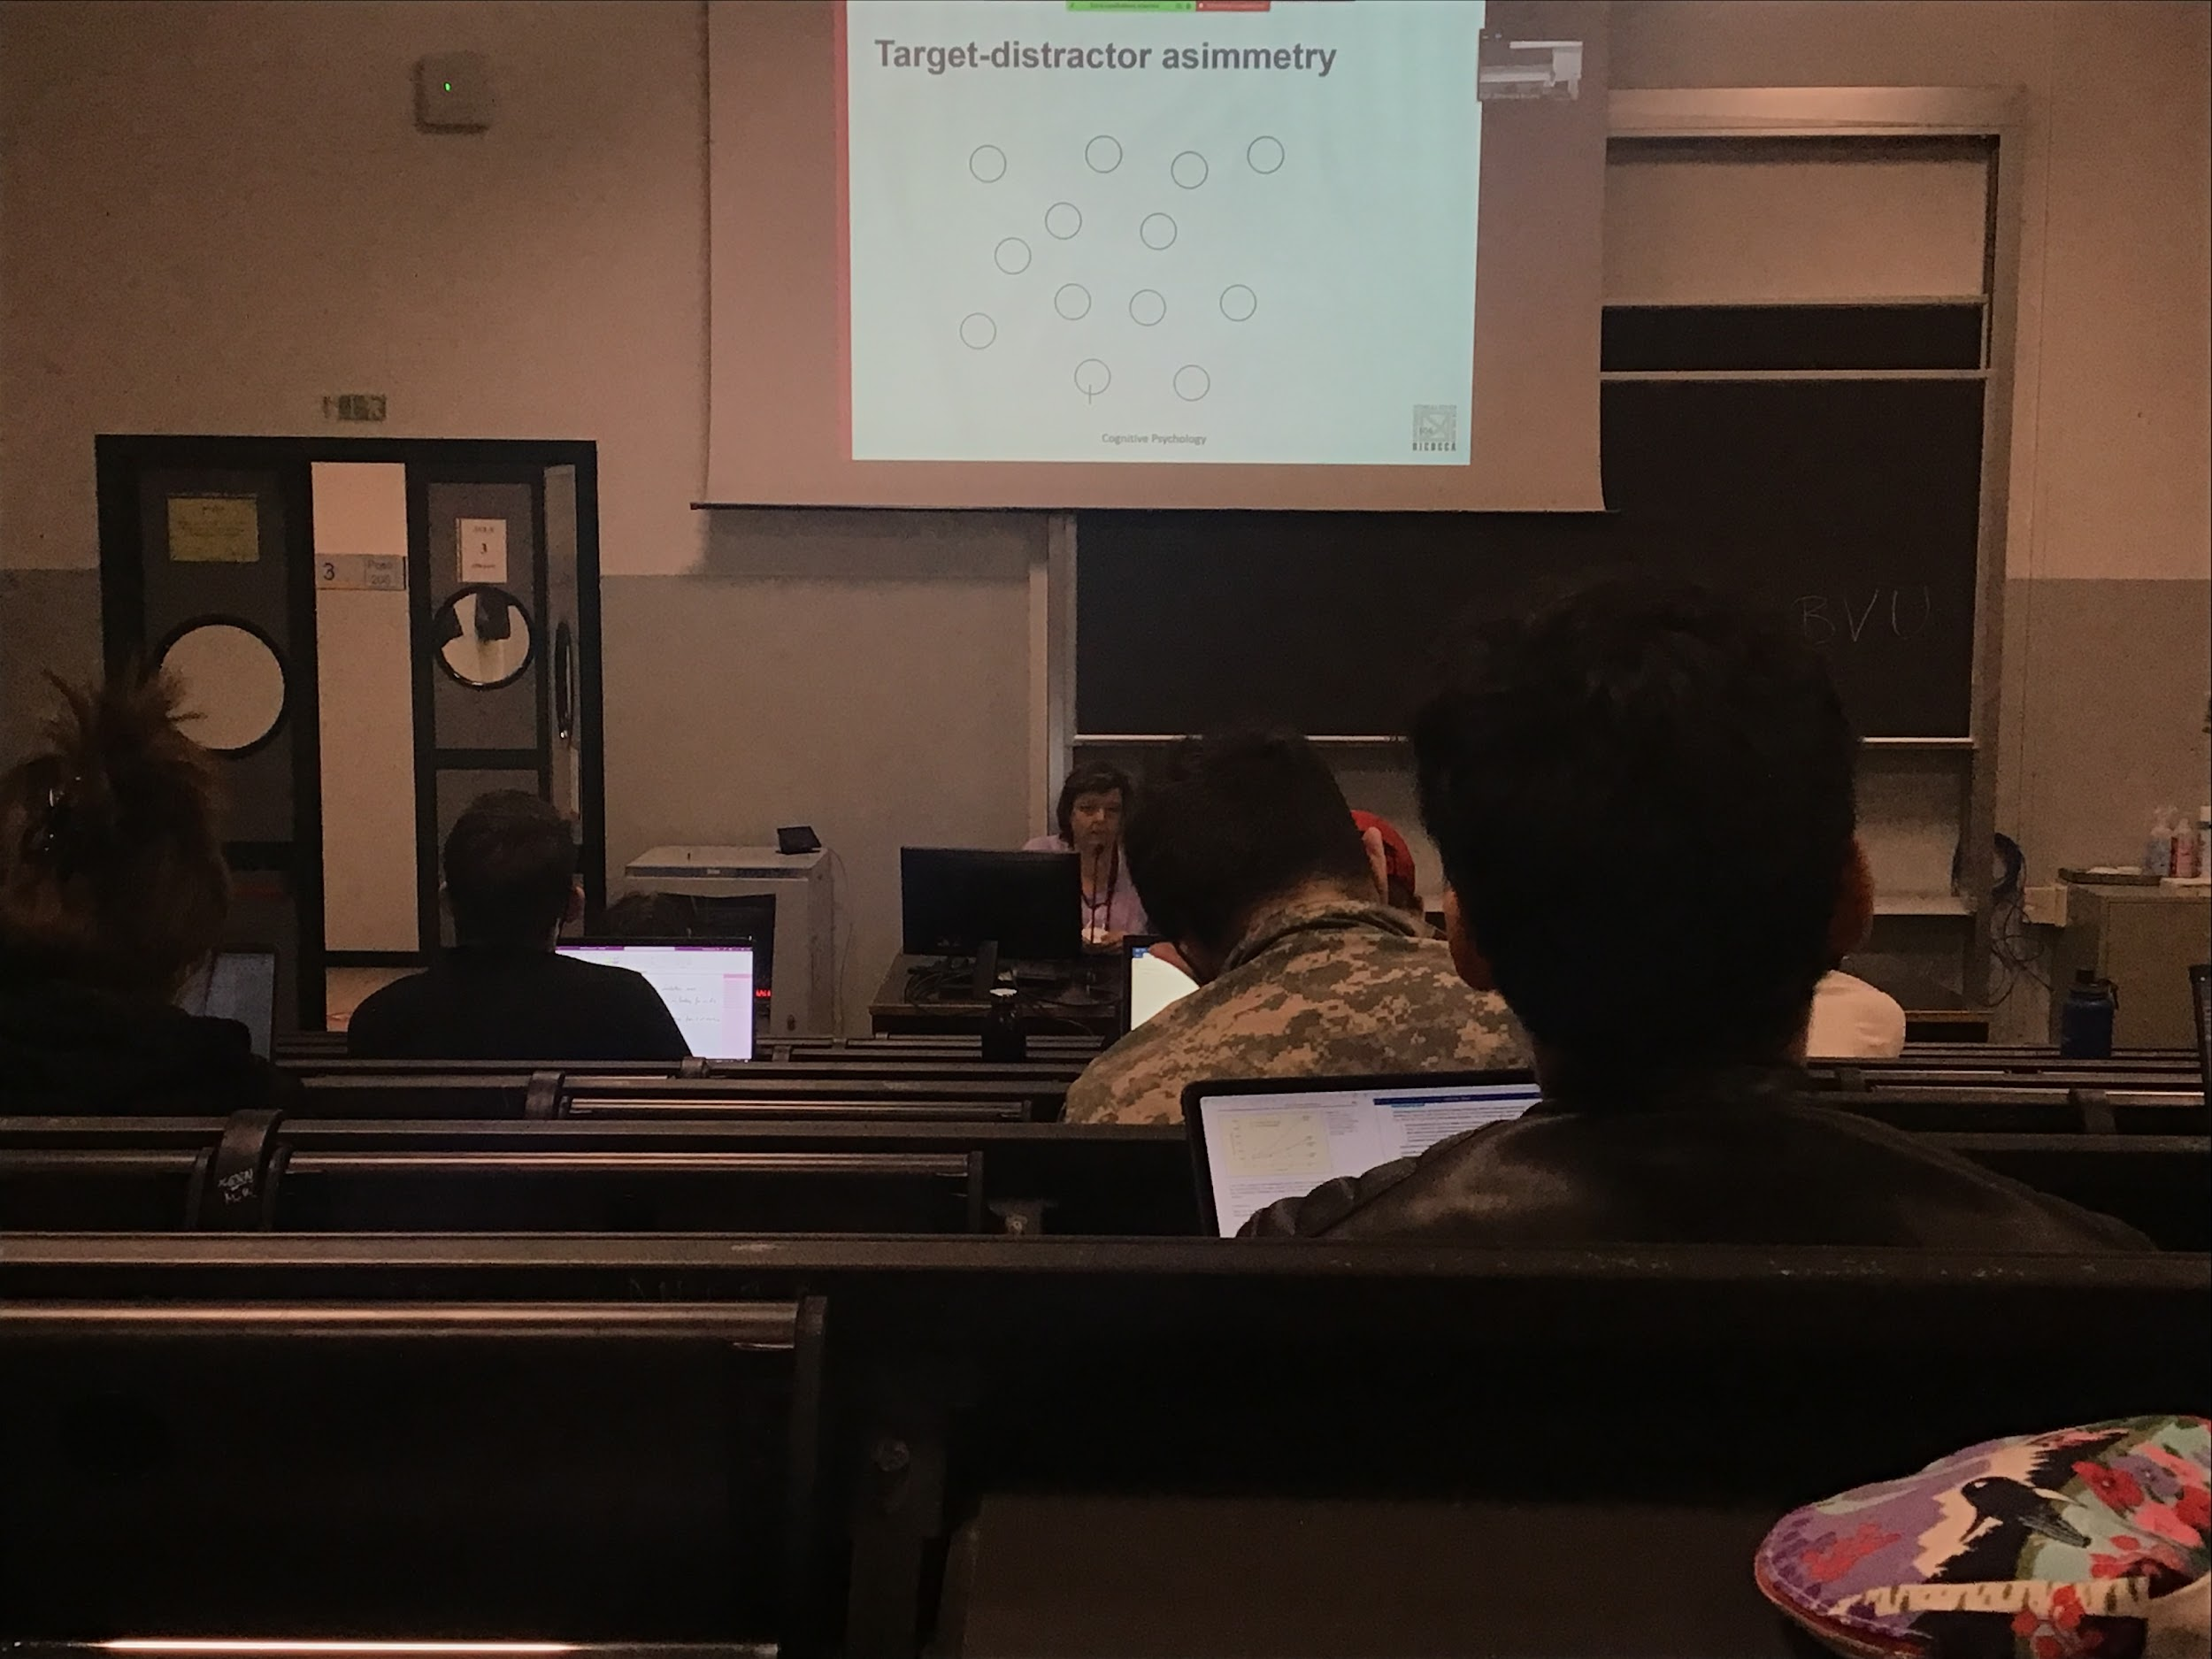

The results depends on what is the difference between target and distractors

No attention required because on the vertical bar map there is only one illusion (parallel)

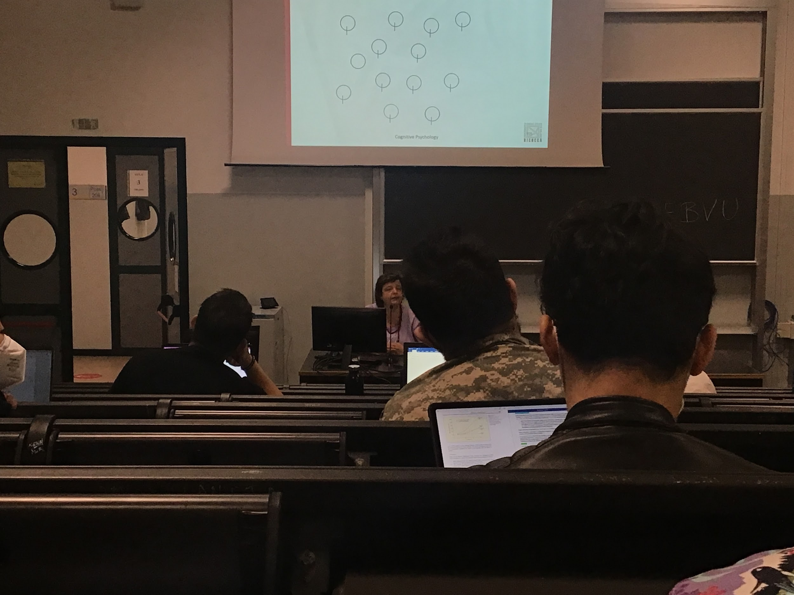

Serial because you have many

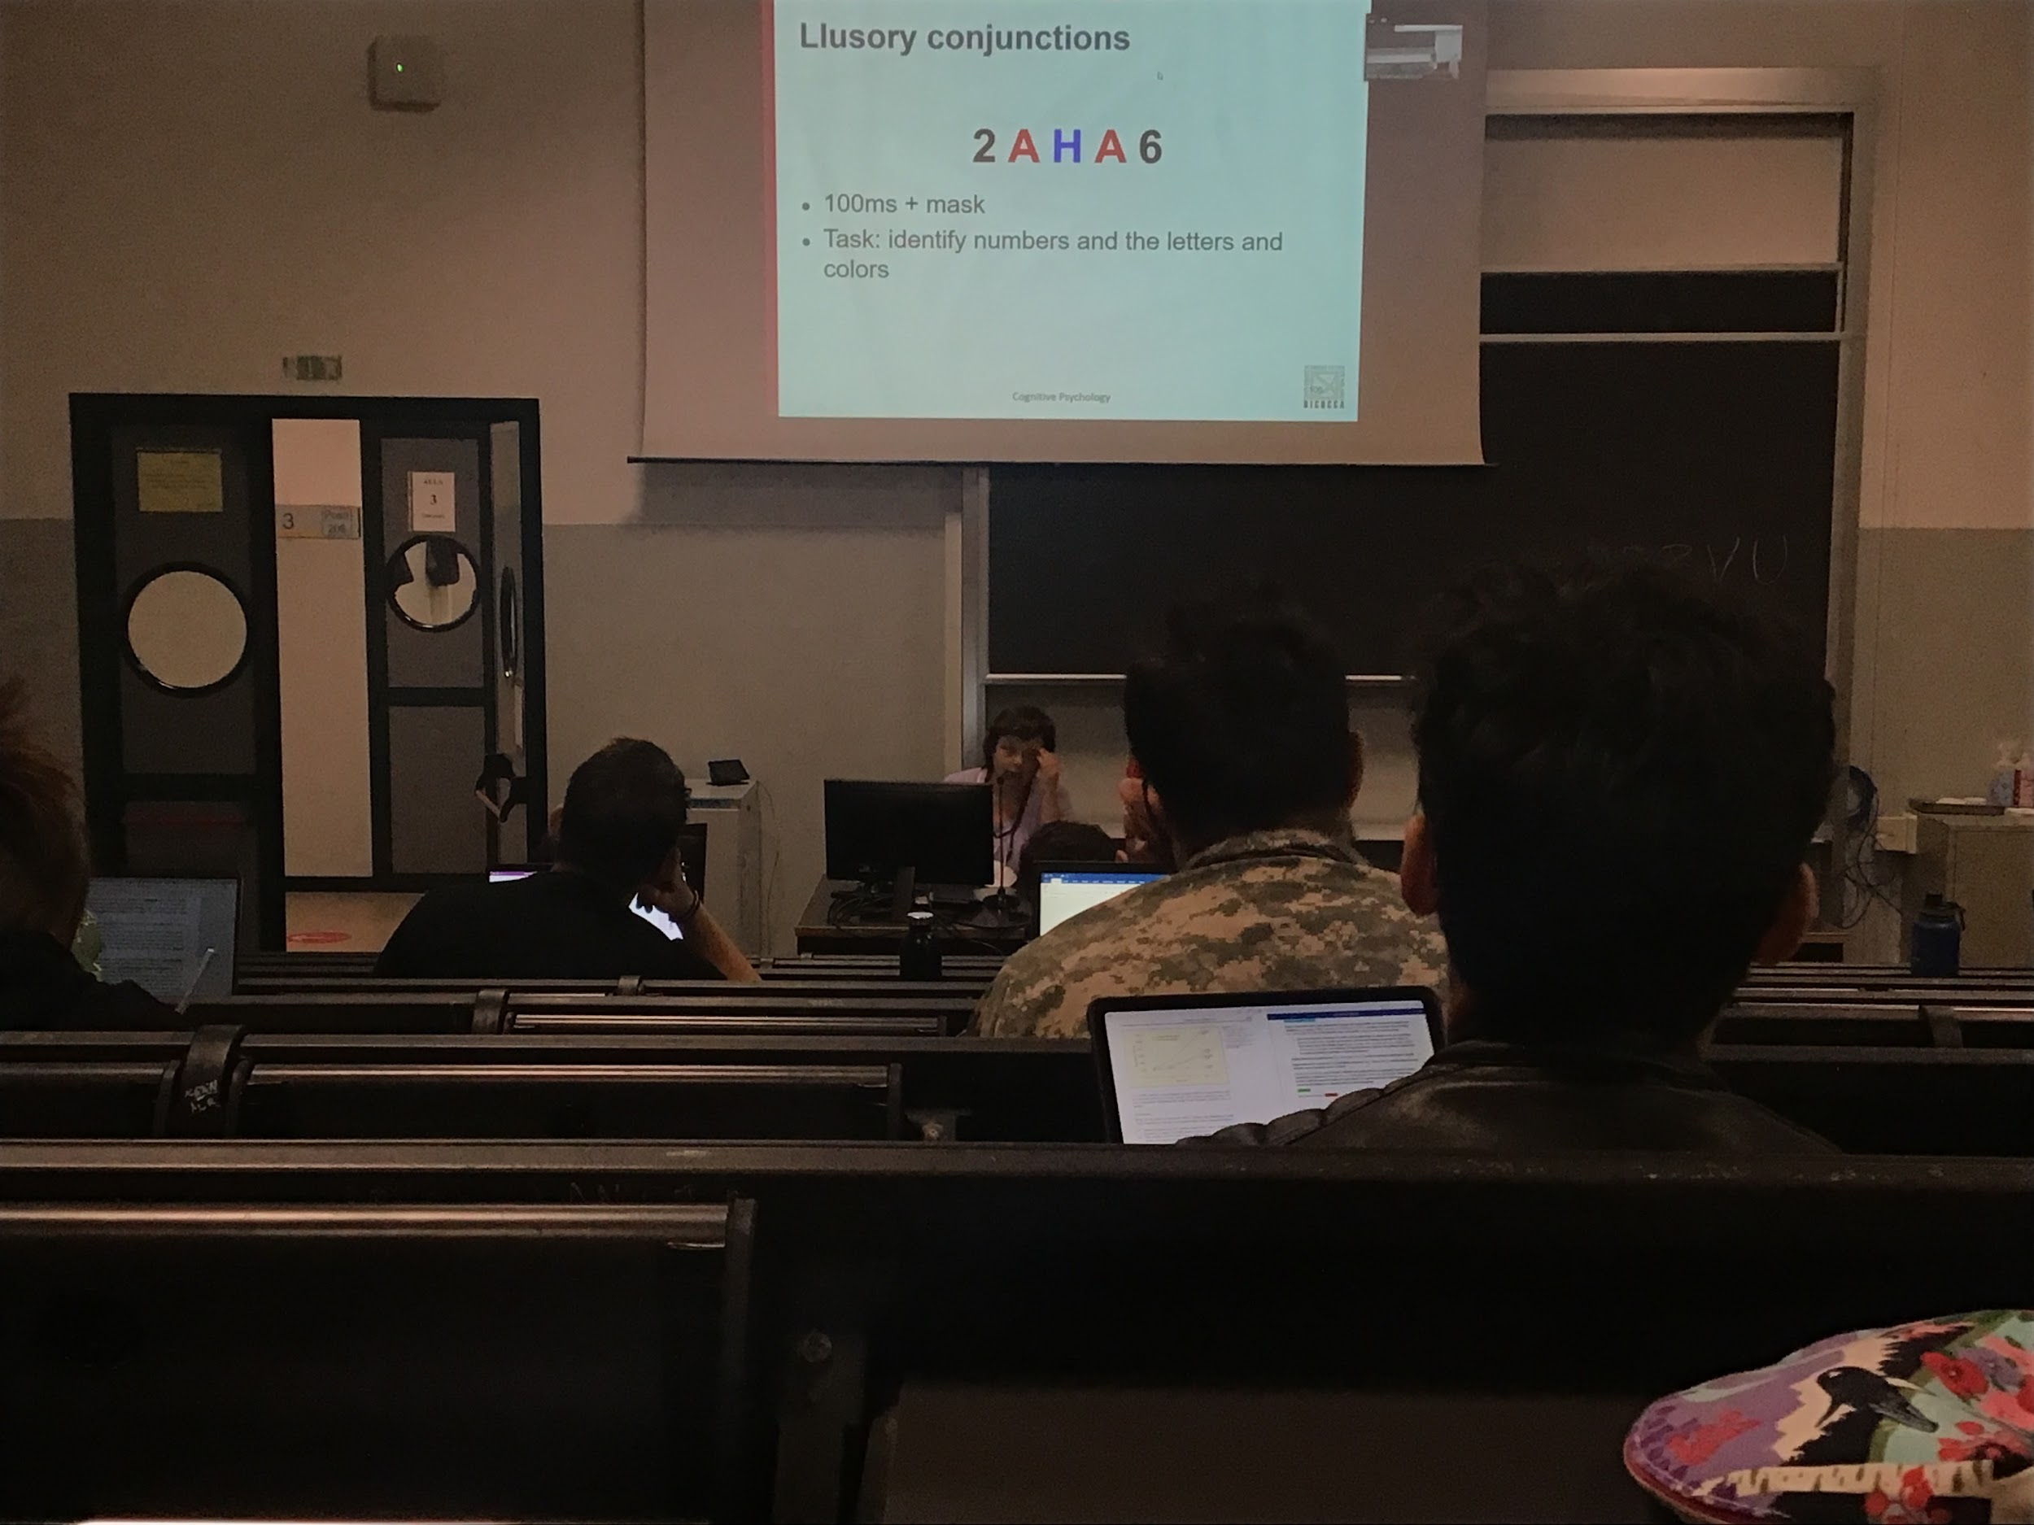

Show letter from very **short time**. Don’t let you enough time to do all the attention movement

Ask to tell you what are the number at the experiments and then the letters of the colour

Unable to tell the correct colours

Can no bind together the informations when I don’t have enough time

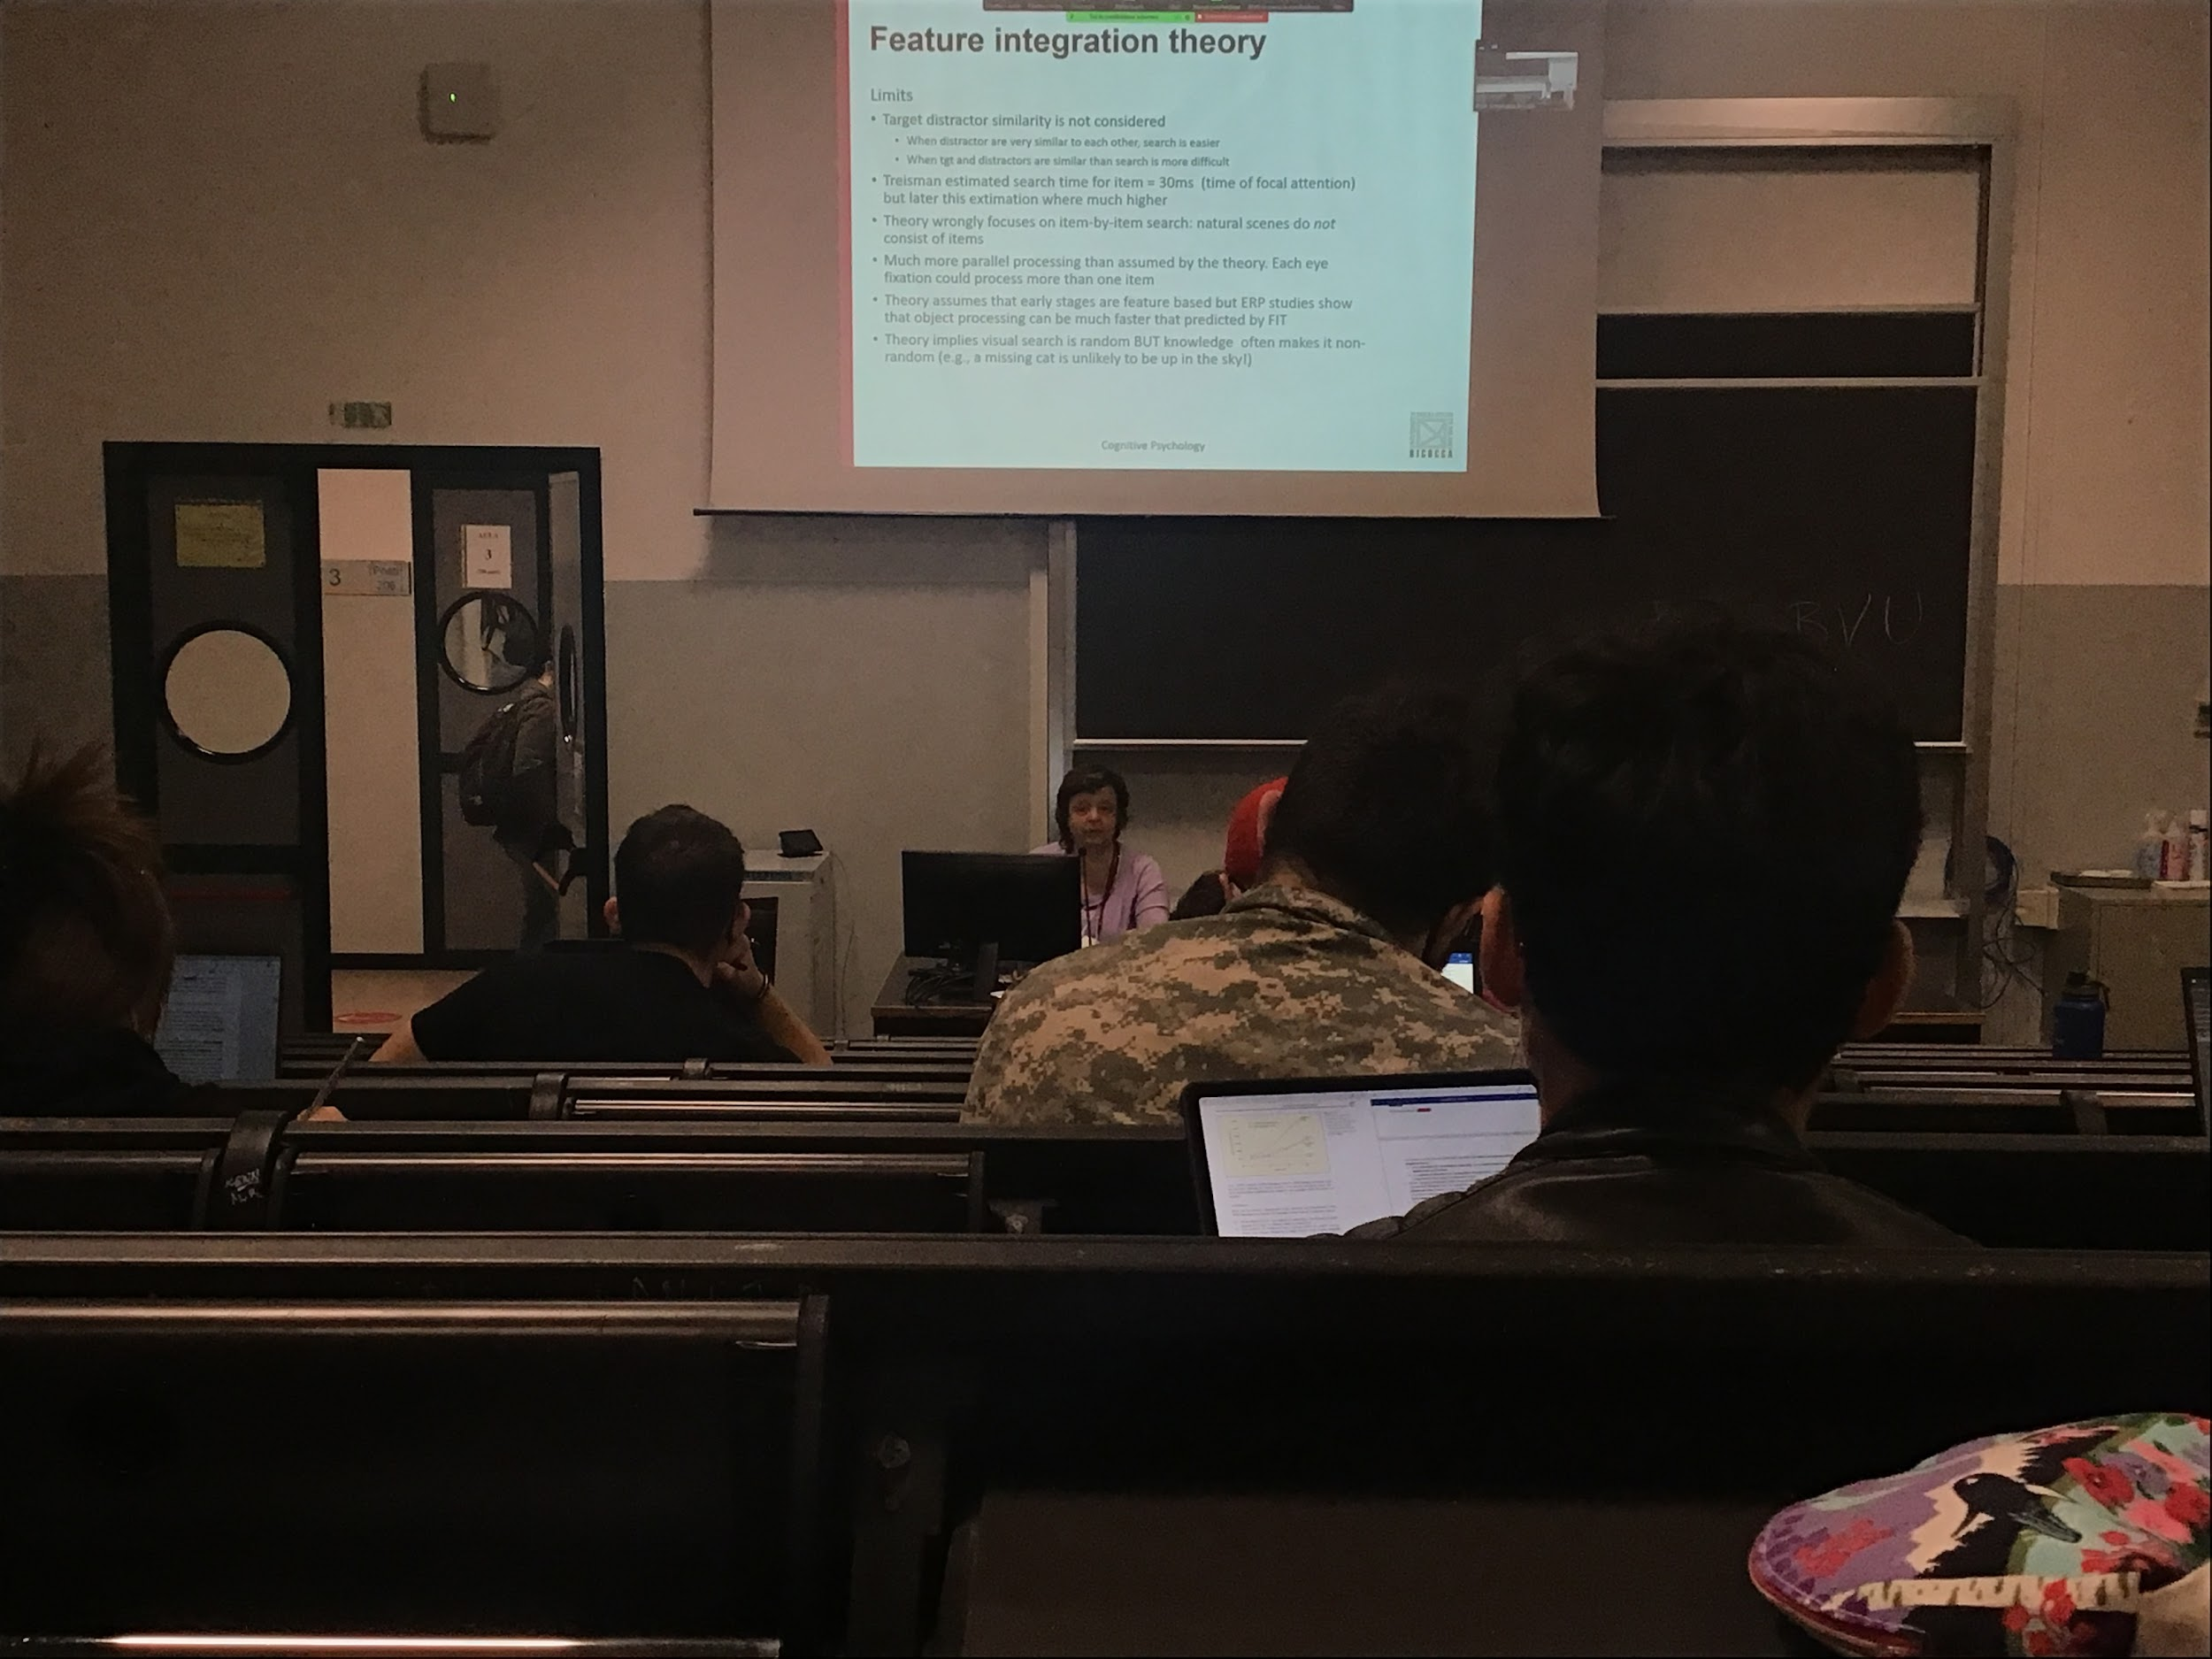

Ttreisman theory is very dated. Very easy to understand

There are problems with the theory

* No idea of the fact that we can increase difficulty when targets and distractors become similar. When when we change similarly the task can become more easy or difficult and that is not explained by the theory
* Theory based on **artificial stimuli**, in real life there are no items in the middle of nowhere
* In an artificial task looking for a red dot it can be anywhere, in real live task we avoid some location, when looking for the tv controller we are not looking on the ceiling, when you look for objects you look to specific position that are given from the top down process
* There is much more parallel search than what was predicted from the theory